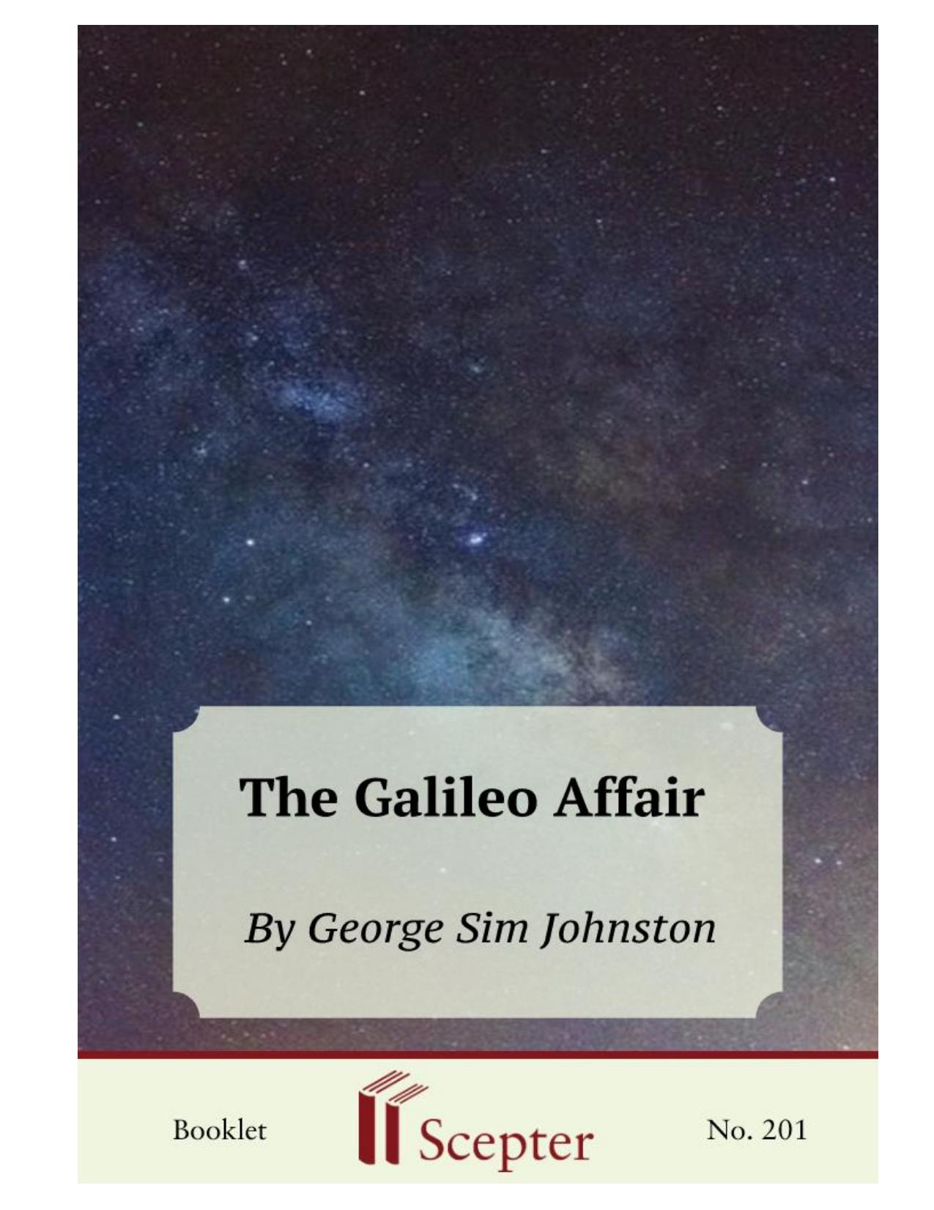
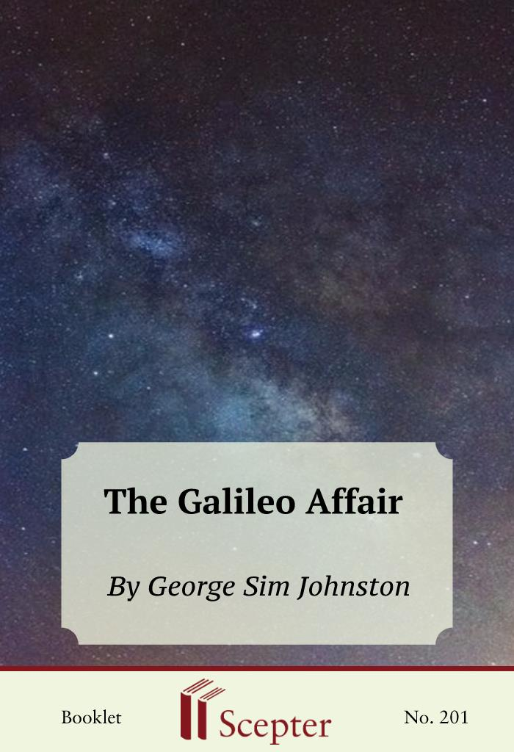

SCEPTER BOOKLETS

The Galileo Affair
By George Sim Johnston

Scepter Publishers
PO Box 360694,
Strongsville, Ohio 44136

Toll Free: 800-322-8773 (US & Canada only)
Tel: 212-354-0670
Fax: 646-417-7707

info@scepterpublishers.org

www.scepterpublishers.org

©1994 Scepter Publishers
Second Edition, © 2017
Booklet and Cover design by Parker Eidle

Booklet Number: 201

© Scepter Publishers, Inc. This information protected by copyright of Scepter Publishers, Inc., New York, NY USA. It is for the free use of readers and we encourage you to redistribute this without permission. None of this information can be sold, either in electronic or print form, unless permission has been obtained from Scepter Publishers, Inc. Direct all inquiries to
info@scepterpublishers.org.

CONTENTS

Introduction 1
John Paul II and Galileo 2
“Saving the Appearances” 4
Toys for Virtuosi 5
The Copernican Revolution 6
Galileo’s Telescope 7
The Astronomer’s Belligerence 9
Scripture and Science 11
The Opposition Musters 12
Bellarmine Changes Galileo 13
Papal Overreaching 15
Unjust Condemnation 17

INTRODUCTION

No episode in the history of the Catholic Church is so misunderstood as the condemnation of Galileo. It is, in Cardinal Newman’s phrase, the one stock argument used to show that science and Catholic dogma are antagonistic. To the popular mind, the Galileo affair is prima facie evidence that the free pursuit of truth became possible only after science "liberated"
itself from the theological shackles of the Middle Ages. This case makes for such a neat morality play of enlightened science versus dogmatic obscurantism that historians are seldom inclined to correct the anti-Catholic
"spin" that is usually put on it. Even many intelligent Catholics would prefer that the whole sorry episode be swept under a rug.

CATHOLIC BOOKS FOR SPIRITUAL GROWTH

JOHN PAUL II AND GALILEO

Such avoidance, however, is not the attitude of Pope John Paul II. In 1979
he expressed the wish that the Pontifical Academy of Sciences conduct an in-depth study of the celebrated case. A commission of scholars was convened, and they presented their report to the Pope on October 31, 1992. Contrary to reports in The New York Times and other conduits of misinformation about the Church, the Holy See was not on this occasion finally throwing in the towel and admitting that the earth revolves around the sun. That particular debate, as far as the Church is concerned, was closed not later than 1741 when Benedict XIV told the Holy Office to grant an imprimatur to the first edition of The Complete Works of Galileo.

What John Paul II wanted was a better understanding of the whole affair by both scientists and theologians. It has been said that while politicians think in terms of weeks and statesmen in years, the Pope thinks in centuries. The Holy Father was trying to heal the tragic split between faith and science which occurred in the seventeenth century and from which Western culture has not recovered. Following the guidelines of the Second Vatican Council, he wanted to make clear that science has a legitimate freedom in its own sphere and that this freedom was unduly violated by Church authorities in the case of Galileo.

But at the same time—and here the secular media tuned out—the Holy Father pointed out that "the Galileo case has been a sort of 'myth,' in which the image fabricated out of the events was quite far removed from the reality. In this perspective, the Galileo case was the symbol of the Church's supposed rejection of scientific progress." Galileo's run-in with the Church, according to the Pope, involved a "tragic mutual incomprehension" in which both sides were at fault. It was a conflict that ought never to have occurred because faith and science, properly understood, can never be at odds.

Since the Galileo case is one of the historical bludgeons used to beat on the Church—the others being the Crusades and the Spanish Inquisition — it is important that Catholics understand exactly what happened between the Church and that very great scientist. A close look at the facts puts to rout almost every aspect of the reigning Galileo legend.

The Victorian biologist Thomas Henry Huxley, who never supported Catholicism, once examined the case and concluded that "the Church had the best of it." The most striking point about the whole affair is that until Galileo forced the issue into the realm of theology, the Church had been a willing ombudsman for the new astronomy: it had encouraged the work of Copernicus CATHOLIC BOOKS FOR SPIRITUAL GROWTH
and sheltered Kepler against the persecutions of Calvinists. Problems only arose when the debate went beyond the mere question of celestial mechanics. But here we need some historical background.

CATHOLIC BOOKS FOR SPIRITUAL GROWTH

“SAVING THE APPEARANCES”

The modern age of science began in 1543 when Nicholas Copernicus, a Polish Canon, published his epochal On the Revolution of the Celestial Orbs.
The popular view is that Copernicus "discovered" that the earth revolves around the sun. Actually, that notion is at least as old as the ancient Greeks.
But the geocentric theory, endorsed by Aristotle and given mathematical plausibility by Ptolemy, was the prevailing model until Copernicus. It was given additional credibility by certain passages of Scripture which seemed to affirm the mobility of sun and the fixity of the earth. Most early Church Fathers simply took geocentrism for granted; but they weren't really interested in scientific explanations of the cosmos. As St. Ambrose wrote, "To discuss the nature and position of the earth does not help us in our hope of the life to come."

Prone as we are to what C. S. Lewis called "chronological snobbery,"
we must try to understand the prevailing attitude toward science when Galileo began his work. Since the time of the Greeks, the purpose of astronomy had been to "save the appearances" of celestial phenomena. This famous phrase is usually taken to mean the resorting to desperate expedients to "save" or rescue the Ptolemaic system. But it meant no such thing. To the Greek and medieval mind, science was a kind of formalism, a means of coordinating data, which had no bearing on the ultimate reality of things.
Different mathematical devices—such as the Ptolemaic cycles—could be advanced to predict the movements of the planets, and it was of no concern to the medieval astronomer whether such devices touched on the actual physical truth. The point was to give order to complicated data, and all that mattered was which hypothesis (a key word in the Galileo affair) was the simplest and most convenient.

CATHOLIC BOOKS FOR SPIRITUAL GROWTH

TOYS FOR VIRTUOSI

The almost universal belief that the purpose of science was not to give a final account of reality, but merely to "save appearances," accounts for how lightly the Church hierarchy initially received Copernicus's theory. Astronomy and mathematics were regarded as the playthings of virtuosi. They were accounted as having neither philosophical nor theological relevance. There was genuine puzzlement among Churchmen that they had to get involved in a quarrel over planetary orbits. It simply did not make any difference to them how the
"appearances" were "saved." And, in fact, Copernicus, a good Catholic, published his book at the urging of two eminent prelates and dedicated it to Pope Paul III, who received it cordially.

That Copernicus believed the heliocentric theory to be a true description of reality went largely unnoticed. This was partly because he still made reassuring use of Ptolemy's cycles and epicycles; he also borrowed from Aristotle the notion that the planets must move in circles because that is the only perfect form of motion. There was, moreover, the famous preface by Osiander, a Protestant who oversaw the printing of the first edition. Osiander knew that Luther and Melanchthon violently opposed any suggestion that the earth revolves around the sun. So he wrote an unsigned preface, which everyone took to be Copernicus's, presenting the theory as a mere mathematical devise for charting the movements of the planets in a simpler manner than the burdensome Ptolemaic system, one that was not meant to be a definitive description of the heavens.

CATHOLIC BOOKS FOR SPIRITUAL GROWTH

THE COPERNICAN REVOLUTION

But in reality Copernicus's book marked a basic change in human thought, one that caught the universities even more off guard than the Church. Owen Barfield, in his fascinating book Saving the Appearances, calls it "the real turning point" in the history of science: "It took place when Copernicus (probably—it cannot be regarded as certain) began to think, and others, like Kepler and Galileo, began to affirm, that the heliocentric hypothesis not only saved the appearances, but was physically true.... It was not simply a new theory of the nature of celestial movements that was feared, but a new theory of the nature of theory; namely that, if a hypothesis saves all the appearances, it is identical with truth."
Copernicus had delayed the publication of his book for years because he feared, not the censure of the Church, but the mockery of academics. It was the hide-bound Aristotelians in the schools who offered the fiercest resistance to the new science. Aristotle was the Master of Those Who Know; perusal of his texts was regarded as almost superior to the study of nature itself. The Aristotelian universe comprised two worlds, the superlunary and the sublunary. The former consisted of the moon and everything beyond; it was perfect and imperishable. The latter was the terrestrial globe and its atmosphere, subject to generation and decay, the slagheap of the cosmos.
Ptolemy's methodizing of Aristotle to explain the motion of the stars was part of this academic baggage. And it made perfect empirical sense; by using it, ships were able to navigate the seas, and astronomers were able to predict eclipses. So why give up this time-honored system for a new unproved cosmology which contradicted not only common sense (as no less an authority than Francis Bacon averred), but also the apparent meaning of Scripture?

CATHOLIC BOOKS FOR SPIRITUAL GROWTH

GALILEO’S TELESCOPE

Such was the scientific mind of Europe when Galileo burst on the scene in 1610 with his startling telescopic discoveries. Up to that point, the forty-six- year-old Galileo had been interested mainly in physics, not astronomy.
His most famous accomplishment had been the formulation of the laws of falling bodies. (Contrary to legend, he never dropped anything from the Tower of Pisa.) Galileo was a gifted tinkerer; and when he heard about the invention of the telescope in Holland, he immediately built one for himself, characteristically taking full credit for the invention.
Looking through his new spyglass, he made some discoveries which shook the foundations of the Aristotelian cosmos. First, he saw that the moon was not a perfect sphere, but pocked with mountains and valleys like the earth. Second, and more astonishing, Jupiter had at least four satellites; no longer could it be said that heavenly bodies revolve exclusively around the earth. Moreover, he observed the phases of Venus, the only explanation for which is that Venus moves around the sun and not the Earth.
The response to these discoveries ranged from enthusiastic to downright hostile. The leading Jesuit astronomer of the day, Christopher Clavius, was skeptical; but once the Roman college acquired an improved telescope, he saw for himself that Galileo was right about Jupiter's moons, and the Jesuits subsequently confirmed the phases of Venus. These men were not ready to jump on the Copernican bandwagon, however; they adopted as a half-way measure the system of Tycho Brahe, which had all the planets except the Earth orbiting the sun. This accounted quite satisfactorily for Galileo's discoveries. Still, Galileo was the man of the hour; in 1611 he made a triumphant visit to Rome, where he was feted by cardinals, and was granted a private audience by Pope Paul V who assured him of his support and good will.
Galileo returned to Florence, where he might have been expected to continue his scientific research. But for about two decades after 1611, pure science ceased to be his main concern. Instead, he became obsessed with converting public opinion to the Copernican system. He was an early instance of that very modern type, the cultural politician. Galileo insisted that all of Europe, starting with the Church, had to buy into Copernicus. This crusade would never have ended in the offices of the Inquisition had Galileo CATHOLIC BOOKS FOR SPIRITUAL GROWTH
possessed a grain of discretion, not to mention charity. But he was not a tactful person; he loved to put people down and make them look ridiculous.
And he would make no allowance for human nature, which does not easily shuck off an old cosmology to embrace a new one which seems to contradict both sense and tradition.
Cardinal Newman, who was not one to think that secular truths are determined by ecclesiastical fiat, wrote concerning Galileo's crusade, that
"had I been brought up in the belief of the immobility of the Earth as though a dogma of Revelation, and had associated it in my mind with the incommunicable dignity of man among created beings, with the destinies of the human race, with the locality of purgatory and hell, and other Christian doctrines, and then for the first time had heard of Galileo's thesis.... I should have been at once indignant at its presumption and frightened at its speciousness, as I can never be, at any parallel novelties in other human sciences bearing on religion."

CATHOLIC BOOKS FOR SPIRITUAL GROWTH

THE ASTRONOMERS BELLIGERENCE

But Galileo was intent on ramming Copernicus down the throat of Christendom. The irony is that, when he started his campaign, he enjoyed almost universal good will among the Catholic hierarchy. But he managed to alienate almost everybody with his caustic manner and aggressive tactics.
His position gave the Church authorities no room to maneuver: they either had to accept Copernicanism as a fact (even though it had not been proved) and reinterpret Scripture accordingly; or they had to condemn it. He refused the reasonable third position which the Church offered him: that Copernicanism might be considered a hypothesis, one even superior to the Ptolemaic system, until further proof could be adduced.
Such proof, however, was not forthcoming. Galileo's belligerence probably had much to do with the fact that he knew there was no direct proof of heliocentricism. He could not even answer the strongest argument against it, which was advanced by Aristotle. If the earth did orbit the sun, the philosopher wrote, then stellar parallaxes would be observable in the sky. In other words, there would be a shift in the position of a star observed from the Earth on one side of the sun, and then six months later from the other side.
Galileo was not able with the best of his telescopes to discern the slightest stellar parallax. This was a valid scientific objection, and it was not answered until 1838, when Friedrich Bessel succeeded in determining the parallax of star 61 Cygni.
Galileo's other problem was that he insisted, despite the discoveries of Kepler, that the planets orbit the sun in perfect circles. The Jesuit astronomers could plainly see that this was untenable. Galileo nonetheless launched his campaign with a series of pamphlets and letters which were circulated all over Europe. Along the way, he picked fights with a number of Churchmen on peripheral issues which helped to stack the deck against him.
And, despite the warnings of his friends in Rome, he insisted on moving the debate onto theological grounds.
There is no question that if the debate over heliocentricism had remained purely scientific, it would have been shrugged off by the Church authorities. But in 1614, Galileo felt that he had to answer the objection that the new science contradicted certain passages of Scripture. There was, for example, Joshua's command that the sun stand still. Why would Joshua do CATHOLIC BOOKS FOR SPIRITUAL GROWTH
that if, as Galileo asserted, the sun didn't move at all? Then there were Psalms 93 ("He has made the world firm, not to be moved.") and 104 ("You fixed the earth upon its foundation, not to be moved forever."), not to mention the famous verse in Ecclesiastes. These are not obscure passages, and their literal sense would obviously have to be abandoned if the Copernican system were true.

CATHOLIC BOOKS FOR SPIRITUAL GROWTH

SCRIPTURE AND SCIENCE

Galileo addressed this problem in his famous Letter to Castelli. In its approach to biblical exegesis, the letter ironically anticipates Leo XIII's encyclical, “Providentissimus Deus” (1893), which pointed out that Scripture often makes use of figurative language and is not meant to teach science.
Galileo accepted the inerrancy of Scripture; but he was also mindful of Cardinal Baronius's quip that the bible "is intended to teach us how to go to heaven, not how the heavens go." And he pointed out correctly that both St.
Augustine and St. Thomas Aquinas taught that the sacred writers in no way meant to teach a system of astronomy. St. Augustine wrote that: “One does not read in the Gospel that the Lord said: ‘I will send you the Paraclete who will teach you about the course of the sun and moon.’ For He willed to make them Christians, not mathematicians.”
Unfortunately, there are still today biblical fundamentalists, both Protestant and Catholic, who do not understand this simple point: the bible is not a scientific treatise. When Christ said that the mustard seed was the smallest of seeds (and it is about the size of a speck of dust), he was not laying down a principle of botany. In fact, botanists tell us that there are smaller seeds. He was simply talking to the men of his time in their own language, and with reference to their own experience. Hence the warning of Pius XII in Divino Afflante Spiritu (1943) that the true sense of a biblical passage is not always obvious, since the sacred writers made full use of the idioms of their time and place.
But in 1616, the year of Galileo's first "trial," there was precious little elasticity in Catholic biblical theology. The Church had just been through the bruising battles of the Reformation. One of the chief quarrels with the Protestants was over the private interpretation of Scripture. Catholic theologians were in no mood to entertain hermeneutical injunctions from a layman like Galileo. His friend Archbishop Piero Dini warned him that he could write freely as long as he "kept out of the sacristy." But Galileo threw caution to the winds, and it was on this point—his apparent trespassing on the theologians' turf—that his enemies were finally able to nail him.

CATHOLIC BOOKS FOR SPIRITUAL GROWTH

THE OPPOSITION MUSTERS

In December 1614, a meddlesome and ambitious Dominican priest, Thomas Caccini, preached a fiery sermon in Florence denouncing Copernicanism and science in general as contrary to Christian faith. The attack was clearly aimed at Galileo, and a written apology from a Preacher-General of the Dominicans did not take the edge off Galileo's displeasure at being the target of a Sunday homily. About a month later, another Dominican, Father Niccolo Lorini, read a copy of Galileo's letter to Castelli and was disturbed to find that Galileo had taken it upon himself to interpret Scripture according to his private lights. He sent a copy to the Inquisition in Rome—a copy, moreover, which had been tampered with to make Galileo's words more alarming than they actually were. The Consultor of the Holy Office (or Inquisition) nevertheless found no serious objections to the letter, and the complaint was dismissed.
A month later, Caccini appeared in Rome uninvited, begging the Holy Office to let him testify against Galileo. Arthur Koestler writes that "Caccini beautifully fits the satirist's image of an ignorant, officious, and intriguing monk of the Renaissance. His testimony before the Inquisition was a web of hearsay, innuendo, and deliberate falsehood." The judges of the Inquisition did not buy his story, and the case against Galileo was again dropped.
But the letter to Castelli and Caccini's testimony were in the files of the Inquisition, and Rome was buzzing with rumors that the Church was going to condemn both Galileo and Copernicanism. Galileo's friends in the hierarchy, including Cardinal Barberini, the future Urban VIII, warned him not to force the issue. But Galileo only intensified his campaign to get the Church to accept Copernicanism as an irrefutable truth.

CATHOLIC BOOKS FOR SPIRITUAL GROWTH

BELLARMINE CHALLENGES GALILEO

At this point, one of the great saints of the day, Cardinal Robert Bellarmine, entered the drama. Bellarmine was one of the most important theologians of the Catholic Reformation. He was an expansive, gentle man who possessed the sort of meekness and good humor that are the fruits of a lifetime of ascetical struggle. As Consultor of the Holy Office and Master of Controversial Questions, he was unwillingly drawn into the Copernican controversy. In April 1615, he wrote a letter which amounted to an unofficial statement of the Church's position. He pointed out that 1) it was perfectly acceptable to maintain Copernicanism as a working hypothesis, and 2) if there were "real proof" that the earth circles around the sun, "then we should have to proceed with great circumspection in explaining passages of Scripture which appear to teach the contrary...."
Bellarmine, in effect, challenged Galileo to prove his theory or stop pestering the Church. Galileo's response was to produce his theory of the tides, which purported to show that the tides are caused by the rotation of the earth. Even some of Galileo's supporters could see that this was patent nonsense. Determined to have a showdown, however, Galileo came to Rome to confront Pope Paul V. The Pope, exasperated by all this fuss about the planets, referred the matter to the Holy Office. The Qualifiers (i.e., theological experts) of the Holy Office soon issued an opinion that the Copernican doctrine is "foolish and absurd, philosophically and formally heretical inasmuch as it expressly contradicts the doctrine of Holy Scripture in many passages...."
A milder decree, which did not include the word "heresy," was subsequently published, and Galileo was summoned before the Holy Office.
For that day, February 26, 1616, a report was put into the files of the Holy Office which states that Galileo was told to relinquish Copernicanism and commanded "to abstain altogether from teaching or defending this opinion and doctrine, and even from discussing it."
There still is an unresolved controversy over whether this document is genuine, or was forged and slipped into the files by some unscrupulous curial official. At Galileo's request, Bellarmine gave him a certificate which simply forbade him to "hold or defend" the theory. When, sixteen years later, Galileo wrote his famous Dialogue on the Two Great World Systems, he technically CATHOLIC BOOKS FOR SPIRITUAL GROWTH
did not violate Bellarmine's injunction. But he did violate the command recorded in the controversial minute, of which he was completely unaware and which was used against him at the second trial in 1633.

CATHOLIC BOOKS FOR SPIRITUAL GROWTH

PAPAL OVERREACHING

This second trial was again the result of Galileo's tactless importunity.
When, in 1623, Galileo's friend and supporter Cardinal Barberini was elected Pope Urban VIII, Galileo naturally thought that he could get the decree of 1616 lifted. Urban gave several private audiences to Galileo, during which they discussed the Copernican theory. Urban was a vain and irascible man who, in the manner of a prince of the late Renaissance, thought he was qualified to make pronouncements in all areas of human knowledge. At one audience, he told Galileo that the Church did not define Copernicanism as heretical and would never do so. But at the same time, he opined that all this quibbling about the planets did not touch on reality: only God could know how the solar system is really disposed.
As a scientist, Galileo was perfectly correct in rejecting this half-baked philosophizing. But he grossly miscalculated Urban's tolerance by writing the great Dialogue. There he not only made it clear that he considered the defenders of Aristotle and Ptolemy to be intellectual clowns, but he made Simplicio, one of the chief interlocutors of the dialogue, into a silly mouthpiece for Urban's views on cosmology. Galileo was mocking the very person he needed as his protector, a pope whose hubris did not take such barbs with equanimity. At the same time, Galileo alienated the Jesuit order with his violent attacks on one of its astronomers, Horatio Grassi, over the nature of comets (and, in fact, the Jesuit was right—comets are not exhalations of the atmosphere, as Galileo supposed.) The result of these ill-advised tactics was the famous second trial, which is still celebrated in song and myth as the final parting of ways between faith and science. Galileo, a sick old man, was summoned before the Inquisition in Rome. In vain he argued that he was never shown the document which, unbeknownst to him and Bellarmine, had been slipped into the file in 1616 forbidding him even to discuss heliocentricism. Contrary to popular accounts, Galileo did not abjure the theory under threat of torture.
Both he and the Inquisitors knew that the threat of torture, whose purpose would have been to make him simply admit he held the theory, was pure formality. Galileo was, in fact, treated with great consideration. Against all precedent, he was housed with a personal valet in a luxurious apartment overlooking the Vatican gardens. As for the trial itself, given the evidence and CATHOLIC BOOKS FOR SPIRITUAL GROWTH
the apparent injunction of 1616, it was by the standards of seventeenth-century Europe extremely fair. The historian Giorgio de Santillana, who is not disposed toward the Church's side, writes that "we must, if anything, admire the cautiousness and legal scruples of the Roman authorities" in a period when thousands of "witches" and other religious deviants were subjected to juridical murder in northern Europe and New England.
Throughout the trial, Galileo implausibly insisted that he had not defended or held the Copernican theory since the decree of 1616. The Holy Office nevertheless condemned him as "vehemently suspected of heresy."
The choice of words was debatable, as Copernicanism had never been declared heretical by either the ordinary or extraordinary Magisterium of the Church. In any event, Galileo was sentenced to abjure the theory and to keep silent on the subject for the rest of his life, which he was permitted to spend in a pleasant country house near Florence. As the philosopher Alfred North Whitehead wrote, "In a generation which saw the Thirty Years' War and remembered Alva in the Netherlands, the worst that happened to men of science was that Galileo suffered an honorable detention and a mild reproof, before dying peacefully in his bed."

CATHOLIC BOOKS FOR SPIRITUAL GROWTH

UNJUST CONDEMNATION

Galileo's condemnation was certainly unjust, but in no way impugns the infallibility of Catholic dogma. Heliocentricism was never declared a heresy by either ex cathedra pronouncement or an ecumenical council. And as the Pontifical Commission points out, the sentence of 1633 was not irreformable. Galileo's works were eventually removed from the Index, and in 1822, at the behest of Pius VII, the Holy Office granted an imprimatur to the work of Canon Settele, in which Copernicanism was presented as a physical fact and no longer as an hypothesis.
The Catholic Church really has little to apologize for in its relations with science. Indeed, Stanley Jaki and others have argued that it was the metaphysical framework of medieval Catholicism which made modern science possible in the first place. In Jaki's vivid phrase, science was
"stillborn" in every major culture—Greek, Hindu, Chinese—except the Christian West. It was the insistence on the rationality of God and his creation by St. Thomas Aquinas and other Catholic thinkers that paved the way for Galileo and Newton.
So far as the teaching authority of the Church is concerned, it is striking how modern physics is playing catch-up with Catholic dogma. In 1215, the Fourth Lateran Council taught that the universe had a beginning in time—an idea which would have scandalized both an ancient Greek and a nineteenthcentury positivist, but which is now a commonplace of modern cosmology. Indeed, the more we learn about the universe, the closer we come to the ontological mysteries of Christian faith.

CATHOLIC BOOKS FOR SPIRITUAL GROWTH
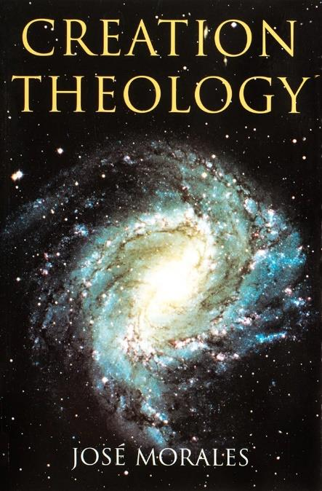
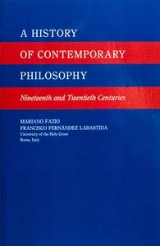
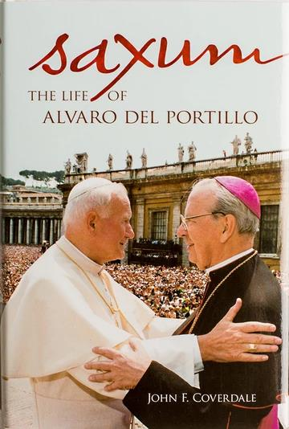

We want to help you become a saint every day, from right where you are and share Christ with others.
Have you ever tasted the beauty of God’s presence? It's natural to want to experience his closeness more often—as often as you can! As St. Josemaría Escrivá said: “Either we learn to find our Lord in ordinary, everyday life, or else we never find Him.”
We can help you discover and grow closer to God every day in your work, family life, and other ordinary activities. We want you to become a saint and everything we publish and do is directed towards that goal.
Thank you
Thank you for reading the booklet. Please feel free to redistribute the booklet to anyone who might benefit from it. If you are interested in similar reading, see the related books below.

CATHOLIC BOOKS FOR SPIRITUAL GROWTH

