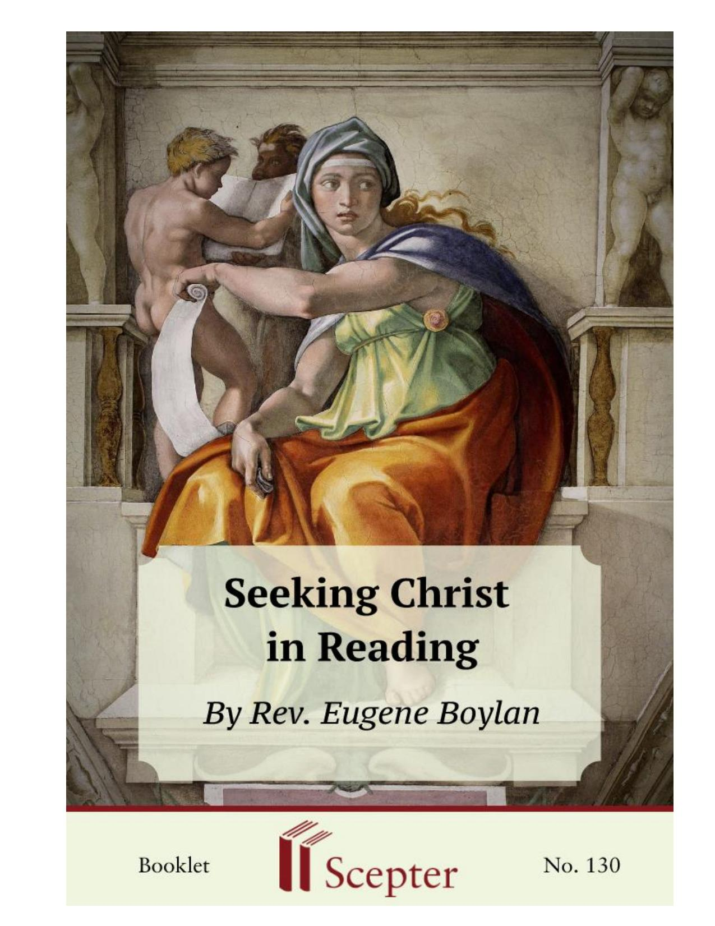
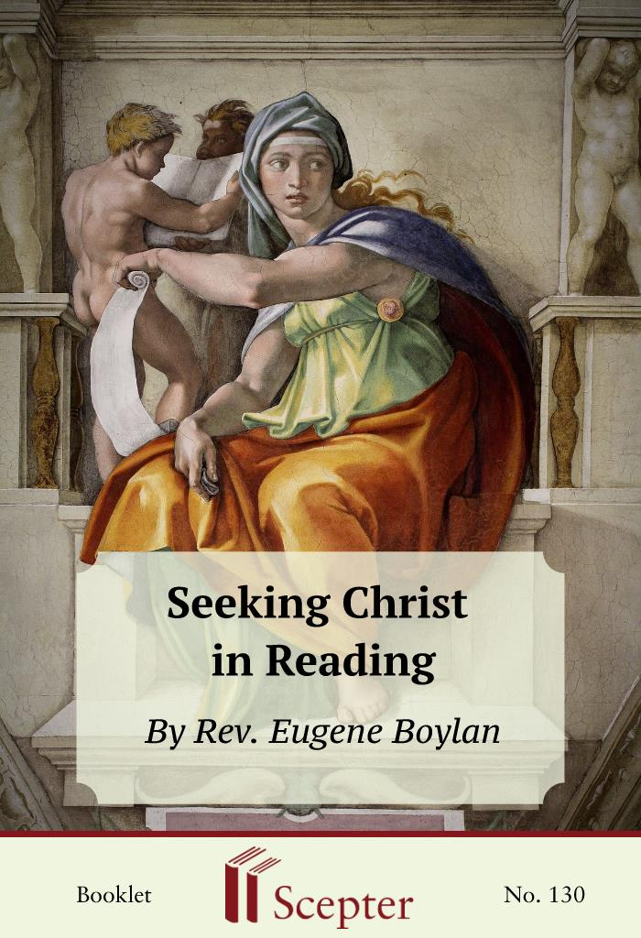

SCEPTER BOOKLETS

Seeking Christ in Reading
Reprinted from This Tremendous Lover by Dom Eugene Boylan, O.C.S.O. -1964 by The Mercier Press. Used by permission of Paulist Press.
By Rev. Eugene Boylan

Scepter Publishers
PO Box 360694,
Strongsville, Ohio 44136

Toll Free: 800-322-8773 (US & Canada only)
Tel: 212-354-0670
Fax: 646-417-7707

info@scepterpublishers.org

www.scepterpublishers.org

©1981 Scepter Publishers
Second Edition, © 2017
Booklet and Cover design by Parker Eidle

Booklet Number: 130

© Scepter Publishers, Inc. This information protected by copyright of Scepter Publishers, Inc., New York, NY USA. It is for the free use of readers and we encourage you to redistribute this without permission. None of this information can be sold, either in electronic or print form, unless permission has been obtained from Scepter Publishers, Inc. Direct all inquiries to
info@scepterpublishers.org.

ISBN: 9781594172953

CONTENTS

Introduction 1
Gripping the Imagination 2
The Barrier of Boredom 3
Essential for Progress 4
Love, Not Sentiment 6
The Educated Catholic 8
A Disease of The Mind 10
Religious and Laity 11
Reading as Food 13
A Daily Exercise 14
Unfortunate Biographies 15
Ask for Help 16
As Essential as Eating 17
Reading and Meditation 18
Indefinite Boundaries 19
About the Author 20
SEEKING CHRIST IN READING

1

INTRODUCTION

There Are no new principles in the spiritual life. The fundamental principle — to seek God and to be united to him in Christ — never changes.
The other principles are derived from that one, and are also fixed; but their application to particular circumstances, and the choice of means to the end, must take into account the varying conditions of human life. Thus it may be the case that in modern times, there is need to insist with greater emphasis on certain practices than formerly. Now if there is one thing for which modern conditions have produced a special necessity, it is the regular practice of spiritual reading. It is, of course, only a question of degree; for reading, or some other form of instruction, was always necessary. But oral instruction, the common opinion of men, the example of our neighbors, and the trend of life in general, play a smaller part in the formation and instruction of Catholics than they did formerly. People do not go to hear sermons now as they used to; religion is not talked about, at least with any accuracy; our neighbors often have ideals that are far from Catholic — if indeed they have any at all; and there is little in our general surroundings that is of direct help to incite us or to help us to find God.
In fact the general effect of our modem environment is not merely negative; it has even a positive tendency to lead us away from God. This it does not so much by being against God, but rather by leaving him out. We live in fact in a pagan civilization. The remnants of Christian ideals that are still found in common opinion, and which still express themselves in common practice, are divorced from their dogmatic foundation of real fact and true faith — they are based mainly on sentiment — and like all branches cut off from their original stock, they are withered and warped, and often twisted quite out of recognition. As guiding ideals, they rather tend to mislead. The need for something to counteract this effect is one of the reasons for spiritual reading.

HELPING YOU FIND GOD WHEREVER YOU ARE
SEEKING CHRIST IN READING

2

GRIPPING THE IMAGINATION

But another reason comes from the reading matter in common use today. Examine for a week the ordinary man’s reading by which his mind is nourished, and what does one find? One long series of items which could hardly be more efficiently designed to concentrate his attention upon this world and upon the things of this world. One may question the accuracy of much that the newspapers print, but one cannot deny that what is printed is presented in a fashion that tends to grip the reader’s imagination. To the news are added photographs which are often of considerable interest and artistry. Then there are the various weeklies, the magazines, the digests, and all the other publications that one finds everywhere today. They are easy to read, they can make the most of trifles, they can flatter the intelligence of the reader and make him take superficial gossip for deep thought, and, of late, they have brought condensation to a fine art. As a general rule they do not lead to thought — in fact for the most part they only increase the passivity of the reader — but when they do make one think, it is not of God and of his love, but of the things of this world, and generally of those things which are of least importance. When one considers the skill and artistry, the attraction and the sympathy, the ingenuity and the insistence, which are therein at work to concentrate our whole attention on the passing moment, one must recognize that there is an urgent need for some personal effort to restore the balance by keeping the realities of eternity before the mind and by making oneself see the present moment in its true context.

HELPING YOU FIND GOD WHEREVER YOU ARE
SEEKING CHRIST IN READING

3

THE BARRIER OF BOREDOM

What has been said of periodicals is no less true of books taken generally; and there is another effect common to all such reading: it produces a distaste, not merely for the things that really matter, but also for the style and manner in which those things are presented in spiritual books. The result is that when one does by an effort force oneself to open a spiritual book, it requires a still greater effort to keep it open, and not to close it with a yawn.
And, truth to tell, it is not always the reader who is to blame. So many spiritual books come from another age or are translated from another tongue, and have, therefore, a foreign and artificial air, so many are written by religious for religious and from the viewpoint of religious — so many are deliberately “edifying” and seem, therefore, unreal — so many show a lack of understanding for the difficulties of the laity and fail still more by having no sympathy with these difficulties or even with the weakness of human nature
— that it is not surprising that many lay people find spiritual books so hard to read that they soon give up the practice of regular reading HELPING YOU FIND GOD WHEREVER YOU ARE
SEEKING CHRIST IN READING

4

ESSENTIAL FOR PROGRESS

Despite all such difficulties, we insist that regular reading of a suitable sort plays a more and more important part in the life of Catholics today, and that for the educated at least, it is well nigh essential for their progress if not also for their salvation. To our mind, this practice ranks equally with mental prayer and the other exercises of devotion in importance, and in fact it is so closely connected with these other exercises, especially the essential one of mental prayer, that without it — unless one finds some substitute — there is no possibility of advancing in the spiritual life; even perseverance therein is rendered very doubtful.
Obviously one way of dealing with this problem would be to reduce the amount of secular reading. The degree to which that is necessary or desirable depends upon so many individual circumstances that it cannot be determined here. Personal experience is the best guide, at least, if prudent counsel be taken. For our part, we do not agree with those who would have lay people live like religious, out of touch with their surroundings. They are members of society, they have their place in it and their relations to it, and they have quite a legitimate interest in it. In fact the chief hope of modern society is that Catholic laymen may exercise considerable influence on it.
Therefore, they have to keep in touch with it. But, as in all such matters, they must do so prudently.
What one must do is to make a firm resolution never to cease from regular reading of the right type. And what is the right type? That is a wide question, and the answer can only be general — for here especially, the variations of individual temperament must be considered. First preference must be given to that reading which makes us know Jesus Christ, his Person, his practice and his preaching. He is the Way, the Truth and the Life. He is God’s manifestation of himself to men, and man’s model for going to God.
The obvious place to find him is in the New Testament; and the four Gospels at least should be the familiar and frequent reading of every Catholic. The best approach to Scripture reading is a personal matter and depends upon many circumstances, but the reading of the Scripture cannot be too highly HELPING YOU FIND GOD WHEREVER YOU ARE
SEEKING CHRIST IN READING

5

recommended; it is, however, by no means as general as it should be. The Bible contains the inspired word of God, and we Catholics have the infallible interpreter of God’s word in the Catholic Church. But it must be remembered that all the Bible is not easy to understand. Only the original text in the language in which it was originally written is inspired; the English translations we read are not inspired, and in fact they do not always succeed in making us understand the full sense of the original. That is why it is often helpful to use one of the shorter commentaries on Scripture. But very often one will find in the Bible a personal message from God that not only gives one knowledge but also strength and joy — in fact one will often hear God speaking to one’s heart from those sacred pages.
There is many an excellent life of Christ, one at least of which should be read. The teaching of Christ is found in Christian doctrine and in books on the spiritual life; and the example of Christ is reproduced in the lives of his saints. The primary purpose of our reading is not so much to educate ourselves as to produce goodness of life — to help us live in union with Christ.
But education is a first step to good living, and we can say that our initial purpose in our reading should be to educate ourselves in doctrine and in spirituality up to a level which will depend upon individual circumstances, but which should be high enough to enable us to give God that reasonable and rational service that he requires of us, to give our neighbor an account of the faith that is in us, and to give ourselves motives, direction, and strength for our spiritual life. Once that level of education has been achieved, the principal purpose of our regular reading changes somewhat. Henceforth we read to keep the super-natural before our minds, to develop and maintain the sense of the reality of the things we know by faith, to keep our attention on the eternal life of our soul rather than on our temporal interests, and above all to keep alive within us the memory and the presence of our Lord, so that we may live in touch and in union with him, talking to him, working with him, resting with him, always praying to him and in him.

HELPING YOU FIND GOD WHEREVER YOU ARE
SEEKING CHRIST IN READING

6

LOVE, NOT SENTIMENT

Obviously individual needs will vary so much that there can be no question of prescribing for each one here. But some things may be said which are of fairly general application, though their adoption is left to the common sense of the individual reader. It must be remembered that although the spiritual life is a life of love, it is not a life of sentiment.
On the contrary, love is based on knowledge given by faith and reason.
In a word, devotion is founded on dogma. Now some acquaintance with the dogmatic teaching of the Church is essential for any Catholic. Quite a number of educated Catholics try to be satisfied with what they have learned of doctrine at school; this would seem to be a mistake. A man’s mind develops after he leaves school; his knowledge and experience increase, his view broadens, his judgment matures, and he meets many problems that require a doctrinal solution. To expect the grown and mature mind of the man to be satisfied with the hazy memory of what his immature mind had acquired from the limited instruction suitable to boys is, at the least, imprudent; one runs the risk of having religion rejected as inadequate. It amounts almost to asking a grown man to re-adopt the mental habits and immature outlook of the schoolboy, to renew his juvenile tastes, and to maintain that attitude throughout his life towards the things that are of the greatest importance to him. If the man has grown up in a country where the Faith is in the atmosphere, as long as he still lives in that atmosphere he may retain his hold upon his religion without further instruction, but it seems almost like tempting Providence to hope that he will do so. Anyhow, the desirability of further instruction is evident. The question is still more acute in the case of the professional classes and of all those whose work produces or requires a trained mind. In one field of knowledge at least, such men are familiar with a complete and scientific treatment of a subject. Their trained minds, consciously or unconsciously, tend to estimate things by the reasons lying behind them, and if their knowledge of Catholicity is not sufficiently wide or deep to show them something of its solid foundations and extraordinary logic and to enable them to see that it can hold its own as a science with their own HELPING YOU FIND GOD WHEREVER YOU ARE
SEEKING CHRIST IN READING

7

subject, they may be led to contempt for what little they do know of religion, and may even be tempted to abandon it altogether. Certainly, they are not likely to make it the driving force of their whole life, as God wants them to do.

HELPING YOU FIND GOD WHEREVER YOU ARE
SEEKING CHRIST IN READING

8

THE EDUCATED CATHOLIC

Even if a man’s reading of Catholic theology were only enough to teach him to know how much he does not know about it, a lot would be gained. But there is no reason why any educated Catholic should not go further, and bring his knowledge of Catholic theology up to the standards of the other branches of his knowledge — in principle if not in detail. There are sufficient manuals in English to meet the needs of most people, and their publication is on the increase. It must of course be admitted that a proper understanding of Catholic theology involves some of the ideas of Catholic philosophy, and the mode of thought connected with it. In fact, there is a lot to be said for the view that some training in such philosophy should be given as part of the ordinary Catholic secondary education. Theological discussion involves philosophy in much the same way as physics involves mathematics. And indeed both theology and philosophy are closely connected with the highest form of human thought, a form which has disappeared from practically the whole intellectual life of today outside the Catholic schools. For the source of all the evils and errors in the intellectual life of today — the disease that makes much of its utterances, the mere wanderings of a feverish imagination
— is the loss of metaphysics and of the ability for abstract thought.
Perhaps a slight digression may be forgiven, especially as it is closely concerned with the understanding of the main thesis of this book, though it will not have the same reference to every reader. The human intellect draws its food for thought from the working of the senses, and when it represents to itself the idea of any object, that internal sense which is called the imagination, tries to form some corresponding picture or phantasm of the same object in terms of sensation or sense experience. Try the experiment of thinking about a triangle. Despite its name, the essential definition of a triangle is a figure which has three sides. That is the idea which the intellect forms of it, and that idea is absolutely universal in its application; it represents equally every possible triangle that exists or could exist: a figure with three sides.

HELPING YOU FIND GOD WHEREVER YOU ARE
SEEKING CHRIST IN READING

9

The imagination, however, also tries to represent a triangle, but it has to be more concrete; and if one attends closely to its representation, one finds that the triangle in the imagination, is, more or less vaguely, some particular triangle. It has a color, it has a definite shape, a definite orientation, a definite size, a definite feel — possibly a definite taste. It tries to become general by being vague. The sides are a neutral gray, and the whole thing is rather
“woolly,”— but as soon as one attends to it carefully, it becomes definite. Now one of the first things one has to learn in metaphysical thought, is to think with ideas and not with phantasms. One can imagine contradictions, but one cannot think them. One can imagine a being who is a man and a horse, but one cannot think him, for he is either rational or unrational, either one thing or the other. Obviously failure to abstract completely from the particular accidents of the phantasm may lead to error, and when one argues from phantasms instead of ideas —doing one’s thinking with the imagination instead of with the intellect —confusion and obscurity are inevitable.

HELPING YOU FIND GOD WHEREVER YOU ARE
SEEKING CHRIST IN READING

10

A DISEASE OF THE MIND

Metaphysics is the science of being —that is, of anything that exists or can exist — as being, and is, therefore, at the root of all other sciences, which indeed presuppose it. It has been abandoned by the modern mind, which seems to be unable to think otherwise than with its imagination. What cannot be imagined is — according to it — impossible; what can be imagined is, therefore, capable of being and existence. From this disease of the mind, we get sentiment for principle in morals, the particular for the general in argument, metaphor in place of reality, opinion for certainty, prejudice for judgment, quantity for quality, matter for the ultimate reality, and all the whole host of false coins that are current in the intellectual commerce of today. Curiously enough, it is often the trained mind that shows the greatest tendency to errors of this sort. The mathematician tends to think in terms of symbols and graphs, or at least in terms of quantity; the scientist, when he is not a mathematician, tends to be a mechanic. The medical man in particular finds it hard to get away from the “too, too solid flesh,” and is often unable to recognize the reality of a vital principle which he cannot imagine, and which he does not know how to demonstrate by reason.
Intellectual Catholics, therefore, have need of knowing something of theology and philosophy; and indeed all Catholics of any education would do well to keep their knowledge of the Church’s doctrine up to a sound standard.
Where theology is read by the laity, it is usually rather from the point of view of apologetic argument than from that of a dogmatic foundation for true devotion. We would rather see the reverse. Granted that such meat is not for everyone, it is still quite true that there are a considerable number of Catholics who, if not starving, are at least undernourished for want of a proper diet of Catholic doctrine.

HELPING YOU FIND GOD WHEREVER YOU ARE
SEEKING CHRIST IN READING

11

RELIGIOUS AND LAITY

Such reading, however, is not the most important. In the beginning, the important thing is to acquire a knowledge of the principles of the spiritual life and to keep them constantly in mind; what then becomes more and more important as one grows in the spiritual life, is to keep one’s mind supplied with motives for perseverance and advancement and to restore daily any distortion in one’s perspective and sense of relative values that may arise from everyday contacts. In all this the layman is faced with quite a different problem from that of the religious, and it is well that he should remember it.
Each religious order “forms” its members in the novitiate by precept, example, and practice; each order has its own traditions, its own spirit, its own standard authors, and its own system and methods of the spiritual life.
In every religious house a member can always find someone who is well acquainted with that spirit, and who is also well acquainted with him and understands his outlook. Advice on suitable reading is then easy to get, and can be accepted blindly.
The layman has no such planned path before him nor definite tradition behind him. He needs advice and counsel, but he needs it from someone who is prepared to examine his personal needs, and who is not predetermined to impose upon the client the adviser’s own spiritual system. There are various schools of spirituality; in principle they can differ very little; but they can differ sufficiently in minor, accidental details to have quite opposite effects upon different souls, especially in the case of beginners or of those who are not well grounded in the spiritual life. To a certain extent, therefore, the responsibility for choice rests upon the layman himself, and that is why we ask him to educate himself first in the spiritual life. The study of two or three standard works will give him some idea of its principles, and he will be better able to decide what to take and what to leave in all that he reads. For it must be remembered that not all that is written applies to all who read it. One excellent way of starting this education is by attending a series of retreat conferences, where the main points of the spiritual life are summarized. But it will probably take some time for the beginner to get his bearings and to HELPING YOU FIND GOD WHEREVER YOU ARE
SEEKING CHRIST IN READING

12

develop a prudent sense of his own personal needs and vocation. Prayer for light and guidance is indispensable, and will always be heard.
Once educated, as we have said, one reads differently; in fact it is only then that one performs the exercise which we wish to describe as a daily practice of the spiritual life. The choice of a book is usually determined by its effect, and each reader has his own favorites. However, one should not be afraid to go back to some of those books that did not suit on first reading, for there is a time and a mood for every book. Prejudice must be laid aside; eagerness to master the contents of a book is a serious obstacle. If necessary, one should run through a book quickly to find out what it is about, and then go back and digest it.

HELPING YOU FIND GOD WHEREVER YOU ARE
SEEKING CHRIST IN READING

13

READING AS FOOD

That one word gives the key to the whole method of spiritual reading.
For spiritual reading is a food, and we must digest what we read. First of all, therefore, the matter must be digestible. To some extent that is an individual question, but goodwill can work wonders even when a book at first appears insipid and useless. The next thing is that we must read slowly; at least those part of the book that are helpful should be read reflectively, and if they stimulate immediate thought, it is far better to pause and reflect on what has been read. Not every page need be read in this way. Common sense can never be left aside at any part of the spiritual life, and this is no exception.
Books that bear on conduct should be digested by examining one’s own conduct in the light of their teaching. However, there is one mistake that must be avoided. If one finds difficulty in deciding whether some particular remark applies to one’s own case, or in fact, if one hesitates to believe that it has personal reference, it is a mistake to let that uncertainty or hesitation disturb one’s peace. It is always permissible to keep an open mind until one has read more, or until some advice can be obtained on the point. Peace of mind and liberty of spirit are essential for the growth of the spiritual life; and unless there is a clear reprimand from one’s conscience, it is always wise to put aside anything in reading which upsets our peace or liberty — even if there be a doubt which appears to have some foundation — until some occasion of wise counsel arises. If God wishes to indicate some line of action to a soul he will not be content with speaking merely once. He will repeat his request with a quiet insistence, which sooner or later will produce a clear and certain knowledge of his wishes. He never blames us for refusing to follow doubtful leads. Uneasiness of this type is nearly always either the work of the devil or of our own pride.

HELPING YOU FIND GOD WHEREVER YOU ARE
SEEKING CHRIST IN READING

14

A DAILY EXERCISE

This exercise of spiritual reading should be a daily one. One good way of ensuring that it be so is to fix a time for it each day. That is not always possible. But at least a certain minimum of time should be decided upon, and given to it daily. Ten minutes every single day is far better than a hundred minutes every seventh day, (we are not speaking now of educational reading). Individual needs differ widely, and any attempt here to fix a duration that would suit some readers would only mislead others. Besides, there is a close connection between reading, reflection and mental prayer; and as the spiritual life varies from season to season or from soul to soul, time may be taken from one of these exercises and given to another of them.
If five minutes’ reading is enough to start a man thinking for half an hour, then he is quite entitled to put down his book, and if it helps, to go off for a walk and think out what has occurred to him. If the mere opening of a book starts one’s heart speaking to God, then reading has done its work —
for the moment at any rate. Nevertheless, considering the difficulty and distaste that are connected with reading, we should be slow to dispense ourselves from our regular minimum, even for the sake of reflection or of prayer, for the gain may be short-lived. If the period we appoint for daily reading is long, it may help to use two books, one of a lighter type which could be used after a page or two of the heavier work has been read. The lives of the saints will often supply such a lighter fare.

HELPING YOU FIND GOD WHEREVER YOU ARE
SEEKING CHRIST IN READING

15

UNFORTUNATE BIOGRAPHIES

Of some of these lives of the saints it is hard to write without apparent irreverence. Sometimes one is tempted to say that half of them should be publicly burned as obstacles to holiness. That, of course, would be an exaggeration; but like all exaggerations, it expresses a truth. And the truth is that there are many accounts written of the lives of the saints, which, because of manifold distortion and of the emphasis of the accidental at the expense of the essential, are further from the reality than are the stained glass attitudes which are seen in church windows. These latter have their justification in ornament and conventional symbolism; but a biographer is expected to tell us the exact truth about his subject. Now the truth about a saint is that he had a human nature exactly the same as each of us has, but that he so cooperated with God’s grace as to love God with his whole heart and his whole soul, and that this love became the constant and principal motive of all his actions. Instead of telling us the truth, these accounts often mainly consist of miracles, extraordinary mortifications, and superhuman achievements, so that if they are taken at their face value, the saints must be a race apart, supermen, into whose ranks we have no possibility of entering.
Recently, there has been a movement in the right direction; but the reader is warned that the true notion of holiness or of its possibility, must not be looked for in such books about the saints, and that is one reason why a sound grasp of the true principles of the spiritual life is so essential. There are, however, many sound works which show the true saint, and while setting a very high example before us, still leave us room to hope to imitate it.

HELPING YOU FIND GOD WHEREVER YOU ARE
SEEKING CHRIST IN READING

16

ASK FOR HELP

This daily exercise of spiritual reading should always be closely connected with prayer. It should be commenced with a prayer, and if we are alone, it is good to kneel for a moment. But whatever our attitude, we should ask God to speak to us, to enlighten us and to give us the grace to carry out his wishes. In fact, we should make our reading a spiritual communion with our Lord: “Jesus, give me yourself through this book!” If possible, one should try to read “in the divine presence.” God, of course, is always present, but —
there is a difference! We should try to read “under his eye,” so to speak. And we should not be afraid to intersperse our reading with prayerful ejaculations, comments, or questions — any of those remarks that one might make if one could share a book with a friend.
We must, of course, read in a spirit of faith. That does not mean that we are not to read critically, or that we have to accept every statement that every writer makes, or to believe that every advice or direction given applies to our own particular case. On the contrary, one should only follow such advice with caution and prudence, taking frequent counsel of some wise priest or other guide. But we must believe that God will speak to us in our reading, and when he does speak, we must be ready to listen to him and heed his words. In fact, if one asks in what dispositions should one read, the answer is: “with faith, hope, charity, humility, and submission to God’s will.”

HELPING YOU FIND GOD WHEREVER YOU ARE
SEEKING CHRIST IN READING

17

AS ESSENTIAL AS EATING
Let us make it clear that our intention here is to give more prominence to the exercise of spiritual reading than is usually done. We regard this exercise as of very special importance for the cultivation of the spiritual life, and for facility and progress in prayer, particularly in the case of the laity.
Quite apart from its fruits, it is an exercise of the spiritual life in itself, and as such is meritorious. We consider that a firm resolution to read in this fashion is of capital importance for everyone who wishes to live in Christ. In fact, unless some sufficient substitute for it be provided, we would say that there is as little chance of living spiritually without reading, as there is of living corporeally without eating!
This reading has for its purpose first of all to make us know what we really have to do and how it is to be done, and afterwards to make us remember and think of what we are really doing and why it is to be done. It is so easy to forget the supernatural or to keep it all for Sunday morning, that one must do something to preserve its remembrance on weekdays. Reading is a most important means to that end. And to reading one should join reflection.

HELPING YOU FIND GOD WHEREVER YOU ARE
SEEKING CHRIST IN READING

18

READING AND MEDITATION

We have still to treat of the exercise known variously as meditation and mental prayer, but we shall find that most books on the subject suggest a method which involves reading (generally to be done the night before), reflection, and prayer. The three things are made part of the one exercise.
Our own desire is to make at least two — if not three — practices of them.
What we mean by reflection is that part of the exercise usually called meditation, to which the name properly applies. If a methodic approach to it is necessary, a method must be adopted. But there are many minds who pass from reading to reflection quite naturally and spontaneously, or who could easily acquire the habit of doing so. Such a habit is of incalculable value for the spiritual life. And we do not visualize this exercise as one which is to be done in the church, or on one’s knees — at least of necessity. To us it seems quite sufficient that a man should, say, sit down at his own fire — smoking if it helps him — or that he should go out for a walk, and think out the ideas he has found in his book or in his experience. As far as thinking goes, there are many men and women who will achieve much more in such a way, than by trying to think on their knees in the cold of the morning before breakfast, or in the church where their normal instinct is to pray. Besides, such a practice has the happy result of making this reflection something that fits in with the ordinary day’s round; there is no question of a special religious exercise to be done and finished with when one gets up off one’s knees. However, men and their minds vary, and each should do what suits him best in the matter. The usual advice in these matters is certainly sound and time tried; our own suggestions are inspired by a purpose of going as far as we can to bring the interior life within the reach of the layman, and making it spread through as much as possible of his whole day.

HELPING YOU FIND GOD WHEREVER YOU ARE
SEEKING CHRIST IN READING

19

INDEFINITE BOUNDARIES

It is obvious then that both prayer and reading, as far as we have discussed them, lead on naturally to mental prayer, and that the boundary lines are not very definite. One subject that should be brought to our mind daily is the Passion of Christ. Assistance at Mass, or making the Way of the Cross, or some such practice would do so; but if no other provision is made for it it would be well to form a practice of spending a few minutes daily in reflection on, say, some Station of the Cross, or upon some sorrowful mystery of the Rosary.
There is no reason why we should not spend part of the time going to or from work, for example, in thinking of some of the stations. There is no reason why we may not think of the mysteries of the Rosary without saying the decade. A ploughman, for example could take one mystery to each furrow
— and we all could imitate him in some way.
Whatever way we do it, we must keep the memory of Christ and his love, of our union with him, of the things which he has done for us and the things which he wants us to do for him, fresh in our minds. He never forgot us for a single moment on earth; he never forgets us for a single moment in heaven; should we not daily think of him who lived and died for love of us?

HELPING YOU FIND GOD WHEREVER YOU ARE
SEEKING CHRIST IN READING

20

ABOUT THE AUTHOR

Eugene Boylan was born in Dublin in 1904. After being trained in Vienna as an atomic physicist, he was offered a professorship at Trinity College in Dublin, but chose instead to enter the Cistercian monastery of Mount St. Joseph in Rosecrea, Tipperary. He wrote profoundly about the mysteries of faith, but always with a light touch and a keen insight into the needs of lay people. This Tremendous Lover, from which this booklet has been taken, will always remain one of the great masterpieces of modern spiritual literature. Dom Boylan died in an automobile accident in 1964.

HELPING YOU FIND GOD WHEREVER YOU ARE
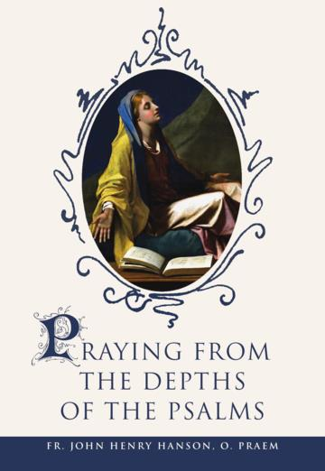
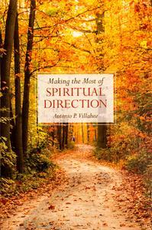
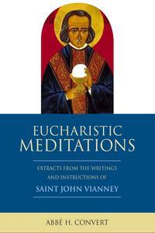
SEEKING CHRIST IN READING

21

We want to help you become a saint every day, from right where you are and share Christ with others.
Have you ever tasted the beauty of God’s presence? It's natural to want to experience his closeness more often—as often as you can! As St. Josemaría Escrivá said: “Either we learn to find our Lord in ordinary, everyday life, or else we never find Him.”
We can help you discover and grow closer to God every day in your work, family life, and other ordinary activities. We want you to become a saint and everything we publish and do is directed towards that goal.
Thank you
Thank you for reading the booklet. Please feel free to redistribute the booklet to anyone who might benefit from it. If you are interested in similar reading, see the related books below.

HELPING YOU FIND GOD WHEREVER YOU ARE

