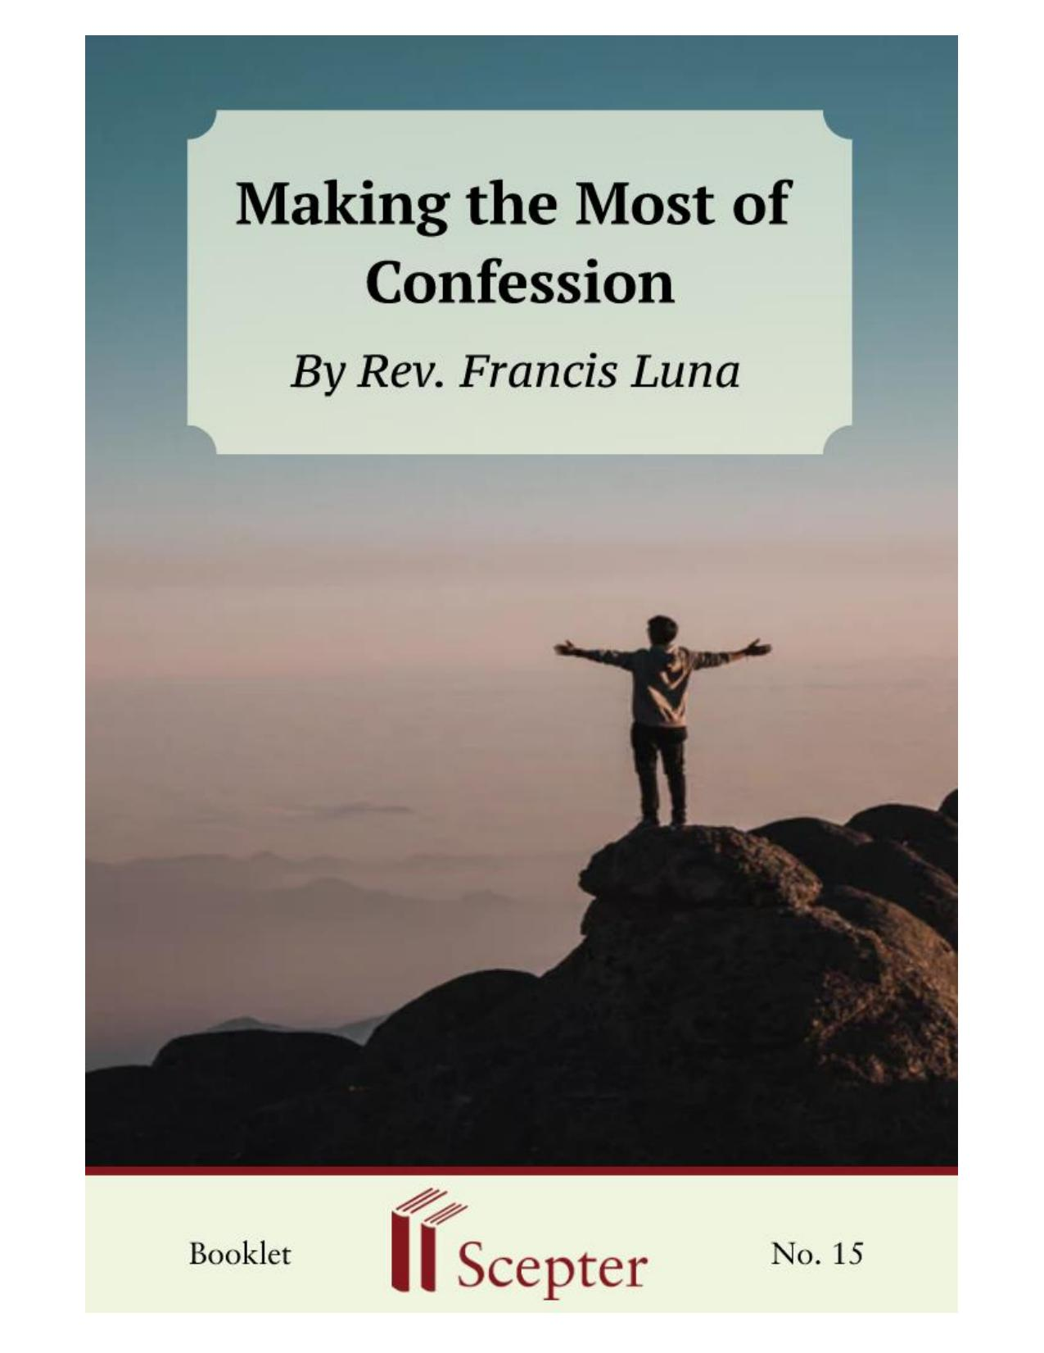

SCEPTER BOOKLETS

Making the Most of Confession
Nihil Obstat: Jose C. Abriol Censor librorum Imprimatur: Artemio G. Casas, Vicar General Archdiocese of Manila, April 18, 1974
By Rev. Francis Luna

Scepter Publishers
PO Box 360694,
Strongsville, Ohio 44136

Toll Free: 800-322-8773 (US & Canada only) Tel: 212-354-0670
Fax: 646-417-7707

info@scepterpublishers.org

www.scepterpublishers.org

©1974 Scepter Publishers
Second Edition, © 2019
Booklet and Cover design by Parker Eidle

Booklet Number: 15

© Scepter Publishers, Inc. This information protected by copyright of Scepter Publishers, Inc., New York, NY USA. It is for the free use of readers and we encourage you to redistribute this without permission.
None of this information can be sold, either in electronic or print form, unless permission has been obtained from Scepter Publishers, Inc. Direct all inquiries to info@scepterpublishers.org.

CONTENTS
Introduction……………………………………………………1
Facing the Facts………………………………………………2
Sizing up Sin……………………………………………………3
Returning Home……………………………………………….5
Examining the Conscience…………………………………...6
Need for Repentance………………….………………………8
Purpose of Amendment……………………………………....9
Telling Our Sins……………………………………………...10
Fulfilling the Penance………………………………………11
Confessing Frequently………………………………………13

Examination of Conscience for Confession…………...15
The First Commandment……………………………………15
The Second Commandment…………………………………16
The Third Commandment……………………………….….16
The Fourth Commandment…………………………………17
The Fifth Commandment……………………………………19
The Sixth and Ninth Commandments……………………...20
The Seventh and Tenth Commandments…………………..21
The Eighth Commandment…………………………………22
MAKING THE MOST OF CONFESSION

1

INTRODUCTION

The culprit must be self-love. What else would make us think we are smarter, wittier, better-looking, or more virtuous than we really are?
Although modesty restrains us from manifesting what we think about ourselves, we normally feel that we are not fully appreciated. While a man may joke about his ugliness, he is annoyed when others point it out. It is one thing to realize we have certain defects—"nobody's perfect," we say by way of excuse—and quite another to accept them as something personal. But when we don't accept our faults, they pile up and impede our coming close to God and treating him as our Father.
In its chapter on the sacrament of confession, the catechism of the Council of Trent describes interior penance as the virtue by which we are converted to God with our whole heart. This virtue makes us profoundly detest the sins we have committed, firmly resolve to amend our bad habits, and hope thus to obtain pardon from God. The catechism says that this attitude forms the very matter of the sacrament; whatever else we do would be of little value. In other words: the simple confession of our faults is useless if not accompanied by interior penance.
We should humbly recognize our sins lest what happened to the Pharisee be our fate: Jesus spoke "this parable to some who trusted in themselves that they were righteous and despised others: `Two men went up to the temple to pray, one a Pharisee and the other a tax collector. The Pharisee stood and prayed thus within himself: "God, I thank thee that I am not like other men, extortioners, dishonest, adulterers, or even like this tax collector. I fast twice a week; I give tithes of all that I get." But the tax collector, standing far off, would not even lift up his eyes to heaven, but beat his breast, saying, "God, be merciful to me a sinner!"'" (Lk 18:9-13).

HELPING YOU FIND GOD WHEREVER YOU ARE
MAKING THE MOST OF CONFESSION

2

FACING THE FACTS

If we think about our Lord's words, we are struck by the resemblance between the Pharisee and ourselves. Isn't it true that we tend to think we are good because our behavior is better than others'? The Pharisee apparently behaved well; but loving God does not consist only in giving alms, respecting others' property, and fasting. Surely the tax collector was the greater sinner; but he went home justified because he humbly recognized his faults and asked pardon for them.
Often we are slow to accuse ourselves, since we have become so skillful at excusing ourselves. We forget that God has no need for the righteous, because they think they have no need for him. Rather than avoiding our sins, we should gladly search for them, and examine our lives with a fine-tooth comb. After all, aren't our sins and failures our entitlement to divine mercy?
When we are weak, when we have learned to lean on God, then we are strong, then God lends his strength to us (to paraphrase St. Paul). Only the person who is ready to disclose the symptoms will be cured by the divine physician.
Some people mistakenly suppose that a special kind of malice—hatred of God—is necessary in order to sin. But we offend God as we offend any other person: not only when we specifically intend to hurt him, but also when we voluntarily disobey his law, given especially for our benefit and cure. To fall into sin it is enough to know God's law and not fulfill it.
Theologians tell us that for sin actually to exist, three conditions must be present: 1) that a thought, word, desire, deed, or omission be wrong or that we believe it to wrong; 2) that we realize it offends God; and 3) that we act freely and with knowledge that we are doing wrong. These conditions are traditionally called matter, advertence, and consent. And we should be eager to know God's law just as we are ready to admit our weaknesses. How else will we qualify for divine forgiveness? The words Jesus Christ quotes from the prophet Isaiah spell out a real danger: "For this people’s heart has grown dull, and their ears are hard of hearing, and their eyes they have closed lest they should perceive with their eyes, and hear with their ears, and understand with their heart, and turn for me to heal them" (Mt 13:14-15).

HELPING YOU FIND GOD WHEREVER YOU ARE
MAKING THE MOST OF CONFESSION

3

SIZING UP SIN

To understand the gravity of sin we must consider the greatness of God's love for us, brought to light by the supernatural virtues of faith, hope, and charity. God thought about us from all eternity, so to speak; we were no more than a possibility. But God loved us so much, so intensely, that he brought us into being. Moreover God made us for himself, in his own image and likeness, so that by knowing and loving him we might be happy with him forever. Eternal life is indescribable so that the Apostle can only stammer with Isaiah: "Eye has not seen nor ear heard, nor the heart of man conceived, what God has prepared for those who love him" (I Cor 2:9).
God created us immortal, full of grace and gifts. But by disobedience in paradise, we lost the immortality of the body and the grace of the soul.
Nevertheless God did not stop loving us; and he willed that since man had sinned, so man would repair the damage. Thus the Son of God became man in the womb of the Virgin Mary in order to pay the debt incurred by humanity. That debt is why he died, forgiving us and offering his life to the Father for the sins of all men.
What is sin? It is simply despising his dying for our sins; it is forgetting the love with which God created us, rejecting the love with which he sustains our existence, ignoring the incarnation of the Son of God, his years of work, his hidden life, his obedience to St. Joseph and our Lady, his passion, his scourging, his death on the cross.
If some people do not understand the malice of sin, it is because they do not look at God. They look instead at themselves and behave as though a fault were more or less serious depending on the impression it makes on them personally. They forget that the offense to God does not depend on how much a fault may repel them, but on how much it separates them from God.
If an individual fails once to attend Mass on a holy day of obligation, he will be conscious of having displeased God; and if he becomes accustomed to missing Mass, his conscience will reproach him less and less. But a lack of remorse doesn't mean a sin is less serious. The malice of sin is not to be measured by whether we are moved inwardly. In order to know the gravity of a fault, we have to pay attention to what God teaches us through his HELPING YOU FIND GOD WHEREVER YOU ARE
MAKING THE MOST OF CONFESSION

4

Church. Throughout the gospel we can see Jesus' compassion for men. As we see twice in the miraculous multiplications of bread and fish, he was even concerned about feeding those who followed him out into the desert to hear his teaching. But his overriding concern is that we live a life of grace. Our Lord restored limbs and even life in order to show us what he could do with souls, if only we let him. The crowds were awed by the miraculous cures. But what is most remarkable is that time and again Christ spoke words of forgiveness, and opened the doors of heaven for sinners. The same marvel is repeated today in the sacrament of penance. Jesus perpetuated his mercy among men by conferring on St. Peter and the other apostles the power to forgive sins. God's abiding and unshakable love for us is the greatest miracle of all. He is not deterred by our sins. He answers our infidelities with fidelity.
He bears no grudges. All he wants is our return.

HELPING YOU FIND GOD WHEREVER YOU ARE
MAKING THE MOST OF CONFESSION

5

RETURNING HOME

"Human life is in some way a constant returning to our Father's house.
We return through contrition, through the conversion of heart which means a desire to change, a firm decision to improve our life and which, therefore, is expressed in sacrifice and self-giving. We return to our Father's house through the sacrament of pardon in which, by confessing our sins, we put on Jesus Christ again and become his brothers, members of God's family" (J.
Escriva de Balaguer, Christ Is Passing By, n. 64).
Let's never forget that we are not here merely to avoid evil, to stay barely on the better side of sinning. We are here to do good, to strive for human and Christian perfection in everything we do, to love and serve God and other people, aware that God will vomit out the lukewarm. It is not enough to skirt mortal sin. If such were our aim, life would probably be comfortable; but our aim is not comfort but love for our Father, who weans us from venial sins and imperfections.
Never forgetting that God plays the main role, we should do all in our power to ready ourselves for sacramental reconciliation with God. Let's examine how we can make more of this sacramental help by improving its essential elements: examination of conscience, repentance, purpose of amendment, telling our sins, and fulfilling the penance. We should never view these requirements as mere formalities, things that we can do mechanically, much as we might take medicine. Beyond what we do, we must prayerfully see confession as a personal encounter with Jesus Christ who forgives our sins and gives us sanctifying grace. Confession is not just another remedy; it calls for personal correspondence to God's mercy.

HELPING YOU FIND GOD WHEREVER YOU ARE
MAKING THE MOST OF CONFESSION

6

EXAMINING THE CONSCIENCE

In seeking God's pardon for our sins, the first thing we have to do is examine our conscience to uncover the faults which have offended him.
There is no fixed way to do this. Methods should vary as much as personal circumstances (child or adult; married or single; manual worker or professional; one who confesses every week or every year; etc.). But we are all obliged to observe the same commandments; everyone is called to sanctity. Each person must determine how much time he needs and the best method he can find for discovering his sins, so that he can bring them to Christ in the person of the priest.
If we want to examine ourselves well, we should ask the Virgin Mary and our guardian angel for help. They will obtain for us from the Holy Spirit the grace we need not to overlook faults we might otherwise ignore more or less unconsciously. If we want our confession to be a means of advancing in spiritual life, in love of God, we must examine ourselves carefully, putting at least as much interest in our examination of conscience as we would in any other important matter. Our examination does not need to be complicated or difficult; what really matters is that we make sure nothing important remains hidden or forgotten.
Sometimes we are so accustomed to personal ways of acting that only exceptional things attract our attention. But we cannot limit ourselves to a superficial glance at the past. We should go after faults committed from habit, acts which little by little cause real damage to the soul.
Lukewarmness, negligence in fulfilling personal duties, frivolity in speech, judgments of others (even if more or less true), omitted duties to our neighbor, lies, not keeping our word, worldliness in our amusements or social and family relations, lack of moderation, curiosity, voluntary distraction at Mass or prayer, carelessness in spiritual life, resistance to God's calling us to certain acts of virtue, and so on—all these matters merit our attention and should move us to sincere accusation and wholehearted repentance in the sacrament of pardon. Purified thus by God's grace, we advance a little each day on the way of personal sanctity.

HELPING YOU FIND GOD WHEREVER YOU ARE
MAKING THE MOST OF CONFESSION

7

If we are to "make up" with God, we must be sorry for our misdeeds.
But repentance should not be understood as something emotional. We do not lack any of the conditions essential to the sacrament of penance just because we fail to weep over our faults or feel sorry for them.

HELPING YOU FIND GOD WHEREVER YOU ARE
MAKING THE MOST OF CONFESSION

8

NEED FOR REPENTENCE

Maybe we cannot bring ourselves to hatred for some sin. We might even notice a greater tendency to fall again because previous sins have left us weaker. Sorrow for sin, however, does not necessarily mean that a sinful action no longer appeals to us; it means that we have firmly decided to detest it. Repentance in some way should refer to God; otherwise it would not draw us close to him or win his pardon. Sorrow based on merely human motives would leave us entrapped within the narrow walls of our own poverty.
Fundamentally there are three kinds of sorrow for sin. The first, sorrow of love (contrition), springs from the heart: "Sorrow of Love—because he is good; because he is your Friend, who gave his life for you; because everything good you have is his; because you have offended him so much; because he has forgiven you. He! Forgiven you! Weep, my son, with sorrow of Love" (J.
Escriva de Balaguer, The Way, n. 436).
The second, sorrow of fear (attrition), proceeds from fear of the just punishment due in the next life on account of our sins. It is not so perfect or disinterested as contrition. Since fear of God's retribution at least refers to our Lord, it suffices to win God's pardon.
A third form of sorrow, alien to the supernatural life, belongs to pride.
It originates not in love or fear of God, but in a self-love wounded by the spectacle of its own shortcomings. We are hurt and humiliated not by the offense against God, but by our own smallness. In this case, we approach confession unworthily because we are not rightly disposed: instead of aiming at God's pardon, we are seeking ourselves in a disordered desire for self-perfection.
Sorrow brought about by faults is not sincere unless it is accompanied by determination not to sin again. But such a resolution does not guarantee that things will indeed work out well. To make a good confession, it is not necessary to be certain that we will never again offend the Lord; what is required is the will to use the means that can help us avoid sin in the future.
All of us can fall into sin again, but the fear of future faults should not keep us away from the sacrament. A patient does not reject medicine even though he knows he is likely to get sick again.

HELPING YOU FIND GOD WHEREVER YOU ARE
MAKING THE MOST OF CONFESSION

9

PURPOSE OF AMENDMENT

A person determined not to fall again sets about removing any occasions of sin. Let's not fool ourselves. If we want to give up sinning we must use the means to do so. A patient who wants to be cured takes the medicine and follows the diet prescribed by the doctor. If he doesn't, it cannot be said—no matter how you look at it—that he really wants to get well.
"But I don't want to sin; it's just that I'm weak." And that is why we are especially obliged to avoid occasions of sin. In the wrong setting each of us becomes a pushover.
A steadfast purpose of amendment is shown also in our willingness to use positive means of strengthening ourselves. And the means are prayer ("Pray that you may not enter into temptation" [Lk 22:46]); frequent—if possible, daily—reception of Holy Communion; and devotion to the blessed Virgin. How can we conquer temptations to sensuality, laziness, selfishness, and so on, if we do not turn to our Lord and his Mother, asking them for the necessary strength for us?
"Consider what depths of mercy lie in the Justice of God! For, according to human justice, he who pleads guilty is punished; but in the divine court, he is pardoned. Blessed be the holy sacrament of penance!" (J.
Escriva de Balaguer, The Way, n. 309).
Some think that an interior conversion is enough for returning to God's good graces after sinning, that all they need to do is to tell God that they are deeply sorry for having offended him. But such people forget that it was Jesus himself who said, "If you forgive the sins of any, they are forgiven; if you retain the sins of any, they are retained" (Jn 20:23). Because nobody is a good judge of his own case, the power to pardon or not has been committed by Christ to his ministers to be exercised in the tribunal of penance. If they are to grant or deny pardon, priests must know the sins and interior dispositions of the penitents.

HELPING YOU FIND GOD WHEREVER YOU ARE
MAKING THE MOST OF CONFESSION

10

TELLING OUR SINS

The confession of all mortal sins and their precise number is called by theologians the integrity of the confession. Confession will be incomplete if we omit some mortal sin or fail to declare the number of times it was committed. Confession should be sincere, really sincere. It is useless to attempt to hide mortal sins or remain silent about them. Such silence would increase the number of sins by adding a new one-the abuse of a sacrament—
which is a further offense against God. Moreover, none of the sins confessed would be pardoned. If this omission were due not to bad will but to an involuntary oversight, we would be forgiven that sin too; but the obligation to mention it in the following confession would remain.
To avoid getting tongue-tied, it is advisable to say first what is most difficult or what most shames us. Thus we avoid the danger of passing over that particular sin or of remaining silent through embarrassment at the last moment. Sometimes it might be advisable to let the priest know that it is hard for us to confess such sins. Then he can help us through his questions to make a good confession. If we do this, the rest comes easy. We should confess as delicately as possible, but without searching for such polite ways of saying things that the confessor comes to regard our defects as little short of virtues.

HELPING YOU FIND GOD WHEREVER YOU ARE
MAKING THE MOST OF CONFESSION

11

FULFILLING THE PENANCE

Once we have confessed our sins, the priest imposes a penance.
Because we don't fully understand the malice of sin, we seldom grasp the need for penance. Mortal sin makes us deserving of eternal punishment, of hell, where torments never cease. Venial sin carries with it the pain of purgatory, where the soul suffers much as in hell, but where suffering is mitigated by the certainty of heaven.
On receiving sacramental absolution, our sins—and the punishment due us—are pardoned by God. It often happens, however, that our dispositions are not truly perfect when we approach confession. In this case our sins are forgiven, but we are not granted total remission of the punishment.
An article of faith confirms this, and the very existence of purgatory demonstrates that part of our punishment is still to be paid even after the faults have been pardoned. Sin leaves traces in the soul which must be cleansed either in this life or in purgatory, where the souls of those who died truly repentant complete the satisfaction for faults they committed during their lives. True love for Jesus Christ requires more than belief in his word of pardon and gratitude toward him; it leads us to share in his sorrow and suffering. Does expiating our sins here on earth mean converting life into a torture chamber? Quite the contrary. Our life on earth should be a time of joy as we begin to taste the happiness of heaven, but it cannot be until we learn to embrace suffering gladly.
Usually the best opportunities for penance are right at hand. We don't have to go far to find an occasion to offer something to God that requires a little effort: work well done; punctuality; order in our personal effects; restraining a sharp tongue; overcoming anger; guarding our senses; understanding people with different tastes and opinions; small sacrifices at meals; getting up and going to bed on time; finishing what we are doing; delaying a cigarette; putting things away; not being a pest; not worrying about trifles; and so on. These ordinary situations provide the best opportunity to mortify ourselves and to offer God this prayer of the body.

HELPING YOU FIND GOD WHEREVER YOU ARE
MAKING THE MOST OF CONFESSION

12

Even in the case of little things, the value comes from doing them out of love. And the proof of love is cheerfulness. When that is missing, our good deeds lose their value. Jesus himself tells us: "But when you fast, anoint your head and wash your face, so that your fasting may not be seen by men, but by your Father...who sees in secret" (Mt 6:17).
We ought not to bear suffering grudgingly, but as an opportunity provided by God to make reparation for our sins and those of others. We need faith, a faith that will teach us that joy is compatible with suffering. The saints who suffered very much in this life were always cheerful. Faith enables us to understand the meaning things have in the eyes of God, since absolutely nothing occurs without his permitting or wanting it. That's why sickness, problems, and even death are, for a Christian, further proofs of God's love for us. He wants to purify us of our sins in order to have us with him as soon as possible.

HELPING YOU FIND GOD WHEREVER YOU ARE
MAKING THE MOST OF CONFESSION

13

CONFESSING FREQUENTLY

It is true that a fixed rule cannot be given about the frequency of confession. It is probably sufficient for some people to go every two weeks, while others would do well to go every week. Because it depends on many circumstances, it is best for each to consult his confessor. By Church law, we are all obliged to confess at least once a year, and when in danger of death, and before going to communion, provided we are in mortal sin. But a person who truly wants to love God goes beyond this minimum. There is more to Christian life than rules. We are here to correspond. "God can put up with all our infidelities. Our Father in heaven pardons any offense when his child returns to him, when he repents and asks for pardon. The Lord is such a good Father that he anticipates our desire to be pardoned and comes forward to meet us, opening his arms laden with grace" (J. Escriva de Balaguer, Christ Is Passing By, n. 64).
If we want to advance in the spiritual life, frequent confession is absolutely essential. One does not lose a spirit of devotion by frequent confession; for tepidity comes from heartlessness—going to confession without the right dispositions—not from routine. We will be further helped by having a regular confessor, who understands us and tells us things clearly, who gets to know us well and can counsel us in our difficulties. If we are sincere in confession, he will be able to guide us in the spiritual life and help us train our conscience.
Those who confess frequently should fix their attention on the roots of their defects, rather than on a detailed enumeration of tiny faults. It is one thing to confess mortal sins, which must be specified, and quite another to go into a minute, almost scrupulous, analysis when only faults are involved.
Our object should be a more profound sorrow and a more determined purpose of amendment.
A well-prepared confession will not last very long—and spiritual direction ought to be short, too. That is why it is advisable to go to the heart of the matter at the very start. Sins, mortal and venial, should be told first, with sincerity and clarity. Then the necessary consultation and opportune advice can be sought for our spiritual improvement. Without this order, our HELPING YOU FIND GOD WHEREVER YOU ARE
MAKING THE MOST OF CONFESSION

14

confession would be confused; and we would cause the confessor and those who are waiting to waste their time. Neither should we confess with frantic haste; each should take the time he needs.
In any case, we must see beyond our discomfort and the preparation and the confessional and the priest to the person of Jesus who beckons us:
"Behold, I stand at the door and knock; if any one hears my voice and opens the door, I will come in to him and eat with him, and he with me" (Rev 3:20).

HELPING YOU FIND GOD WHEREVER YOU ARE
MAKING THE MOST OF CONFESSION

15

EXAMINATION OF CONSCIENCE FOR
CONFESSION

The First Commandment of God

Have I seriously entertained doubt against the truths of faith? Have I denied the faith or some of its truths in thought or before others? Have I despaired of my salvation? Or have I abused confidence in God by presuming that he will not abandon me, thus allowing me to sin with greater ease? Have I inwardly or outwardly grumbled against our Lord after some misfortune has befallen me? Have I abandoned the means that are necessary for salvation?
Have I tried to acquire proper religious formation? Have I spoken irreverently about holy things, the sacraments, the Church, its ministers?
Have I given up dealing with God in prayer or the sacraments? Have I practiced superstition or spiritism? Do I belong to any society or ideological movement opposed to the faith? Have I received a sacrament unworthily?
Have I read or kept books, magazines, or newspapers which are contrary to faith and morals? Have I given such things to others to read? Do I try to increase my faith and love of God? Do I use the means to acquire religious formation that will enable me to bear witness to Christ by word and example?
Have I performed duties referring to God reluctantly?

HELPING YOU FIND GOD WHEREVER YOU ARE
MAKING THE MOST OF CONFESSION

16

The Second Commandment of God

Have I blasphemed? Have I blasphemed in the presence of others? Have I taken a vow, oath, or promise which I failed to fulfill through my own fault?
Have I honored the holy name of God? Have I uttered the name of God irreverently, out of anger, in jest, or in any other disrespectful way? Did I make at least an internal act of reparation on hearing a blasphemous expression or seeing God offended? Have I sworn unnecessarily? Did I do it untruthfully, imprudently, or without full consideration, or in matters of little importance? Have I sworn to do evil? Have I sworn falsely or when in doubt? Have I repaired the damage that may have resulted from false swearing?

The Third Commandment of God (The Church’s
First Four Commandments)

Do I believe everything the Catholic Church teaches? Do I haggle over its ordinances? Have I missed Mass on Sundays or holy days of obligation? Was I voluntarily distracted at Mass? Did I arrive so late without sufficient reason that I did not fulfill the Mass obligation? Have I prevented people subject to me from attending holy Mass? Have I done manual work on a holy day of obligation, or made others work, for a considerable length of time (for instance, more than two or three hours)without urgent necessity?
Have I observed abstinence on the Fridays of Lent? Have I performed a penitential act if I did not observe the law of abstinence on other Fridays throughout the year? Did I neglect to fast on Ash Wednesday or Good Friday?
Did I fulfill the penance imposed by the priest in my last confession? Do I make reparation for my sins? Do I go to confession at least once a year? Did I receive Communion during the established time in order to fulfill my Easter duty? Did I go to confession if necessary in order to receive Communion in a state of grace? Do I excuse or justify my sins? Have I concealed any serious sin in confession out of shame? If so, did I receive Holy Communion afterward? Do I fast for an hour before receiving Holy Communion?

HELPING YOU FIND GOD WHEREVER YOU ARE
MAKING THE MOST OF CONFESSION

17

The Fourth Commandment of God

For children: Have I disobeyed my parents or superiors? Have I saddened them by my behavior? Have I threatened them or mistreated them by word or deed, or have I wished them harm, whether serious or light? Do I do whatever I want to or take what I want even if it is contrary to the commands of my parents? Do I realize that this rebellion comes from pride? Do I feel responsible toward my parents? Do I show gratitude for the efforts they make to educate me by studying hard?
Have I failed to help them in their spiritual or material needs? Do I submit to bad moods, and or do I get angry without a justifiable motive? Have I quarreled with my brothers or sisters? Am I selfish about my possessions?
Does it bother me to share them with my brothers and sisters? Have I stopped talking to members of my family and neglected to bring about reconciliation? Am I envious, feeling hurt if members of my family stand out in any way more than I do? Did I give bad example to my brothers or sisters?
Have I covered up my brothers’ or sisters’ faults in such a way as to hinder them from correcting or compensating for them?
For parents: Have I disobeyed in important matters? Am I indifferent to the needs, problems, sufferings, and so on of those around me, in particular if they are close to me because they live or work with me? Do I upset my companions at work through negligence, lack of courtesy, bad manners, etc.?
Have I given bad example to my children by not fulfilling my religious, social, family, or professional duties? Have I caused them anxiety by my behavior?
Have I reprimanded my children for their defects, or have I ignored their defects? Do I correct my children with justice and out of love for them, or am I ometimes carried away by selfish motives or anger (because they annoy me or shame me before others or interrupt me, etc.)?
Have I threatened them or mistreated them by word or deed? Did I wish them any harm, whether serious or not? Have I neglected my obligation to help them fulfill their religious duties, avoid bad companions, etc.? Have I abused my authority and influence over them by forcing them to receive the sacraments, without realizing that through shame or human motives they might be doing so without the right dispositions? Have I hindered my children from following a vocation by which God calls them to his service, or HELPING YOU FIND GOD WHEREVER YOU ARE
MAKING THE MOST OF CONFESSION

18

have I put obstacles in their way or counseled them badly? Am I constantly concerned about their religious training? When guiding their professional preparation, have I been led by objective reasons of talents, means, etc., or have I rather followed the dictates of vanity or selfishness? Have I opposed their marriage without a reasonable motive?
Do I allow them to work or study in places dangerous to soul or body? Have I neglected to supervise them when they get together with mixed company at home? Have I left them on their own in situations of temptation? Do I exercise prudence in directing their amusements? Have I tolerated scandals or other moral or physical dangers to the people who live in my home? Have I been concerned about the moral and religious formation of those who live in my home or depend on me? Do I sacrifice my tastes, fancies, amusements, etc., in order to fulfill my duty of devotion to my family? Do I try to become a friend of my children? Have I showed confidence in my children and not interfered with their legitimate freedom? Do I make the facts of life known to my children in a gradual way, adapting information to their mentality and capacity to understand, gently anticipating their natural curiosity? Do I have conflicts with my children because of my exaggerating trifles that can be overcome with a little objectivity and sense of humor? Am I cordial with strangers, and do I show cordiality in my family life? Do I avoid routine in showing affection to my spouse? Have I quarreled with my spouse? Have I treated my spouse harshly, either in word or deed? Do I back up my spouse and strengthen his (her) authority by not correcting, contradicting, or arguing in front of children? Have I disobeyed or injured my spouse? If so, did I give bad example? Have I left my spouse alone too long or often? Do I complain in the presence of my family about the burdens of domestic obligations? Do I try to strengthen my faith in God, while trying to earn enough to have more children and to educate them? Have I neglected to help my parents in their spiritual or material needs, even though I am in a position to do so?

HELPING YOU FIND GOD WHEREVER YOU ARE
MAKING THE MOST OF CONFESSION

19

The Fifth Commandment of God

Do I feel enmity, hatred, or deep-seated resentment toward anybody? Have I stopped speaking to anybody? Have I rejected reconciliation, or have I failed to do what I could to bring it about? Do I prevent political or professional differences from leading to aversion, ill-will, or hatred toward others? Have I wished anybody ill? Have I rejoiced at misfortunes which have befallen others? Have I been overcome with envy? Do I let myself be carried away by anger? Have I hurt or inconvenienced anybody by my anger? Have I despised anybody? Do I deride, criticize, annoy, or ridicule others? Am I disagreeable in asking for or giving things? Have I mistreated people by word or deed?
Have I injured or killed anybody? Have I been careless in driving? Have I led other people to sin by my conversation, my way of dressing, my invitation to a show, or by lending a particular book or magazine? Have I tried to repair any scandal I may have caused? Have I neglected my health? Have I attempted suicide? Have I let myself to be overcome by gluttony, by the pleasure of eating or drinking more than is reasonable? Have I gotten drunk, used liquor to excess, or abused drugs? Have I desired death, thus failing to submit to the providential designs of God? Am I concerned about other people’s welfare? Have I neglected to warn people about danger—material or spiritual—in which they may find themselves? Have I corrected people as Christian charity requires? Do I neglect my work? Am I willing to repair damage that has resulted from my negligence? Do I try to finish my work well, realizing that I should not offer work to God that is poorly done? Do I approach my job with adequate skill and preparation? Have I abused the confidence my superiors have in me? Have I wronged others? Do I facilitate the work or study of others, or do I slow it down in some way, for instance, by quarreling, by a defeatist attitude, by interrupting, etc.? Have I been lazy about fulfilling my duties? Do I often delay starting work or study? Do I tolerate abuses or injustices which I have an obligation to prevent? Have I permitted laziness to cause serious in my career? Have I neglected to give my best efforts in important matters, thus harming those whom I work for?

HELPING YOU FIND GOD WHEREVER YOU ARE
MAKING THE MOST OF CONFESSION

20

The Sixth and Ninth Commandments of God (The
Sixth Commandment of the Church)

Have I entertained indecent thoughts or memories? Have I recalled impure thoughts or deeds? Have I let myself be carried away by desires opposed to purity, even though I did not act on them? Was there any circumstance that may have aggravated such thoughts, for instance the relationship, marriage, consecration to God, etc., of the persons whom they were directed toward?
Have I carried on impure conversations? Have I started such conversations?
Have I attended entertainment that put me in the proximate occasion of sinning (immoral dances, movies, or shows, bad readings or companions)?
Do I realize that to put myself in such occasions is already a sin?
Have I observed the details of modesty which safeguard purity? Have I sometimes equated these details with prudishness? Before attending a show or reading a book, do I seek information about its moral content in order to avoid the proximate occasion of sinning and the deformation of conscience that could result? Have I prolonged impure glances? Have I encouraged impure sensations? Have I performed impure actions, alone or with other persons, with the same or different sex? Was there any circumstance, such as relationship, etc., that could make such impurity more serious? Did such actions lead to conception? Have I done anything to prevent conception?
Have I been involved in abortion? Have I committed any other sin against purity?
Do I have bad companions? Do I maintain friendships that are a continual occasion of sin? Am I ready to give them up? Have I encouraged or allowed another person to get serious whom I have no intent to marry? Is true love the fundamental motive of my courtship? Is my courtship an occasion to deepen affection and mutual knowledge? Is this relationship inspired, not by a desire to possess, but by a spirit of self-giving, understanding, respect, and refinement? Do I degrade human love by confusing it with selfishness or sensual pleasure? Do I approach the sacrament of penance more frequently during the time of courtship in order to obtain more grace from God? Has this relationship drawn me away from God?

HELPING YOU FIND GOD WHEREVER YOU ARE
MAKING THE MOST OF CONFESSION

21

For spouses: Have I used marriage improperly? Have I denied my spouse his or her conjugal rights? Have I lacked fidelity in desire or deed? Have I restricted the marriage act to those times when generation is not feasible?
Do I continue to use this method of birth control without serious reasons?
Have I used drugs or other means to avoid having children? Do I persuade others to use them? Have I used my influence in any way—advice, jokes, attitudes, etc.—to foster a birth-control mentality?

The Seventh and Tenth Commandments of God
(The Fifth Commandment of the Church)

Have I stolen an object or some quantity of money? Did I make restitution or repair the damage when able to do so? Am I ready to do so? Have I cooperated with others in theft or robbery? Was there any circumstance that might aggravate the theft: was it a sacred vessel, or was the quantity or the value of the object important? Am I keeping something that does not belong to me against the will of its owner? Have I spent more than is wise, given my income? Do I bear the lack of what is necessary with a Christian spirit? Have I worked conscientiously? Have I neglected to pay my family’s expenses?
Have I defrauded my spouse of some of the goods we share in common? Have I neglected to give what is appropriate to support the Church? Have I given alms in accordance with my financial situation? Have I harmed others by deception, trickery, or coercion in contracts or commercial relations? Have I damaged other peoples’ goods? Have I deceived people by charging more than what was Have I repaired damage that I have caused, or do I intend to repair it? Have I unlawfully retained or delayed payment of wages or salaries? Do I pay, my employees a just salary? Do I rigorously fulfill social obligations toward my employees: in the payment of social security, etc.? Do I disregard the law—thus harming a third party—in order to avoid paying social security or other employee-related costs? Have I paid my taxes? In the performance of public offices or jobs, have I showed partiality or favoritism?
Have I tried to prevent injustices, scandals, larceny, revenge, fraud, and other abuses that undermine social relations? Have I supported immoral or anti-Christian programs of social or political action?

HELPING YOU FIND GOD WHEREVER YOU ARE
MAKING THE MOST OF CONFESSION

22

The Eighth Commandment of God

Have I told lies? Have I repaired the damage that my lies have caused? Do I lie by force of habit in matters of little importance? Have I revealed the defects of others without just cause, even though I am certain about them?
Have I atoned somehow, by speaking well of the person for instance? Have I calumniated others by attributing to them what is not true? Have I repaired such damage, or am I willing to do so? When in a position to do so, have I neglected to defend a person who has lost his good name or has been calumniated? Have I made rash judgments about somebody? Did I tell such judgments to others? Have I rectified inaccurate judgments? Have I disclosed secrets of others, revealing them without legitimate reason? Have I repaired any such harm? Have I spoken badly about others through frivolity or envy, or because I allowed myself to be carried away by bad temper? Have I spoken badly about others—persons or institutions—when the only grounds were "that's what they say" or "the word is getting around"? Have I allowed political, professional, or ideological differences to blind me to the extent that I judge or speak ill about others, or reveal their moral defects, unless the common good demands it? Have I disclosed or made use of what I knew to be classified information for my personal benefit? Have I repaired the harm that may have resulted? Have I opened or read correspondence or other writings with knowledge or the strong possibility that their owners did not want the contents known? Have I eavesdropped on the conversations of others? Have I indulged in idle gossip, out of curiosity or indiscretion?

HELPING YOU FIND GOD WHEREVER YOU ARE
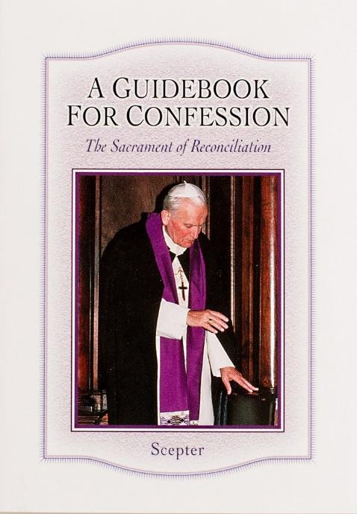
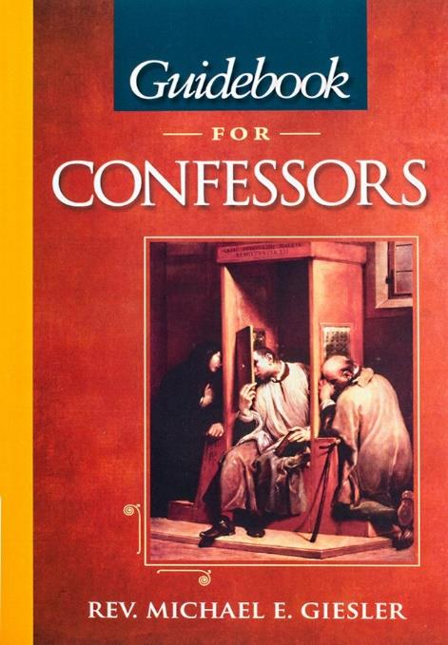
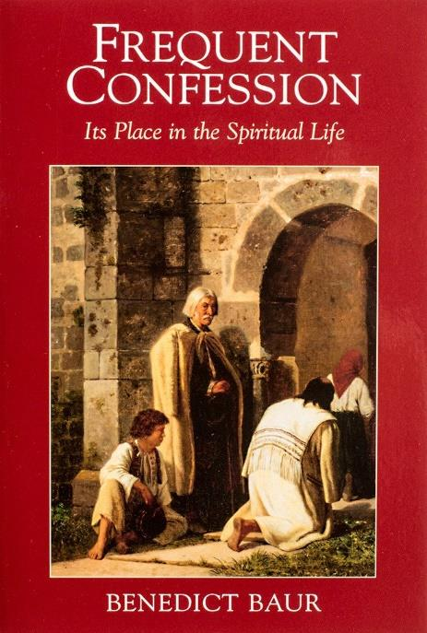
MAKING THE MOST OF CONFESSION

23

We want to help you become a saint every day, from right where you are and share Christ with others.
Have you ever tasted the beauty of God’s presence? It's natural to want to experience his closeness more often—as often as you can! As St. Josemaría Escrivá said: “Either we learn to find our Lord in ordinary, everyday life, or else we never find Him.”
We can help you discover and grow closer to God every day in your work, family life, and other ordinary activities. We want you to become a saint and everything we publish and do is directed towards that goal.
Thank you
Thank you for reading the booklet. Please feel free to redistribute the booklet to anyone who might benefit from it. If you are interested in similar reading, see the related books below.

HELPING YOU FIND GOD WHEREVER YOU ARE

