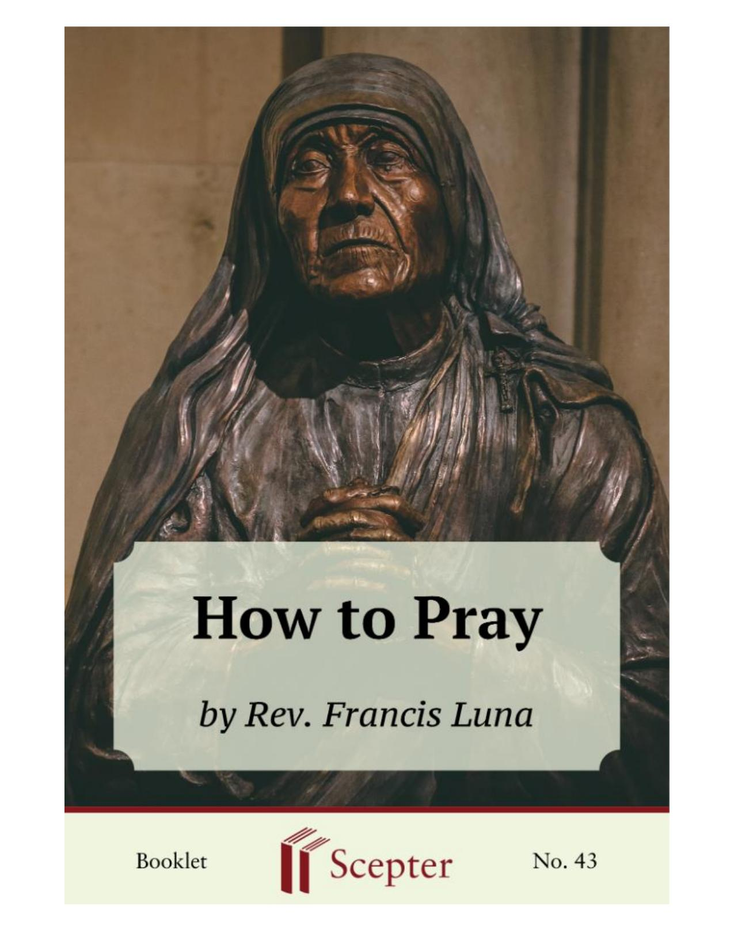
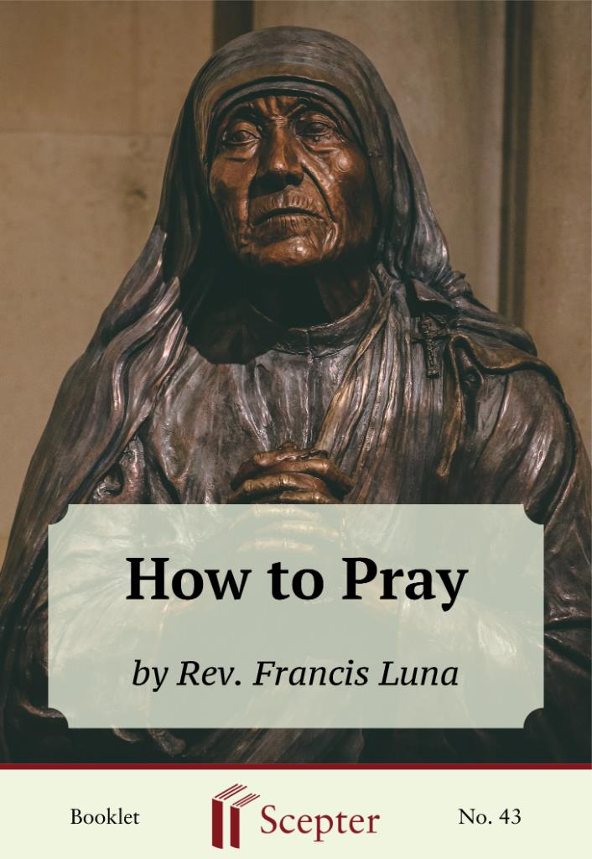

SCEPTER BOOKLETS

How to Pray
[Nihil Obstat: Benjamin L. Marino, Vicar General; Imprimatur: Amado H. Paulino, Auxiliary Bishop of Manila; June 27, 1975]
By Rev. Francis Luna

Scepter Publishers
PO Box 360694,
Strongsville, Ohio 44136

Toll Free: 800-322-8773 (US & Canada only) Tel: 212-354-0670
Fax: 646-417-7707

info@scepterpublishers.org

www.scepterpublishers.org

©1982 Scepter Publishers
Second Edition, © 2019
Booklet and Cover design by Parker Eidle

Booklet Number: 43

© Scepter Publishers, Inc. This information protected by copyright of Scepter Publishers, Inc., New York, NY USA. It is for the free use of readers and we encourage you to redistribute this without permission. None of this information can be sold, either in electronic or print form, unless permission has been obtained from Scepter Publishers, Inc. Direct all inquiries to
info@scepterpublishers.org.

CONTENTS

Foreword 1
Introduction 2
Is It Possible to Love God? 3
In a Submarine 5
Always the Same Tune? 7
“Doing Your Own Thing” 9
God Helps Those Who Help Themselves 10
God’s Answer 12
Resolutions 14
The Great Lover 15
Disinterested Love 16
On the Streets? 17
At Home? 18
Making Use of the Means 19
My Mind Wanders off So Easily 20
The Doorman 21
Our Lady: Model of Mental Prayer 22
HOW TO PRAY

1

FOREWARD

“How to Pray” may seem like a strange title for a booklet. Most people probably feel they know how to pray well enough, and their real problem is getting themselves to do it. In part they are right. Most people do know how to pray — to utter a number of prayers they learned as children, and to pray in their own words in times of special need or in church, especially just after receiving our Lord in Communion. Problems arise, though, when one begins to realize that God is asking a little more of us in terms of our prayer — that he is asking us to devote some time each day to mental prayer, perhaps only ten or fifteen minutes, though perhaps a little more.
In this booklet, Father Luna discusses the need for mental prayer and provides many helpful hints on how it can be made more fruitful.

CATHOLIC BOOKS FOR SPIRITUAL GROWTH
HOW TO PRAY

2

INTRODUCTION

The world takes all kinds. So it’s not surprising to find people who have pushed God to the very edge of their awareness, who live completely oblivious to the fact that God has not only given us life, but has also become man, died for us, and loved us so much that it is by his will “that we should be called children of God; and such we are” (John 3:1).
The fact that we have been created by God should, as a natural consequence, lead us to obey his divine will with gratitude and love, and the fact that we have been adopted as his children should make us even more thankful to him.
In a well-known volume, This Tremendous Lover, Fr. M. Eugene Boylan has written:
God wants our love, he will be satisfied with nothing else. That is what he principally looks for in our works. The things that we do or achieve are not of primary value to God, for he can create them by a mere thought; or with just as much ease he can raise up other free agents to do what we do. But the love of our hearts is something unique, something no one else can give him. True he could create other hearts to love him, but once he has created us and given us free will, the love of our particular heart is something unique and in a way irreplaceable.
For this reason, when God made his will known to us, the first thing he demanded was: “Thou shalt love the Lord thy God, with thy whole heart”
(Deuteronomy 6:5). The life of a Christian will be barren and unsteady if it is not grounded in the fulfillment of this, the greatest of the commandments.

CATHOLIC BOOKS FOR SPIRITUAL GROWTH
HOW TO PRAY

3

IS IT POSSIBLE TO LOVE GOD?

God wants us to love him, and he wants our love to grow. But how is it possible to grow in love for him? Philosophers say that we cannot love what we do not know. This means that it is impossible to love and desire God without knowing him. And how can we know him unless we make his acquaintance through prayer?
Christ our Lord had already told us that we must “pray always” (Luke 18:1). He was not satisfied to teach us this truth by word alone; he also taught us by example. Indeed, the gospel tells us of our Lord’s spending the night in prayer.
For many people, the very words “mental prayer” conjure up something so difficult that only the saints or a few specially gifted persons are capable of it.
Nothing is further from the truth. If we stop to ask ourselves what mental prayer is, we see at once that it is not only something each one of us can do, but indeed something easier than vocal prayer. Vocal prayer requires a given formula of words to be read or recited from memory, but nothing of the sort is required for mental prayer — it wells up spontaneously from our hearts. For instance, in moments of great need we call on God naturally:
“Help me Lord!” or “God grant me this grace!” These cries, short as they are, are the beginning of a dialogue with God, our Father.
St. Josemaria offered the following:
You wrote to me: `To pray is to talk with God. But about what?’ About what? About him, and yourself: joys, sorrows, successes and failures, great ambitions, daily worries — even your weaknesses! And acts of thanksgiving and petition — and love and reparation. In short, to get to know him and to get to know yourself — to ‘get acquainted!’” (The Way, n. 91).
These short lines summarize the essence of prayer. Prayer is simply talking with God — honest talk, uncluttered by well-turned phrases and complicated syntax.

CATHOLIC BOOKS FOR SPIRITUAL GROWTH
HOW TO PRAY

4

Since mental prayer lies well within everyone’s reach, it should come as no surprise that the Church so insistently recommends it. We ought to stop hiding behind excuses, prompted by laziness and comfort, that inhibit our efforts to pray seriously. Such phrases as “I don’t know how to pray,” or
“I have no need for it,” are just rationalizations for our lack of the courage and steadfastness needed to devote some time to mental prayer each day. It is not that people don’t know how to pray, but that they are simply unwilling to make the effort.

CATHOLIC BOOKS FOR SPIRITUAL GROWTH
HOW TO PRAY

5

IN A SUBMARINE

A little boy went to a seaside resort with his parents. He was learning how to swim. One morning he went to the village church with his mother and received Holy Communion. When the Mass ended, his mother was pleasantly surprised to see her little boy quietly recollected in thanksgiving for some time. Once they were out on the street she asked him why he had spent so much time with our Lord that morning. The child replied that he’d been telling Jesus all the exciting things he was going to do that morning:
“We’re going to the beach. You’ll see how much fun it is. I’m learning to dive and swim under water. You’re coming with me aren’t you? Nothing to be afraid of. You’ll find it exciting! Just like riding in a submarine!”
Mental prayer is not really all that difficult, as the little boy’s dialogue shows. To begin one needs only to put oneself in the presence of God. Just say to yourself: “I’m going to talk with God for a little while.” Presto, you’re in the presence of God. Could anything be simpler or easier? As a matter of fact, from the moment I say to myself, “I’m going to spend a little time talking with God,” I’ve already begun to do so.
Each person should speak to God in his or her own way. God does not make class distinctions. He understands us perfectly, even if we have trouble finding the right words.
Our prayer may be like a simple conversation. If we happen to be alone, perhaps it is helpful for us to pray aloud. We should talk to God with simplicity about all the things concerning us. Of course he knows about them already, but we also know that he likes to hear them from our own lips. So let us tell them to him as a child tells his father the things that have happened to him at play or in school. For instance, we could say: “Today I behaved only so–so. I didn’t do my work too well, and I forgot to offer it to you. I hardly thought of you the whole morning. But I think I did better at home. I was able to keep my temper in hand, and I didn’t take it out on the others.”
The things that happen to us during the day, the things we would chat about with our family or friends who care — these things can be the subject matter of our prayer. Gradually, as we feel more and more at home with God, CATHOLIC BOOKS FOR SPIRITUAL GROWTH
HOW TO PRAY

6

the conversation turns to more substantial matters and grows more intimate.
Almost without our perceiving it, there will be a change in the themes of conversation, which will focus more and more on God and what he wants of us.

CATHOLIC BOOKS FOR SPIRITUAL GROWTH
HOW TO PRAY

7

ALWAYS THE SAME TUNE?

Up to now I have explained how we may begin to practice mental prayer. However, since our lives normally follow the regular routine of our jobs, and most of the time nothing spectacular or unusual occurs, we should expect that after a while we are likely to grow bored by repeating the same tune over and over. We must be on guard against this, in order to avoid falling into a rut of lukewarmness and indifference.
Sometimes this boredom results from lack of preparation, which leads to a dull monotony similar to that the visual experience of a shipwrecked survivor on a raft in the ocean, who sees nothing but waves and the horizon.
One who prays is not shipwrecked. Sometimes, however, those who pray find themselves in situations similar to the man on the raft. Why?
Because they do not prepare themselves but come to their prayer just to see what’s going to happen or what’s going to come to mind. They don’t realize that when one goes to pray with such dispositions, it is very likely that nothing happens or comes to mind. And so they simply float around in a vacuum of ideas, as it were, or waste their time fighting off distractions.
No one, therefore, ought to come to mental prayer without preparation. The best method to prepare is to find a topic for conversation.
This doesn’t require study or research. It simply means looking around among the events of our day. Any activity can serve to prompt conversation.
Everything we do, and everything we think of, ought somehow to find place in our prayer.
Our jobs, our attitudes and behavior toward others, our families, our friends, the house in which we live, the food, the things we do for amusement or recreation, our character traits, and so on — all are good material for prayer.
Scenes from the gospels, the life of our Blessed Mother, the lives of the saints, the way we behave toward our guardian angels, the Holy Mass, prayer itself, and so many other things also can be — and ought to be — themes of our conversation with God.

CATHOLIC BOOKS FOR SPIRITUAL GROWTH
HOW TO PRAY

8

This does not mean that we always need to have a prepared theme.
Often it will suffice to put ourselves in God’s presence and remain there, basking quietly and comfortably before the eyes of him who gives rest and solace to our hearts.

CATHOLIC BOOKS FOR SPIRITUAL GROWTH
HOW TO PRAY

9

“DOING YOUR THING”

We should discuss things with our Lord precisely because we are asked to imitate him. The exercises of the spiritual life — Holy Communion, prayer, mortification, spiritual reading — all have this as their purpose. If we live true Christian lives, we will begin to resemble him more and more. Mental prayer is one of the best means of achieving this resemblance.
Each person has his own particular faults: Tom is temperamental; Dick is lazy; Harry neglects the upbringing of his children; Jack shows little concern for his professional obligations; and so on. In short, we are usually far from being the people we would like to be.
Awareness of our defects should not discourage us, provided we have the desire to improve. There is hope for each of us to improve — as long as Tom wants to be more pleasant to his neighbors, Dick more diligent in his work, and Harry a better parent to his children. If these defects have penetrated so deeply into our bones that we no longer want to rid ourselves of them — that would indeed be cause for alarm.
Of course we are weak. But our stumbles and falls are not always exclusively owing to our weakness. They could also be due to by the lack of a fi rm resolve to change, which results from the deep-seated self-love that makes us feel so much at home with our defects.
In prayer we will find the help we need to reform ourselves. There can be no doubt that if I plainly and humbly discuss with the Lord those stumbling blocks that keep me away from him, I will find myself armed with new strength to resist the next time an occasion of sin arises. First, because I have asked our Lord for his grace, and second, because my will is more resolved not to give in.

CATHOLIC BOOKS FOR SPIRITUAL GROWTH
HOW TO PRAY

10

GOD HELPS THOSE WHO HELP
THEMSELVES

In our prayer we should not expect God to do everything. We must contribute a genuine determination to pray well, resting assured that God in turn will help us make our prayer fruitful. It may happen that, despite our efforts, we find ourselves at a loss for a suitable conversation theme, or even if we find one, we may seem unable to make good use of it. On such occasions the best thing to do is turn to a good book. The holy gospels, which contain the teachings and counsels imparted by Jesus to his disciples, can certainly be of great help. We can reap great benefits from simply reading a gospel passage and asking our Lord in prayer to show us its meaning.
It is not a matter of simply reading the gospel or committing it to memory, but rather applying the gospel text to our lives and circumstances.
To illustrate, let us consider the scene of the adulteress brought before our Lord. The scribes and pharisees ask him what is to be done with her.
Jesus bends down to write on the ground, and when they press him, he replies that he who is without sin should cast the first stone. We can react to this story in various ways. We can think of how our Lord’s supreme wisdom enabled him easily to solve a most complicated and difficult problem. Or we can dwell on the maliciousness of those more concerned with rigidly enforcing the law than with mercy and forgiveness. In these sorts of reflections we carry out activity that is more akin to a study of scripture than to personal prayer.
Using scripture as a stimulus for prayer, we should try, with God’s grace, to see something more in this gospel scene. With God’s inspiration we should contemplate it as if it were a scene from our own lives: the woman was a sinner — as I too am a sinner; Jesus forgave her — as he has so often forgiven me; her accusers left in acute embarrassment, their ears ringing with the lesson in charity the Lord gave them — that lesson was also directed at me.
This is what matters. For when I begin to identify myself with the sinners in this gospel scene, my prayer begins to come alive.

CATHOLIC BOOKS FOR SPIRITUAL GROWTH
HOW TO PRAY

11

For those who are no longer enthusiastic beginners, a common stumbling block on the path of mental prayer is one best described as a kind of depression or emptiness that subtly and by degrees invades their souls.
This can even lead them to feel that it is pointless to go on exerting themselves, for they will never be capable of praying well.
Ordinarily this feeling is not the result of lack of good will, but rather a lack of clear ideas. They believe themselves incapable of spiritual life because they do not feel the effects they had expected from prayer. They had expected immediate change; they thought their faults would vanish without difficulty, that prayer was some kind of wonder drug that would at once restore the patient to health without his having to do anything.
As they grow aware that reality is not as they imagined, they draw what appears to be an obvious conclusion: “I am just the way I always was. I haven’t changed in the least. This medicine does nothing for me. Besides, God does not hear me, or if he does, he does not answer. I do all the talking myself, and frankly it is beginning to tire and bore me.”
When we complain that God does not hear us, we only show that we don’t know what we are saying. If we had just a little more faith, we would know that our Lord sees and hears us all the time and everywhere.
Expecting to change overnight is expecting a miracle. But we do not expect God to cure a sick man by working a miracle. So why do we complain because he bides his time and wants us to do something to help ourselves before he gives us what we ask of him? Besides, isn’t it a mistake to say that we haven’t changed at all? Any person who practices mental prayer, even if he does nothing else, already shows a significant improvement. There is a great difference between a man who regularly drops in for a chat with God and a man who never bothers to talk to him at all.

CATHOLIC BOOKS FOR SPIRITUAL GROWTH
HOW TO PRAY

12

GOD’S ANSWER

However, we must admit that there are times when it seems as though God does not answer. I use the verb “seems” because, as a matter of fact, such is not the case. On these occasions what really happens is this: we would really like to see ourselves suddenly transformed by prayer. We would really like to feel God’s grace working within our hearts, to hear his voice, or to perceive him in such a way as to remove all doubts about his response. We forget, however, that God does not have to communicate with us through the medium of our senses or emotions.
What does in fact take place when we pray? Is it true that God speaks to us? Of course he does. But ordinarily he speaks in a simple way, without apparitions or other mystical phenomena. His ordinary manner of replying may lead us to think that we are not getting any answer from him, that we are just the same when we end our prayer as when we began it.
We can’t expect extraordinary manifestations of God’s power when we pray. But God always answers anyone who brings good will and effort to prayer. Otherwise, what is the source of the good thoughts that come to us during meditation, of the resolve to reform our lives and be more generous?
Whence the feeling of revulsion at the emptiness of our lives? Do these good reactions come solely from ourselves? Certainly not. On the contrary, it is God himself who, by his grace, brings them forth within our hearts.
In this way, God sows within us the seeds of a better life. One fi ne day we awaken to the conviction that we must change; or it dawns on us how selfish we are and that things cannot go on like this; or we finally come to realize that there ought to be a great deal more generosity in our lives. These are God’s answers. All these thoughts and aspirations plainly show that we are treading the right path in prayer, and that God is getting through to us.
And yet there might be times when we feel ourselves empty of even such thoughts and feelings. This, however, is no cause for panic. Often we are unaware of the thoughts and feelings generated in prayer. It might happen that, at the end of our prayer, we cannot discern any concrete results, much less any radical improvement. Nonetheless, we can safely assume the CATHOLIC BOOKS FOR SPIRITUAL GROWTH
HOW TO PRAY

13

existence of such unformulated resolutions, of such barely noticed — or even totally unnoticed — aspirations. They lie beneath our consciousness, as the seeds which the farmer plows under the earth so they will germinate and grow in God’s good time.

CATHOLIC BOOKS FOR SPIRITUAL GROWTH
HOW TO PRAY

14

RESOLUTIONS

We don’t always have to end our mental prayer with a new and concrete resolution. Often it’s enough simply to repeat good resolutions made earlier, and, as we talk things over with our Lord, ask for strength to carry them out more fully. Otherwise we would simply be piling resolution upon resolution.
Of course it would be good if we could say of every resolution we make:
“Mission accomplished!” But this is not always the case — because sometimes we reverse our decisions, or carry them out half-heartedly, or simply forget them.
But to say we needn’t always end our prayer with a definite resolution doesn’t mean that we shouldn’t try to form them.
A resolution is simply the will’s desire and readiness to do what God wants of us. When we make a resolution, our will remains in a state of expectation — waiting, so to speak, for the opportunity to carry it out. When the occasion arises, we are prepared for it and in a good position to overcome difficulties, since we are attuned to act in accordance with the dispositions we have acquired through our prayer.
Thus the soul not only converses with God, but also lives in a state of permanent prayer, as it were, which enables it to receive still greater graces from him.

CATHOLIC BOOKS FOR SPIRITUAL GROWTH
HOW TO PRAY

15

THE GREAT LOVER

We come now to an interesting point. Love is the force behind everything we do in life. We love our parents, our brothers and sisters, our children. We love people, and we love things. Love is woven so deeply into our existence that it can be truly said that whatever we do, we do out of love.
But we need to clarify our thoughts about love. First of all, a distinction must be drawn between the feeling we commonly refer to and true love itself.
The feeling is not always the same as love. Too often people make the mistake of identifying the two. When this mistake is carried into the spiritual domain, it causes people to lose their bearings and inhibits their close contact with God.
If we take this feeling as the criterion of love, we must conclude that there are many people whom we should love but don’t. But the feeling is not the criterion. Consider a mother who routinely and matter-of-factly looks in on her child as he sleeps or does his homework. Even though she may not feel any warmth of affection at a particular moment, it is nonsense to claim that she does not love him. We know she would still be ready to lay down her life for her child.
Obviously we must not confuse true love and mere feelings. What is love then? How can we know — and this is the problem — whether we love God or not? The answer begins by understanding that love is in the will. It is with our will that we love people or things. It is, then, to our will, not our feelings, that we must turn to determine whether we love. With this simple measure, many people who thought they had little love for God will be surprised to find out that they do love him above all things, since they are willing to give up everything rather than displease or offend him. This is genuine love, even if unaccompanied by tender feelings.

CATHOLIC BOOKS FOR SPIRITUAL GROWTH
HOW TO PRAY

16

DISINTERESTED LOVE

If our prayer is unaccompanied by feelings of warmth and tenderness, it is very excellent prayer, for it is convincing proof that we seek our Lord selflessly. We drop in to spend some time with him, but we find ourselves devoid of all feelings, and instead have to find something to pass the time profitably and to ward off distractions. To all appearances, at prayer’s end it might seem that it was a waste of time. But could this be true? Can there be a more disinterested love than that shown by a person who engages in mental prayer knowing that he will not derive any satisfaction from it?
At the other end of the spectrum, consider a person who experiences a sense of well-being or satisfaction during mental prayer. In this case is he really seeking God or himself? The question is intriguing and has far-reaching consequences for the spiritual life, though we may set it aside here.
The main point here is that to feel, or not to feel, our love for God is not the essential thing in prayer. The essential thing is to will what God wills, and to will to be with him, to spend time in his company. This thought should reassure anyone who might imagine he has lost the way because he no longer experiences during prayer the fervor that marked his rebirth to the spiritual life.

CATHOLIC BOOKS FOR SPIRITUAL GROWTH
HOW TO PRAY

17

ON THE STREETS?

God is everywhere. This may be a truism, but it is important because, even if we are usually unaware of it, it is a fact that God sees us and hears us at every moment of our lives.
This means, in principle, that we can pray anywhere. I say “in principle” because, though it is true that theoretically any place is a good place to engage in conversation with God, practical experience shows that, in general, prayer is not well done in just any place.
Indeed, when we thread our way along the streets, God sees us walking, and he even sees to the very bottom of our hearts. Therefore the streets are a good place for mental prayer. But there are also the crowds, the neon signs, and the window displays designed to catch the eyes of passersby.
All of this suggests that the streets are ordinarily not the best place for mental prayer. No matter how great our powers of concentration, we will likely be distracted; if we do succeed in maintaining our concentration, however, we might suddenly find ourselves struck by a car, in a hospital, or even having an unforeseen interview with St. Peter.
Undoubtedly the best place for mental prayer will always be a quiet church, where our Lord himself is sacramentally present. There are two reasons for this. One is the obvious fact that if our Lord has decided to stay with us in the Holy Eucharist, it is because he desires our company. The other is that the quiet and seclusion of a church is a great help in avoiding distractions.
Of course it isn’t always feasible to pray in a church. The pressure of time, family commitments, or urgent professional obligations will often prevent us from finding a suitable physical environment for prayer. Notice I refer to genuine needs and obligations — real reasons, not excuses inspired by laziness or disorderly habits. Usually a little ingenuity is all that’s needed to overcome our difficulties. It’s only when, with a spirit of self-sacrifice, we genuinely seek to pray in the presence of Jesus in the Blessed Sacrament but still find it impossible, that we may in good conscience seek some other secluded and quiet place for our prayer.

CATHOLIC BOOKS FOR SPIRITUAL GROWTH
HOW TO PRAY

18

AT HOME?

Many people, if not most, simply must do their praying at home or in some other less than ideal place: for example, the housewife whose time is fully taken up with household chores; the employee, worker, or professional who has to work overtime to make ends meet; the sick or disabled whose physical movements are restricted.
People who find themselves in these and similar circumstances should strive to be as generous as they can toward God. But they need not worry, since it is God himself who permits the circumstances which make it difficult for them to find the ideal place to pray.
At home, at the counter, in the office, in the shop, on the streets —
wherever they happen to be, they should strive to pray well, in spite of the interruptions and involuntary distractions caused by those around them.
The housewife who tries to get away for a few moments of recollection with God will, of course, find herself suddenly interrupted by the children quarreling, crying, or falling off a chair. The man who has no choice but to pray at his desk knows he might have to stop for a telephone call, a meeting with the boss, or a client who must be attended to. Neither need worry too much, because these inconveniences are due not to a lack of good will but to circumstances beyond their control.
Usually, however, we do not find ourselves in such extreme circumstances. The inconveniences we experience are often the consequences of our own disorganization or lack of self-control in little things.
Why is it, for example, that mental prayer is so often the last thing on our list, which is why we have to pray on our way home? The answer is simple enough. It is usually because we have been too easygoing or careless: we have not planned our day with a little foresight, or we have not given our spiritual life the importance it deserves. In short, we do not show proper interest and attention.
Here we ought to be honest with ourselves. Often we blame our circumstances in cases where we ourselves are to blame. True enough, these circumstances sometimes involve real difficulties. But more often than not, we could overcome the difficulties if we really wanted to and made the effort.

CATHOLIC BOOKS FOR SPIRITUAL GROWTH
HOW TO PRAY

19

MAKING USE OF THE MEANS

Since it is not always feasible to avoid completely the circumstances preventing our finding suitable quiet and peace, we may be forced to pray under difficult conditions.
In such cases we have to use the right means to withdraw from whatever hinders our conversation with our Lord.
A little ingenuity is needed here. Persons burdened with many tasks often resort to making themselves unavailable at certain times, and they generally succeed in their purpose. How? Simply stated, they just put around themselves a barrier that is almost impossible to breach. Perhaps we have called on someone, only be told: “He’s not in right now. He’ll be back this afternoon, perhaps, or possibly tomorrow.” Such polite phrases may indicate simply that he cannot see us then and there.
Closing myself in my room, leaving word that I am not to be disturbed, going somewhere where I cannot be reached — these are some measures that can help us achieve the silence needed for mental prayer.
Ordinarily these measures do little or no harm. Our visitor waits until we are finished with our meditation. A certain item of work is delayed for a few minutes. Why should it always be prayer or one of our other devotional practices that is pushed aside and made to wait? Why not our work, our friend, our having some fun? We seem to think — or we behave as if we believed — that our work, friends, and fun cannot wait. But God? Yes, God can wait. Why? Is it because we will be reprimanded by the boss, chided by our friend, nagged by our self-seeking comfort, while God will remain silent?
Aren’t we being very inconsiderate with our Lord when we always push him to the back seat?
Mental prayer can be done at home, on the street, in the office, and so on. If nothing else is available, we can pray while making a trip on the train or bus. We can close our eyes and begin our chat with our Lord while appearing to enjoy a nap. We can look at the countryside, as so many others do, with this difference: while they gaze at it listlessly, with nothing in particular on their minds, we will keep our minds busy with aspirations and acts of love of God.

CATHOLIC BOOKS FOR SPIRITUAL GROWTH
HOW TO PRAY

20

MY MIND WANDERS OFF SO EASILY

A person might say: “When I go to pray, I keep thinking of everything except God. No sooner do I get a grip on my imagination than it is off again.
My mind wanders off so easily!”
Things are not always so bad. There are times when God seems to open himself to us, and our prayer proceeds smoothly, without a hitch. But this is something out of the ordinary. Normally we should expect to exert effort in order to pray.
In the eyes of God, we are only small children. As St. Josemaria has written: “Before God, who is eternal, you are a smaller child than, in your sight, a two-year-old toddler. And besides being a child, you are a child of God. Don’t forget it” (The Way, n. 860). A mother who carries her child in her arms is not offended because the child is distracted. Nor will God hold it against us if we are involuntarily the same way.
Voluntary distractions, by contrast, are another matter. Voluntary distractions always displease God. To entertain them is to be deliberately inconsiderate of God.

CATHOLIC BOOKS FOR SPIRITUAL GROWTH
HOW TO PRAY

21

THE DOORMAN

It’s not necessary to behave during prayer as a doorman at a reception, determined to keep gate-crashers out at any cost. Imagination can be a help instead of a hindrance, if one knows how to handle it prudently. Why not employ it to reinforce what we are telling our Lord, or to picture to ourselves more vividly the scene we’ve just read about in the gospel? Our strategy here should be to turn this God-given power of imagination into an asset. At times these distractions proceed from the worries that beset everyone. Our jobs, our relationships with others, financial difficulties, and so on — all the factors that our struggle for existence entails. To try to eliminate all these things from our prayer would take too much energy. How can we ask a mother to forget her children? How can we ask a man with a demanding job not to think about his work while he is praying?
These and other concerns and preoccupations will come to mind during the meditation, and we don’t have to treat them as if they were evil thoughts. On the contrary, why not talk about them quietly and even at length with God? It is he who will give us the strength we need to confront these difficulties and worries. To attempt to drive them away, not to consider them in God’s presence, is to shy away from what he wants us to do — to talk our troubles over with him. Prayer is our way to ascertain God’s will in these things.

CATHOLIC BOOKS FOR SPIRITUAL GROWTH
HOW TO PRAY

22

OUR LADY:
MODEL OF MENTAL PRAYER

We may imagine that to love God we have to do something great or extraordinary. But our lives seldom afford an opportunity for anything like that. Instead we must learn to turn the little things in our daily lives into grist for the mill of our prayer.
The life of our Lady was for the most part simple and uneventful. We can easily imagine the activities that filled her days — going to the well to draw water, lighting the fi re, preparing the meals, sweeping Joseph’s shop, taking care of Jesus. But these common, domestic chores did not distract her from the presence of God. On the contrary, they furnished her with opportunities for a constant flow of dialogue with him.
One should not imagine that her holiness and intense life of prayer and love of God kept our Lady aloof and removed from the ordinary concerns of living, or that her conversations with God concerned only esoteric or momentous issues having nothing to do with the prosaic realities of everyday life.
In the gospels we find the exact opposite to be the case. At Cana, Mary is the first person to notice the wine running short. Anyone absorbed in the kind of prayer just described, concerned only with spiritual and sublime themes, would certainly have failed to notice such a mundane thing. Yet of all the guests, she seems to have noticed first. More to the point: in this ordinary event she found an opportunity for dialogue with her Son.
We ought to learn from our Lady the art of mental prayer. Anything and everything can be of use — a stroke of good luck, a piece of bad news —
we can bring it all up and to talk over with our Lord, in order to enrich our spiritual life. This is what the Vatican Council says to all Christians: Neither family concerns nor other secular affairs should be irrelevant to their spiritual life, in keeping with the words of the Apostle, ‘Whatever you do in word or work, do all in the name of the Lord Jesus Christ, giving thanks to God the Father through him’ (Col 3:17).

CATHOLIC BOOKS FOR SPIRITUAL GROWTH
HOW TO PRAY

23

The perfect example of this type of spiritual and apostolic life is the most Blessed Virgin Mary, Queen of Apostles, who while leading the life common to all here on earth, one filled with family concerns and labors, was always intimately united with her Son, and in an entirely unique way cooperated in the work of the Savior. Having now been assumed into heaven, with her maternal charity she cares for these brothers of her Son who are still on their earthly pilgrimage and remain involved in dangers and difficulties until they are led into the happy fatherland. All should devoutly venerate her and commend their life and apostolate to her maternal care (Apostolicam actuositatem, n. 4).

CATHOLIC BOOKS FOR SPIRITUAL GROWTH
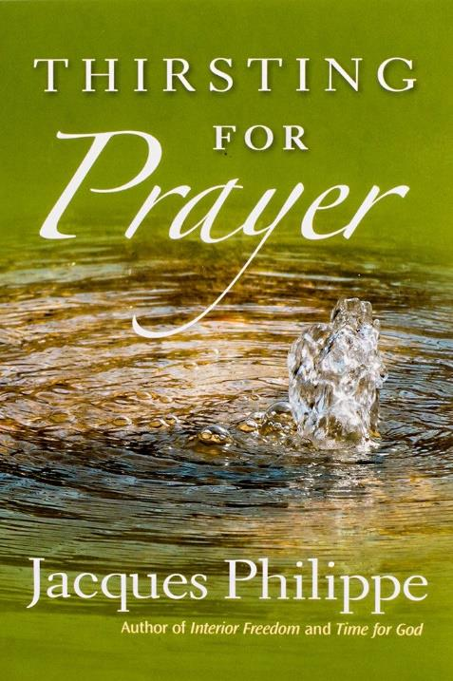
HOW TO PRAY

24

We want to help you become a saint every day, from right where you are and share Christ with others.
Have you ever tasted the beauty of God’s presence? It's natural to want to experience his closeness more often—as often as you can! As St. Josemaría Escrivá said: “Either we learn to find our Lord in ordinary, everyday life, or else we never find Him.”
We can help you discover and grow closer to God every day in your work, family life, and other ordinary activities. We want you to become a saint and everything we publish and do is directed towards that goal.
Thank you
Thank you for reading the booklet. Please feel free to redistribute the booklet to anyone who might benefit from it. If you are interested in similar reading, see the related books below.

CATHOLIC BOOKS FOR SPIRITUAL GROWTH

