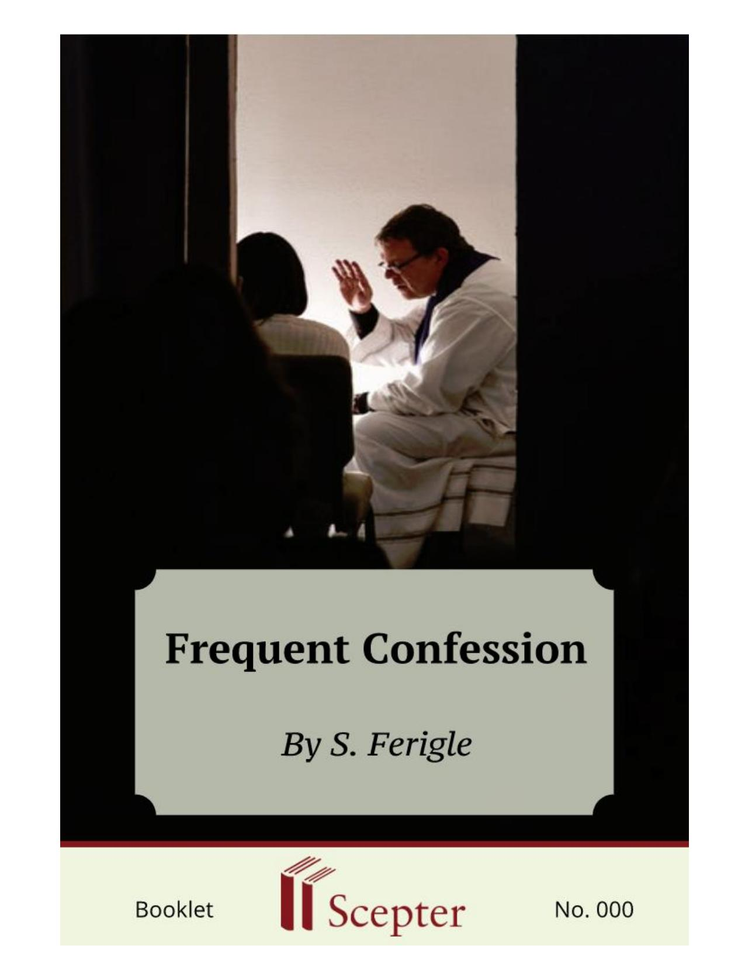
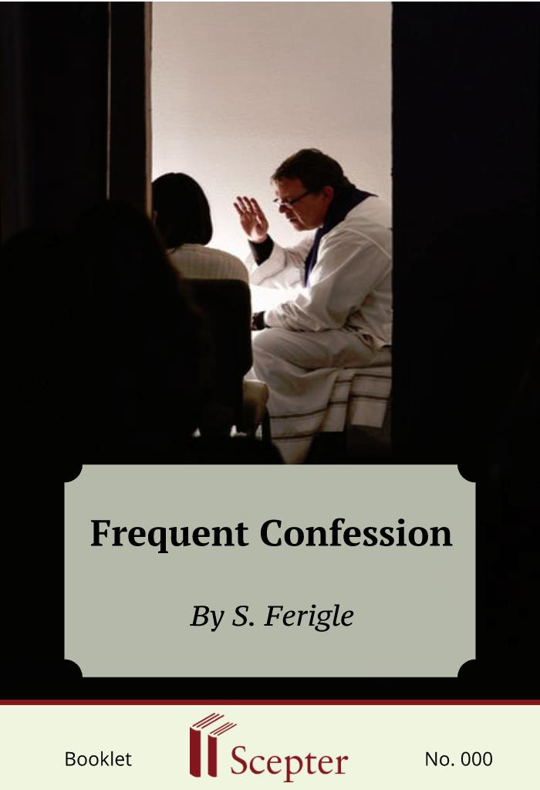

SCEPTER BOOKLETS

Frequent Confession
Nihil Obstat: Daniel V. Flynn, J.C.D., Censor librorum; Imprimatur: James P. Mahoney, D.D., Vicar General, Archdiocese of New York; January 15, 1976
By S. Ferigle

Scepter Publishers
PO Box 360694,
Strongsville, Ohio 44136

Toll Free: 800-322-8773 (US & Canada only) Tel: 212-354-0670
Fax: 646-417-7707

info@scepterpublishers.org

www.scepterpublishers.org

©1976 Scepter Publishers
Second Edition, © 2019
Booklet and Cover design by Parker Eidle

Booklet Number:000

© Scepter Publishers, Inc. This information protected by copyright of Scepter Publishers, Inc., New York, NY USA. It is for the free use of readers and we encourage you to redistribute this without permission. None of this information can be sold, either in electronic or print form, unless permission has been obtained from Scepter Publishers, Inc. Direct all inquiries to
info@scepterpublishers.org.

CONTENTS

Introduction 1

What the Church Teaches 3

The Pope Praises it 7

Is it a Waste of Time 9

Confession Contributes much 11

Religious Should Confess Often 13

What are some Guidelines? 15

A Tool for Perfection 16

It Benefits all Ages 17

FREQUENT CONFESSION

1

INTRODUCTION

AMONG THE DIFFERENT “vague impressions” that priests encounter in the exercise of their ministry is the feeling, on the part of many, that somehow things have changed with regard to confession. It used to be that we were encouraged to go to confession often — once a week, every two weeks, every month. Now the common practice seems to be to receive Communion every time one attends Mass — a very worthwhile practice if one is properly disposed to receive — and to relegate the old practice of frequent confession to the attic along with the statues and images that have been removed from the parish church in the last time it was remodeled.
In view of this general impression and seemingly widespread practice, it is good to recall what the Church has said on the matter.
A 1972 document from the Sacred Congregation for the Doctrine of the Faith states:
Priests should be careful not to discourage the faithful from frequent or devotional confession. On the contrary, let them draw attention to its fruitfulness for Christian living (cf. Mystici Corporis, AAS 35 (1943), 235) and always display readiness to hear such a confession whenever a reasonable request is made by the faithful. It must be absolutely prevented that individual confession should be reserved for serious sins only, for this would deprive the faithful of the great benefit of confession and would injure the good name of those who approach the sacrament singly.
This clear statement is very interesting, especially when at least some of the faithful may have been led to think the so-called devotional confession is discouraged.
The Pastoral Norms are naturally concerned with a practical problem.
If confession were ever reserved for mortal sins only, how could Johnny say without embarrassment on a Saturday afternoon — or any other afternoon, morning or evening, since confessions should, within reason, be available at any time of the day — “Mom, I’m going to confession,” without prompting Mom to worry about the mortal sins Johnny must have committed? Or should Johnny carefully avoid telling anyone that he is going to confession?

CATHOLIC BOOKS FOR SPIRITUAL GROWTH
FREQUENT CONFESSION

2

But this point is a secondary. Primary is “the great benefit of frequent confession” and “its fruitfulness for Christian living.”

CATHOLIC BOOKS FOR SPIRITUAL GROWTH
FREQUENT CONFESSION

3

WHAT THE CHURCH TEACHES

The Church has taught and continues to teach is that it is not necessary to confess venial sins, but that it is advisable to do so.
Speaking about the Sacrament of Penance in the Fourteenth Session of the Council of Trent (November 25, 1551), the Council Fathers wrote in the introduction something which reads like it could have been written last week:
So great is the number of errors of various kinds about this sacrament in this our age, that it would be no small public advantage to have handed down a more exact and complete definition. Thus, under the protection of the Holy Spirit, truth will appear in its clarity and splendor.
In chapter five of the same session, which deals with confession, the Council says in reference to venial sins:
As regards venial sins, which do not deprive us of the grace of God and into which we fall more frequently, they may rightly and profitably and without any presumption be told in confession (canon 7), as is clear from the practice of devout people. Nevertheless, they may be left unsaid without any fault, and they can be atoned for in many other ways.
Moreover, the canon just referred to condemned the opinion according to which “it is not permissible to confess venial sins.”
Two centuries after Trent, in the Constitution Auctorem Fidei, Pope Pius VI rejected the doctrinal errors of the Synod of Pistoia and stated:
[T]he declaration of the Synod (of Pistoia) concerning the confession of venial sins — about which it says that it is not desirable that it be so frequent, lest such confessions be rendered too contemptible — is rash, dangerous and contrary to the practice of the saints and devout people which was approved by the Sacred Council of Trent.

CATHOLIC BOOKS FOR SPIRITUAL GROWTH
FREQUENT CONFESSION

4

From this follows, at the catechetical level, the distinction between the necessary matter and the free and sufficient matter of the sacrament of penance. The necessary matter is all mortal sins committed after Baptism and not already directly forgiven in confession. These sins are called the necessary matter because there is a strict obligation to confess them. The free and sufficient matter for the sacrament are either venial sins, or mortal sins already confessed and for which the penitent has received absolution.
In his Encyclical on the Mystical Body (June 29, 1943), Pope Pius XII warns about “the opinions of those who assert that little importance should be given to the frequent confession of venial sins.” He continues: Far more important, they say, is that general confession which the Spouse of Christ, surrounded by her children in the Lord, makes each day by the mouth of the priest as he approaches the altar of God.
By this he is evidently referring to the Confiteor, equivalent to what in the present liturgy is the penitential rite. In answer to such opinions, the Holy Father, making it clear that it is not a question of obligation, nevertheless insists that frequent confession is a practice to be encouraged: As you well know, Venerable Brethren, it is true that venial sins may be expiated in many ways which are to be highly commended. But to ensure more rapid progress day by day in the path of virtue, We will that the pious practice of frequent confession, which was introduced into the Church by the inspiration of the Holy Spirit, should be earnestly advocated.
Encouraging this practice, he cites some of the benefits to be derived from it (the numbers have been added):
By it
1. Genuine self-knowledge is increased;
2. Christian humility grows;
3. Bad habits are corrected;
4. Spiritual neglect and tepidity are resisted; 5. The conscience is purified;
6. The will strengthened;
7. A salutary self-control is attained; and CATHOLIC BOOKS FOR SPIRITUAL GROWTH
FREQUENT CONFESSION

5

8. Grace is increased in virtue of the sacrament itself.
Pius XII’s concluding words are strong and clear, a succinct message appropriate for printing on small cards and distributing widely at ordination ceremonies, or lettering in a large font and framing for display in rectory parlors and chaplain’s offices: Let those, therefore, among the younger clergy who make light of or lessen esteem for frequent confession realize that what they are doing is alien to the Spirit of Christ and disastrous for the Mystical Body of our Savior.
Four years later, in the Encyclical on the Liturgy Mediator Dei (November 20, 1947), the pope returns to the subject: Since the opinions expressed by some about frequent confession are completely foreign to the Spirit of Christ and His Immaculate Spouse and are also most dangerous to the spiritual life, let Us call to mind what with sorrow We wrote about this point in the Encyclical on the Mystical Body. We urgently insist once more that what We expounded in very serious words be proposed by you for the serious consideration and dutiful obedience of your flock, especially to students for the priesthood and young clergy.
Pius XII expresses his thought on the matter once more in his Apostolic Exhortation to the Clergy (September 23, 1950), where he speaks of the importance of frequent confession for priests. We should keep in mind that the “frequent repetition of the same doctrine” is one of the ways to know the mind and will of the popes regarding a particular point and determining therefore the “religious submission of mind and will” which must be shown to their authentic Magisterium. These are the words of the Holy Father to priests:
This mercy and pardon for sins is granted us in a special manner through the Sacrament of Penance, which is the masterpiece of God’s goodness by means of which our infirmity is given strength. May it never happen, beloved sons, that the minister of this salutary means of reconciliation himself refrains from this sacrament. On this matter, as you know, the Church decrees that “local Ordinaries shall take care that all clerics frequently cleanse the stains of their conscience in the Sacrament of Penance” (Code of Canon Law, can. 125, 1). Even though we are ministers of Jesus Christ, we are still miserable CATHOLIC BOOKS FOR SPIRITUAL GROWTH
FREQUENT CONFESSION

6

sinners; how then can we ascend the altar and perform the sacred mysteries, if we are not careful to expiate our sins and cleanse our souls frequently?
Pius XII then repeats the very same reasons for frequent confession that given in Mystici Corporis and quoted above. The words used — “We urgently insist, very serious words, dutiful obedience, the opinions expressed . . . are most dangerous to the spiritual life” — reveal clearly the concern of Pius XII on this subject. We must remember that his tone or manner of speaking is another way to know the mind and will of a pope in regard to a point of doctrine.
Pius XII was not the only Roman pontiff who dealt with this subject, although he was perhaps the most outspoken and his words have been quoted most often, particularly in the Norms of June 16, 1972.

CATHOLIC BOOKS FOR SPIRITUAL GROWTH
FREQUENT CONFESSION

7

THE POPES PRAISE IT

In addition to the references to the Council of Trent already noted, it may be good to recall the teaching of some other popes. Saint Pius X spoke very often about the Eucharist and the Sacrament of Penance. To his pontificate belong the Decree Sacra Tridentina Synodus (December 20, 1905), on frequent communion, which was a blow to the remnants of Jansenism that unfortunately have not entirely disappeared from the Catholic scene, and the Decree Quam Singulari (August 8, 1910), on the first reception of the Sacraments of Penance and the Eucharist, which enjoyed renewed interest in the 1970s. In the Encyclical Editae Saepe (May 26, 1910), the saintly pope wrote about the means for spiritual growth that Jesus Christ so lavishly communicated to his followers, “especially prayer, sacrifice and the sacraments.”
Since the Church has been endowed with them for the salvation of all men, the faithful man will look for them in her. False reformers, however, despise these means. They make the road crooked and, so wrapped up in reforming that they forget God, they are always trying to make these crystal springs so cloudy and arid that the flock of Christ will be deprived of their waters. In this respect the false reformers of former days are even surpassed by their modern followers. These latter, wearing the mask of religiosity, discredit and despise these means of salvation, especially the two Sacraments which cleanse the penitent soul from sin and feed it with celestial food. Let every faithful pastor, therefore, employ the utmost zeal in seeing that the benefits of such great value be held in the highest esteem. Let them never permit these two works of divine love grow cold in the hearts of men.
Let us look at what Pope John XXIII himself said about it. In the Encyclical on the Cure of Ars (August 1, 1959), he wrote passionately about the work of Saint John Vianney as a confessor. Pope John’s words show perfect continuity with what his immediate predecessor had taught, and in the following he quotes the three references of Pius XII mentioned above: Stirred by the example of the Cure of Ars, let all directors of souls see to it that they devote themselves generously and equipped with the CATHOLIC BOOKS FOR SPIRITUAL GROWTH
FREQUENT CONFESSION

8

proper knowledge to this duty of such great importance, since it is here particularly that the divine mercy emerges victorious over human malice, and here that, freed from their sins, men are reconciled with God. These same men should also remember that “with very serious words” Our Predecessor of happy memory, Pius XII, reproved the opinion of those who belittle the frequent use of the Sacrament of Penance when it is a matter of venial sins. . . . And likewise We are completely confident that priests, before others, will faithfully obey the prescriptions of Canon Law which command them piously and at definite times to receive themselves the Sacrament of Penance which is so necessary for the attainment of holiness. We are also confident that, as is fitting, they may have the highest esteem for and make use of those urgent exhortations which this same Predecessor of Ours more than once imparted “with sorrowful soul.”

CATHOLIC BOOKS FOR SPIRITUAL GROWTH
FREQUENT CONFESSION

9

IS IT A WASTE OF TIME?

Especially in the case of John XXIII, because he has sometimes been misrepresented, it is useful to consider his other writings in order to get the best grasp of his thought. He enjoyed writing the retreat notes that since his death have become, among many other things, an expression of his real soul.
For example, in 1961, at the age of eighty, he wrote: First of all: “I confess to Almighty God.” During my whole life I have kept faithful to my practice of weekly confession. Several times during my life I have renewed my general confession. So now I content myself with a more general examination, without precise details, but in the words of the offertory prayer of my daily Mass: thinking of my
“countless sins, offenses and negligences,” all of which have already been confessed in their turn but are still mourned and detested. . . . The vivid memory of the failings of my life, eighty years long, and of my
“countless sins, offenses and negligences” was the general matter for the holy confession which I renewed this morning to my spiritual director.
We can notice a rather striking contrast between these words and the flippant comments those people, clerical or lay, who laugh at poor Aunt Margie who insists on her monthly trip to the confessional. “Poor thing.
What can a 65-year-old woman do that is worth telling the confessor? She is wasting the time of Father Sullivan who has so many things to do.” Well, it may be worth remembering that good Pope John was fifteen years older than Aunt Margie when he went to weekly confession. It is true that popes carry a heavy burden to teach, sanctify, and rule all the Aunt Margies of the world, as well as all rest of us, holy and less than holy, clerical and lay. But it is also true that they do so through a tremendous amount grace. It is no less true that Aunt Margie has a vocation to sanctity, not unlike Pope John, and she too is entitled to think about and ask for sacramental forgiveness for her
“countless sins, offenses and negligences” as she used to read in her offertory prayers at her daily Mass.

CATHOLIC BOOKS FOR SPIRITUAL GROWTH
FREQUENT CONFESSION

10

Let us also consider Vatican II. More than once the Council used the expression “frequent reception of the sacraments” — for instance, in the Decree on the Pastoral Office of Bishops:
In discharging their duty of sanctifying their people, pastors should see to it that the celebration of the Eucharistic sacrifice is the center and culmination of the whole life of the Christian community. They should labor without stint that the faithful be nourished with spiritual food through the devout and frequent reception of the sacraments and through intelligent participation in the Liturgy. Pastors should also be mindful of how much the Sacrament of Penance contributes to developing the Christian life and, therefore, should always make themselves available to hear the confessions of the faithful.
One of the edifying features of this text is that it was written — with the assistance of the Holy Spirit, we should remember, not as a result of political maneuvering, conciliar or otherwise — by the bishops of the world on the subject of their own pastoral office. It is a contemporary testimony of the successors of the apostles concerning what they themselves and their successors, also successors of the apostles, must do to fulfill their role as good shepherds.

CATHOLIC BOOKS FOR SPIRITUAL GROWTH
FREQUENT CONFESSION

11

CONFESSION CONTRIBUTES MUCH

It is quite obvious which sacraments the Council was speaking about in terms of their frequent reception. Of the seven sacraments, only three can be received once: Baptism, Confirmation, and Holy Orders. Two others are rather restricted in their frequency. We do not expect the Council to wish people to be frequently burying spouses and marrying new ones, or frequently so ill as to receive the Anointing of the Sick. This leaves only two sacraments, the minimum number to justify the plural, namely, the Eucharist and the Sacrament of Penance. Not only would it be uncharitable to wish the frequent reception of the Sacrament of Penance if it were restricted to mortal sins, but the context shows that the Council speaks of confession in terms of “how much it contributes to developing the Christian life.”
In recalling the threefold purpose of the sacraments, namely “to sanctify men, to build up the Body of Christ, and, finally, to give worship to God,” the first document of Vatican II, the Constitution on the Liturgy, emphasized:
[I]t is therefore of the highest importance that the faithful should easily understand the sacramental signs, and should frequent with great eagerness those sacraments which were instituted to nourish the Christian life.
The Sacrament of Penance and the availability of priests to hear confessions was naturally mentioned in the Decree on the Ministry and Life of Priests. Here the Council Fathers wrote to their priests who are
“constituted prudent cooperators of the episcopal order,” who are, like all Christians, including Aunt Margie, called to sanctity but bound to acquire it
“in a special fashion,” who must realize both that the exercise of their priestly tasks is necessary for the attainment of holiness, and that holiness does much for them in carrying out a fruitful ministry. The bishops upon whom “rests the heavy responsibility for the sanctity of their priests” said: In the spirit of Christ the Shepherd, (priests) must prompt their people to confess their sins with a contrite heart in the Sacrament of Penance, so that mindful of His words: “Repent, for the kingdom of God is at CATHOLIC BOOKS FOR SPIRITUAL GROWTH
FREQUENT CONFESSION

12

hand” (Mt 4:17), they are drawn closer to the Lord more and more each day;
and a little later:
[Priests] are united with the intention and love of Christ when they administer the sacraments. This is true in a special way when in the performance of their duty in the Sacrament of Penance they show themselves altogether and always ready whenever the sacrament is reasonably sought by the faithful.
It does not seem that the bishops were one bit worried about Father Sullivan being too busy to waste his time hearing Aunt Margie’s confession.
They thought that Father Sullivan should make himself available to hear Aunt Margie’s confession whenever she reasonably seeks the Sacrament of Penance, be it Saturday afternoon or Monday morning. They even imply that if Father Sullivan really does not have time to hear Aunt Margie’s confession, he is probably spending his time in the wrong places or on the wrong things.
Shortly after the Council, Pope Paul VI spoke about the need for Penance in a long document (February 17, 1966). One point of this document made headlines, namely, that Fridays outside Lent are no longer obligatory days of abstinence for the universal Church; the rest, unfortunately, was largely ignored. It also addressed the unchanging, divine command of penance, the historical perspective of penance in the Old and New Testaments, the need for external manifestations of penance, the unbreakable relationship between the internal spirit and the external acts of penance, and the specific recommendation:
It is very desirable for bishops and other pastors of souls to promote zealously more frequent use of the Sacrament of Penance, and to promote extraordinary works of penance, for the sake of expiation and impetration, especially during the Lenten Season.
During Lent Paul VI routinely spoke about penance, and often about confession.

CATHOLIC BOOKS FOR SPIRITUAL GROWTH
FREQUENT CONFESSION

13

RELIGIOUS SHOULD CONFESS OFTEN

The number of people making confessions may have decreased over the last few decades, but the teaching of the Church on the subject has not diminished. Perhaps Sister Joan ignored the subject altogether in teaching her fifth grade class, or told her students that going to confession once a year was plenty. But the Decree from the Congregation for Religious on Confessions for Religious (December 8, 1970) is straightforward. It says: Religious . . . should value highly the Sacrament of Penance. . . .
Religious should likewise hold in high regard the frequent use of this Sacrament by which true knowledge of self is deepened, Christian humility is strengthened, spiritual direction is provided and grace is increased. These and other wonderful effects not only contribute greatly to daily growth in virtue, but they are highly beneficial also to the common good of the whole Community.
The Decree includes much about frequent confession that can be beneficial to all Christians, young and old — insights which Sister Joan can share with her fifth graders. If she does not see the parallel between this teaching and that of Pius XII in 1943, the Decree itself refers Sister Joan to Mystici Corporis. As for herself, the Congregation for Religious is specific: Therefore, Religious, in their desire to strengthen in themselves union with God, should strive to receive the Sacrament of Penance frequently, that is twice a month. Superiors, on their part, should encourage this frequency and make it possible for the members to go to confession at least every two weeks and even oftener, if they wish to do so.
In her capacity as a teacher, Sister Joan should also have read the Catechetical Directory from the Sacred Congregation for the Clergy (April 11, 1971) and the Fundamentals of Religious Education compiled by a special committee of United States Catholic Bishops. The latter specifically
“indicates those teachings which the bishops expect and require to be taught as Catholic doctrine in instructing the young,” including Sister Joan’s fifth graders. The Directory and, following it, the Fundamentals of Religious Education, states:

CATHOLIC BOOKS FOR SPIRITUAL GROWTH
FREQUENT CONFESSION

14

One should also keep in mind the usefulness of confession, which retains its efficacy even when only venial sins are in question, and which gives an increase in grace and charity; increases the child’s dispositions for receiving the Eucharist, and also helps to perfect the Christian life.
How frequent is frequent? This is a question that can be asked with either a legalistic outlook or a sincere desire to know how best to fulfill the wishes of the Church on frequent confession. It has been clearly stated from the beginning that frequent confession refers essentially to the realm of accusation of venial sins, for which there is no strict obligation. To pin down an exact answer, however, is within the realm of legalism.

CATHOLIC BOOKS FOR SPIRITUAL GROWTH
FREQUENT CONFESSION

15

WHAT ARE SOME GUIDELINES?

For those who sincerely wish to do their best to avail themselves of the opportunity of frequent confession in order to grow spiritually, frequent confession will ordinarily be associated with having a fixed confessor. The confessor will be the best qualified person to suggest the frequency suited to the spiritual development and the physical and moral possibilities of the penitent. Within those rather broad limits of flexibility and in accord with a general rule of common sense, we can refer to one of the documents mentioned above which speaks about “receiving the Sacrament of Penance frequently, that is twice a month.” Previous legislation which specified regular intervals for confession referred to weekly confession. One can therefore say in general terms that, whenever possible, frequent confession will ordinarily mean between once a month and once a week.
The frequency of confession for those who frequently fall into mortal sin and wish to struggle against their failures is a completely different matter.
The answer here requires recourse to a fixed confessor who will counsel the penitent according to his dispositions and to the principles of sound moral and pastoral theology.
Another question refers to some of the specific aspects of the practice of frequent confession. Needless to say, while the Council of Trent emphasized the necessity “according to divine law to confess each and every mortal sin that is remembered after proper and diligent examination, even secret sins, and sins against the last two commandments, and those circumstances which change the species of sin,” and the Pastoral Norms of June 16, 1972, repeated the same doctrine. In the confession of venial sins there is never a problem of integrity, but rather of sufficiency of matter.

CATHOLIC BOOKS FOR SPIRITUAL GROWTH
FREQUENT CONFESSION

16

A TOOL FOR PERFECTION

It may be useful for the penitent to say at the beginning of confession something to the effect of, “since my last confession I am not aware of having committed any mortal sins.” This brings the confession into what has been called a devotional confession. Rather than a complete specification of numbers and kinds, the penitent will ordinarily benefit most by concentrating on some areas of spiritual struggle and by being concrete in order to be moved to a greater sense of contrition. The confessor must, on his part, respect the freedom of the individual, helping him at the same time to prepare future confessions with a greater sense of maturity. Likewise, spiritual writers must avoid a cynical attitude that may disturb the faithful.
If the faithful need greater formation and deeper maturity, let us, by all means, strive to give it to them. But when some popularizers — cleric, religious, or lay — show contempt for what unfortunately they have called
“laundry list confessions,” they show themselves to be frustrated, middle-aged people who would do better to bring their frustrations to their spiritual directors or psychiatrists, if need be, instead of pouring them into reams of useless printed matter.

CATHOLIC BOOKS FOR SPIRITUAL GROWTH
FREQUENT CONFESSION

17

IT BENEFITS ALL AGES

We have already mentioned the benefits of frequent confession with a fixed confessor as a channel for spiritual direction. If such a relationship has been established, the penitent will somehow identify himself. Even if such relationship does not exist, the penitent may help by a general statement such as, “I am a married woman, have been married for twenty years and have ten children. My oldest is in college and the baby is in kindergarten”; or
“I am a high school sophomore”; or whatever the case may be. Although the penitent is always entitled to preserve his anonymity, there is no duty to do so, and especially with a fixed confessor, the penitent may wish to identify himself: “Father, this is Mary Smith, and I have been coming regularly to confession with you.”
We can certainly say that the Church’s teaching has been and continues to be that frequent confession is beneficial to people of all ages, to 65-year-old Aunt Margie and to Sister Joan’s fifth graders who are ready, willing, and curious to discover the unfathomable depths of God’s love.

CATHOLIC BOOKS FOR SPIRITUAL GROWTH
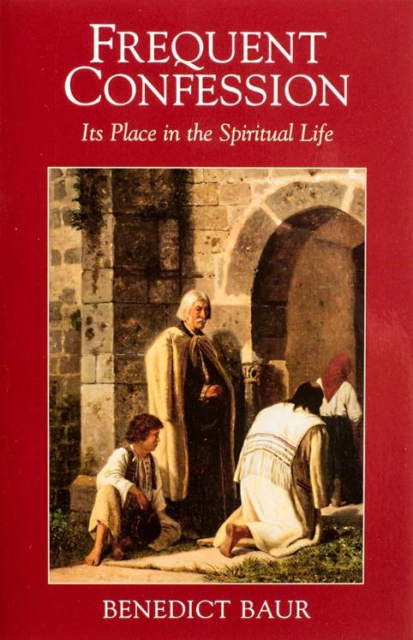
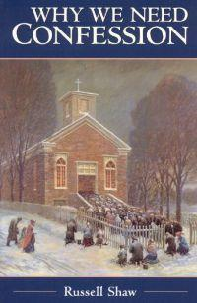
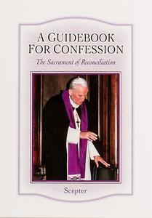
FREQUENT CONFESSION

18

We want to help you become a saint every day, from right where you are and share Christ with others.
Have you ever tasted the beauty of God’s presence? It's natural to want to experience his closeness more often—as often as you can! As St. Josemaría Escrivá said: “Either we learn to find our Lord in ordinary, everyday life, or else we never find Him.”
We can help you discover and grow closer to God every day in your work, family life, and other ordinary activities. We want you to become a saint and everything we publish and do is directed towards that goal.
Thank you
Thank you for reading the booklet. Please feel free to redistribute the booklet to anyone who might benefit from it. If you are interested in similar reading, see the related books below.

CATHOLIC BOOKS FOR SPIRITUAL GROWTH

