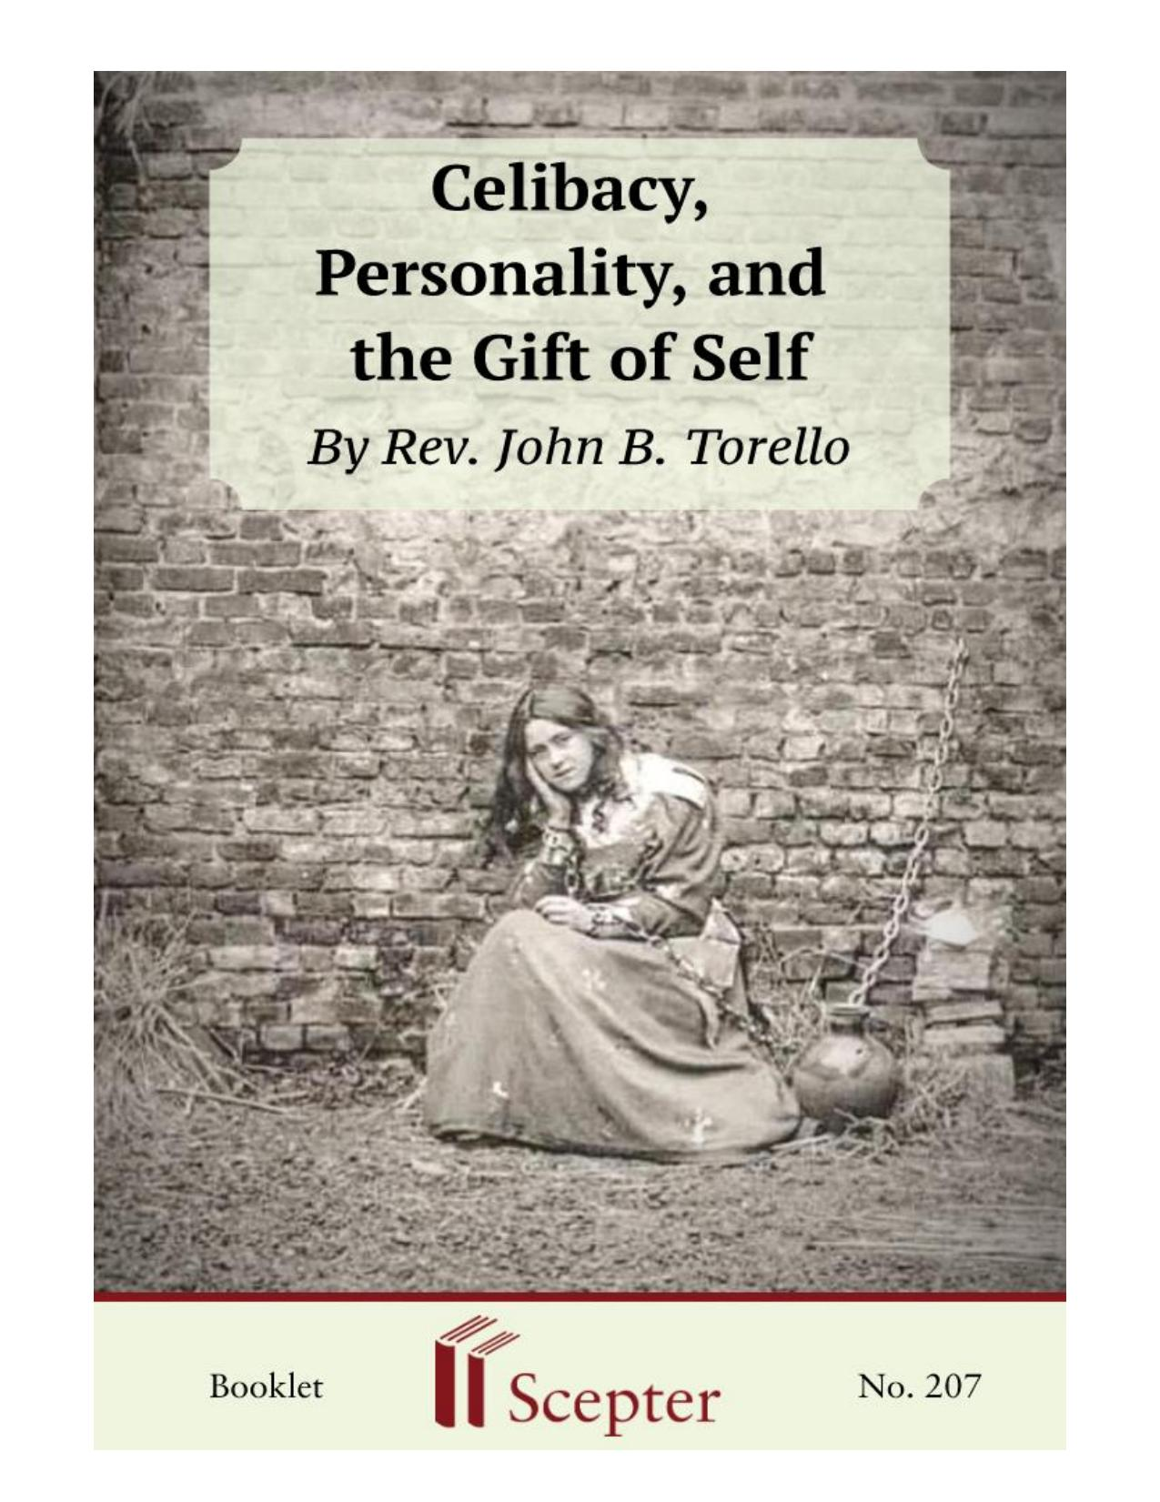
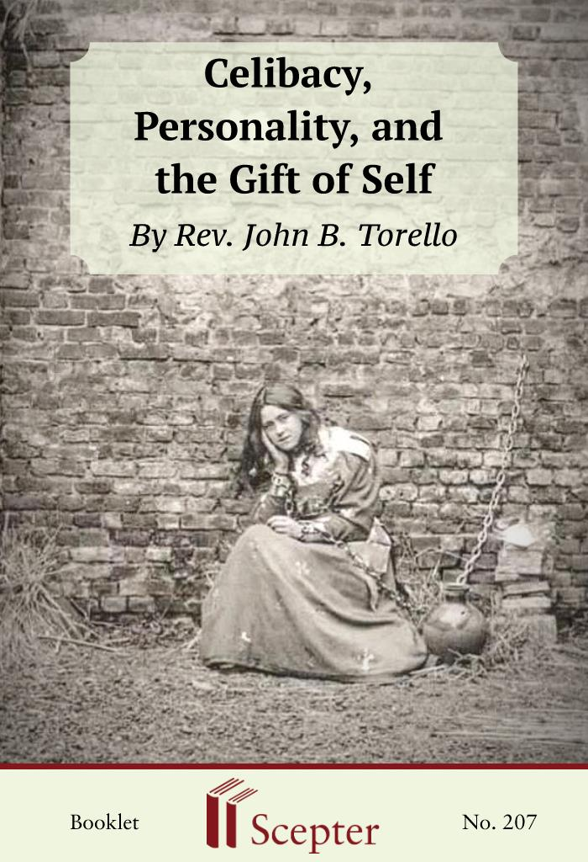

SCEPTER BOOKLETS

Norms of Piety
John B. Torello is a doctor specializing in psychiatry, and he also has a doctorate in theology.
Ordained a priest in 1948, he has combined his intense pastoral commitment with various interests in the field of his medical specialty. He was a professor of psychology at the Higher Institute of Sociology in Palermo (Italy), and professor of pastoral psycho-pathology and spiritual director at the major seminary in the same city. He has also worked in Zurich and Milan. For a number of years now he has been residing in Vienna. Fr. Torello is the author of a number of books, articles, and essays published mostly in Italian and German. Psychoanalysis and Confession (1963) and Open Psychology (1972) are two of his better known works. This booklet, taken from a lecture by Fr.
Torello was originally published at greater length in The Clergy Review.
By Rev. John B Torello

Scepter Publishers
PO Box 360694,
Strongsville, Ohio 44136

Toll Free: 800-322-8773 (US & Canada only) Tel: 212-354-0670
Fax: 646-417-7707

info@scepterpublishers.org

www.scepterpublishers.org

©1997 Scepter Publishers
Second Edition, © 2019
Booklet and Cover design by Parker Eidle

Booklet Number: 207

© Scepter Publishers, Inc. This information protected by copyright of Scepter Publishers, Inc., New York, NY USA. It is for the free use of readers and we encourage you to redistribute this without permission. None of this information can be sold, either in electronic or print form, unless permission has been obtained from Scepter Publishers, Inc. Direct all inquiries to
info@scepterpublishers.org.

CONTENTS

Introduction 1
Freud’s Conception 2
Too Many Unscientific Prejudices 4
Neurosis, Frustration, and Sacrifices 5
Matrimonial Frustrations 6
Maturity 7
Marriage is not a “Remedy” 8
Egocentrism 9
The Errors of Sex Education 11
The Meaning of Life and Self Giving 14
A Dolce Stil Nuovo (Sweet New Style) In Theology 16
Celibacy, Personality, and the Gift of Self 1

INTRODUCTION

In this booklet, John B. Torello examines what the popularization of the ideas of Sigmund Freud has done to Western culture. Two effects particularly harmful for young people have been the gross overestimation of sex, together with the false image of the “harmful” effects of sexual abstinence.
There has been a healthy response from many non-Freudian and independent psychiatrists and specialists. But this response has not been given the notice it deserves. It is this scientific perspective which Fr. Torello brings out and explains in these pages. Sexual abstinence, whether freely embraced or imposed by the circumstances of life, does not make a person neurotic. Quite the opposite. Celibacy, undertaken for spiritual motives, normally produces personalities that are mature, well-balanced, serene, and particularly suited for a generous self-commitment to others.
I have chosen the viewpoint of medical psychology for this booklet rather than a theological, moral, or pastoral study of my theme—the relationship between sex and personality, particularly with regard to that genuinely human phenomenon known as celibacy.
But first I want to call attention to something which I have often noticed in my work both as a priest and as a psychiatrist: that is, the almost superstitious veneration in which medicine and medical practitioners are held by most people, including most priests. This is not the place to analyze this phenomenon, but I must say that I consider it very damaging to a balanced appraisal of the human problems that can be met with every day, since such an attitude embodies a naive admiration for the natural physical sciences and an almost unlimited trust in the manipulators of the human body.

HELPING YOU FIND GOD WHEREVER YOU ARE
Celibacy, Personality, and the Gift of Self 2

FREUD’S CONCEPTION

It was within the context of a now partially outdated scientific co-naturalistic type of medicine that Sigmund Freud elaborated his image of man. In so doing, he consciously let himself be carried away by preconceived ideas borrowed from physics and resolutely turned his back on observable phenomena. “We will not classify or describe the phenomena,” he wrote “but we will conceive them as betokening a play of forces acting upon the psyche.
. . . We are working toward a dynamic conception of psychic phenomena. In our view, the observed phenomena must give way to the energies we presuppose.”
We here come face to face with the limiting dogmatism that lies at the basis of all Freudian investigations, which, inevitably, draw from experience all those things, and only those things, that his theory had chosen to put there.
Freud’s thought can be summed up in this way: 1. Man is an object, a kind of apparatus conceived along the lines of the machines he builds.
2. The fundamental law that governs his behavior is “homeostasis,” i.e., the law of the conservation of psychophysical equilibrium or mental balance.
3. Psychic manifestations are related to one another by psychodynamic causal relations.
4. The discovery of such relations enables one to attack the causes of all psychic alterations, thus making it possible to restore the apparatus to good working order.
5. Such primordial phenomena or “instincts” must be sought at the beginning—in the temporal sense—of the causal chain. According to this postulate, many psychoanalysts believe that the so-called fear of birth—because it came fi rst in time—is the cause of all subsequent fears in the child and in the adult, from the fears of the eight-month-old infant, to a child’s fears in relation to his parents, to an adult’s fear in the face of human or divine authority. Others believe that primordial HELPING YOU FIND GOD WHEREVER YOU ARE
Celibacy, Personality, and the Gift of Self 3

fear is to be sought even earlier, for example in the fearsome pre-history of a parricide committed by some remote ancestor.
6. Any subsequent phenomenon must—precisely on that account—be relegated to the category of secondary results, i.e., to be thought of as mere projections, reactions, sublimations, transfers, or epiphenomena of the only primary factor, that is, instinct.

HELPING YOU FIND GOD WHEREVER YOU ARE
Celibacy, Personality, and the Gift of Self 4

TOO MANY UNSCIENTIFIC PREJUDICES

It is unfortunate that such a rigid reductionism philosophy should have been the most influential contribution made by psychoanalysis to contemporary culture, overshadowing the large number of accurate observations and insights for which we are indebted to Freud, who is unquestioningly acknowledged as the father of modern psychotherapy despite his dependence on a totally outdated mode of thinking.
The work of philosophers such as Henri Bergson, Edmund Husserl, Max Scheler, and Gabriel Marcel and of psychiatrists such as Rudolf Allers, Viktor Frankl, Ludwig Binswanger, and Medard Boss have brought to light how much postulation and preconceived ideas there were in Freudian theory and have inaugurated a new view of man as being essentially a subject—open to suggestion—and not an object or machine closed in on itself.
It is instructive to recall that, even at the apex of this trend of medical thinking, highly regarded scientists and renowned doctors refused to see in sexual abstinence a true cause of organic disturbances. In their opinion sexual abstinence is absolutely harmless from the viewpoint of health, provided that sexuality is not both stimulated and repressed at the same time. It should be further stressed that sexually continent people who show signs of disturbance are not cured by sexual activity, as many medical and psychoanalytic vulgarizers would have us believe and some physicians whisper into the ears of their unwary patients. These doctors have not studied sexual behavior in any school of medicine and consequently in these matters are subject to the same prejudices as the mass of lay people. One result is that disturbed patients transfer their illnesses to the field of sexual relations and easily degenerate into perverts. Sexual pathology ends up, of its own weight, in the psychiatric clinic.
From the biological point of view, it is quite possible to assert plainly that despite its potent attraction sex is a superfluous activity. Forced sexual abstinence in animals—the behavior of which is clearly marked by sexual rhythms—has been proven totally harmless. Woman, unlike man, is subject to a clear sexual rhythm: ovulation. Nonetheless, it has been observed that this doesn’t influence her spontaneous behavior. Nor can it be forgotten that, in contrast to animals, everything in man is permeated by the spirit, that is by freedom. (Aron, Portmann, Marc Oraison).

HELPING YOU FIND GOD WHEREVER YOU ARE
Celibacy, Personality, and the Gift of Self 5

NEUROSIS, FRUSTRATION, AND
SACRIFICES

With regard to the so-called “personality disturbances,” or neuroses, that sexual continence is alleged to cause, it is instructive to recall a statement by Freud himself: “The reason why such persons become ill is the rebuff imposed by reality, in whatever way, to the fulfillment of their sexual desires.” This formulation could be acceptable only on two conditions: 1. that this interpretation of life is not generalized, 2. that the term “imposed” is duly stressed.
As a matter of fact, it is not only a sexual frustration that makes a person neurotic, but an unwanted frustration of any kind, intimately resented. This is absolutely not the case with celibacy freely chosen for love and in a spirit of service. Neurosis, in contrast, denotes a clear absence of love—understanding this term as a committed mode of being in the world—
and thus a considerable limitation, clearly pathological, of the relation “I”—
“world.”
People who because of various circumstances—a woman or man unable to find a spouse, sick people incapacitated for marriage, etc.—are compelled to sexual abstinence certainly ought to make a virtue of necessity.
This is something not only very feasible but also very good. These people should accept their sexual abstinence in the intimacy of the ego, so that their sexuality can be integrated into the whole of their personalities. They will not then turn into eccentric old maids or bachelors who fill the house with small dogs and canaries, who are bad tempered and unreasonable, not because they lack sexual relations but because life is meaningless to them. It is neither marriage nor celibacy which gives meaning to life; it is faith and love that makes it possible for a person to make a transcendent gift of self to the Other.

HELPING YOU FIND GOD WHEREVER YOU ARE
Celibacy, Personality, and the Gift of Self 6

MATRIMONIAL FRUSTRATIONS

Neurosis is not eliminated by simply eliminating frustrations.
Marriage itself also frustrates many human possibilities, not only in the sense adverted to by Andre Gide, “The man who loves a woman has to give up all the others,” but also in the sense that the commitment entailed in human love demands quite a number of sacrifices, and still in the further sense that love and sexual activity themselves demonstrate the insufficiency, the limitation, the relativity of a union that seeks infinity, eternity, absoluteness—things that neither love nor sex is in any position to satisfy.
For this reason, as Gustave Thibon remarks, all lovers should remember that loving does not mean gorging oneself or devouring one another, but suffering hunger together and turning it into a common prayer.
“A frustration is not well endured except in the measure in which one positively lives what is allowed by it” (Oraison). Thus, the celibate person is not exposed to the crises of the married person, not to mention the fact that the frustrations imposed by marriage are commonly less well tolerated than the frustrations implied in celibacy. Hence, from the psychological and statistical viewpoint, it can be asserted that, owing to the self-giving it presupposes and leads to, if the religious motivation does not weaken, celibacy is in no way a disadvantage compared to marriage.
In all sexual matters the decisive factor is always the psychic—better still, the interior spiritual and religious attitude that is focused not on fleeting, provisional, and reversible situations and values, but on the definitive and irrevocable, which betoken a specific commitment and a full exercise of liberty. Positive celibacy is not only a source of liberty, it also contributes to the attainment of freedom in one of its most radical forms and is, in this sense, eminently wholesome. As Carl G. Jung observed, “Sexual abstinence, in effect, is not harmful provided it is not just an escape from the necessities and responsibilities of life and fortune. However, it must be freely willed and based on religious convictions: all other motivations are too weak and produce a lack of interior unity along with neurosis, the latter being always the expression of a moral conflict.”

HELPING YOU FIND GOD WHEREVER YOU ARE
Celibacy, Personality, and the Gift of Self 7

MATURITY

According to contemporary psychopathology, the chances for the celibate’s personality to mature are as great as the love for which he or she lives. In other words, the sole enemy of a mature personality is egocentrism or selfishness.
It can be safely asserted that there are as many persons unsuitable for celibacy as there are for marriage. Indeed, as we have seen earlier, the failures in celibacy are not more numerous than the failures in marriage. In either case the problem is directly linked to the greater or lesser victory achieved over selfishness. Those who have not learned to give themselves suffer shipwreck. People who have not learned to deny themselves are incapacitated for love whether divine or human. Those who are not chaste before marriage will rarely be chaste afterwards. It is naive to think marriage solves the so-called “sexual problem.” Marriage can only provide a natural environment for the development of the decisive factor, that is, the difficult transition from “living for me” (egotism) to “living for you” (love).
Self-giving is the indispensable basis for maturity and for the integration of sex within one’s whole personality. Marriage does not produce such self-giving automatically: it is in every case the fruit of a free and painful conversion, of an intimately personal metanoia. Let us not be deceived: satisfaction of the sexual instincts cannot produce contentment even of the senses, because such isolated instinct does not exist, just as isolated, disincarnate spirits do not exist.
St. Paul has a well-known dictum, “It is better to marry than to burn.”
Some people, misinterpreting the apostle’s phrase, considered it a folly to abstain from marriage since it offers a remedy to concupiscence. Thomas Aquinas had a ready answer: “Such a view would merit consideration, if no other more effective remedy were at hand to curb concupiscence. But people who do not marry have at hand the more effective remedy of spiritual works and the mortification of the flesh.”

HELPING YOU FIND GOD WHEREVER YOU ARE
Celibacy, Personality, and the Gift of Self 8

MARRIAGE IS NOT A “REMEDY”

Any person of experience knows only too well the relative value of the remedium concupiscentiae as evidenced by the innumerable marital failures and divorces taking place despite the satisfaction of instinct, where marriage is not anchored on a robust spiritual structure and on the renunciation of self for love. Therefore, since in celibacy spiritual life and complete self-renunciation should be the result of a real and dedicated love, it follows that it will produce exceptionally well-balanced personalities.
To describe the personalities of such celibates is an undertaking rarely attempted, but all psychologists who are not blinded by prejudice have been able to observe in them a common characteristic, youthfulness of spirit, which is utterly opposed to those false celibates who are often justly termed old bachelors or old maids. These celibates are on the best of terms with everyone and show themselves to be integrated, not overwhelmed, serene, and welcoming. That is why they easily become much-sought-after advisers, valuable commentators who help others to see things dearly without imposing their own views. They give of themselves easily; they are active and dedicated yet at the same time balanced and flexible, so that often people say of them “You wouldn’t know he was single.” They are sure of their own identity (not “self-sure” or “cocky”), that is, authentic and modest; they esteem human love but see its limitations and therefore know how to give themselves ever more generously to tasks that surpass all that is merely worldly and temporal. These characteristics, described fully and simply by Marc Oraison, make of the celibate-for-love a highly attractive figure, someone who can be regarded as an outstanding example of the transcendence of personal life.
Celibacy, which allows an altogether satisfactory expansion of the personality, demands, nonetheless, a minimum of emotional maturity—as is likewise demanded by marriage. It can even be said that in this case the demands are almost the same. No person who is not sufficiently mature can enter into marriage. However, this maturity is achieved only gradually, and in a nonlinear manner, through crises that bear careful watching, support, and guidance so that the person who undergoes them may not lose heart and fall into either unhappiness or infidelity, the Scylla and Charybdis in the journey toward maturity.

HELPING YOU FIND GOD WHEREVER YOU ARE
Celibacy, Personality, and the Gift of Self 9

HELPING YOU FIND GOD WHEREVER YOU ARE
Celibacy, Personality, and the Gift of Self 10

EGOCENTRISM

Rare are the celibates, and even more rare the married people, who embark on their respective undertakings with a completely undivided heart.
All initial affection is infiltrated by egocentrism under more or less honorable and worthy pretenses: a desire for personal satisfaction, a desire to improve, a desire to fulfill hunger for the absolute. The very solicitude for personal holiness, apostolic zeal itself, can be saddled with heavy egoistic burdens which only time, obscurity, the prosaicism of daily life, the aridity of the law, the inflexibility of social structures, temptations, disillusionment, and loneliness can slowly rectify, bringing the imperfect lover to the salutary void described by mystic writers as “the night of the senses and of the spirit,” and which we can simply call “existential crisis.” Self-giving grows and is purified only through each person’s personal history. But he or she who is living through such a crisis must understand that they ought not to run away from it (“One fears the abyss because in its depths one finds God” [Simone Weil]) or pretend that it isn’t there; and, above all, he should not deceive himself with an eventual change of partner because it is he who has to change (Fritz Kunkel).
The greater number of so-called successful marriages are couples who survive these unavoidable shipwrecks, when “either the ego kills love or love kills the ego” (Thibon). The most successful celibates are those who, through crises of greater or lesser extent, have known how to purify the initial motives of their dedication; it is the story of many priests whose vocation was decided in minor seminaries, and of many nuns. We should not split hairs or be too meticulous in facing up to our initial motives so long as these are not completely devoid of authentic aspects, because otherwise, we would destroy the majority of professional, matrimonial, and priestly vocations! A sullied or even heavily tarnished beginning can be rectified, compensated for, and purified; this applies also to a celibacy weighed down with sexual taboos and fears.
Hence the need not to isolate the sexual problem, not to make of it the object of a separate education but to integrate it into the general structure of the personality. Many of the most highly respected names in contemporary psychiatry have repeatedly stressed this, to the point of satiety, against the HELPING YOU FIND GOD WHEREVER YOU ARE
Celibacy, Personality, and the Gift of Self 11

widespread—and often hypocritical—educational practice aimed at liberation from taboos.
Sexuality has its place in the loving relationship of man with the world, i.e., in that mode of being-in the-world called love, in which the oneness and the totality of the I and the You are lived in the form of self-giving, without reservation and without conditions, which shapes all the dimensions of one’s existence: the bodily, the psychic, the spiritual.
Sexuality, according to existential analysts, is love actualized in the bodily sphere: a love that can be incarnated or realized either in sexual activity or in sexual abstinence. At the roots of every sexual disturbance will be found, as we have said, a restriction of the capacity for love, for various reasons: isolation, stubbornness, introspection, fear, etc. This means that the sexual behavior of each person does not depend fundamentally on his own constitution, or on the social conditions in which he lives. It can always be transformed, provided that the individual’s way of being-in-the-world, i.e., his relationship with himself, with others, with life, and with God is also adequately transformed.

HELPING YOU FIND GOD WHEREVER YOU ARE
Celibacy, Personality, and the Gift of Self 12

THE ERRORS OF SEX EDUCATION
These psychopathological premises oblige us to look at the complex question of sex from the viewpoint of the total personality and (most importantly) from the educational point of view. Unfortunately, it should be observed that the people who have been or are successful in the celibate state do not owe their success to the education they have received; more often than not they have succeeded in spite of it. They have achieved success because life itself, as mentioned earlier, teaches and finishes, because self-giving accomplishes wonders, because psychology—thank God!—is not everything.
And because the sacrament of holy orders—in the case of priests—and the grace of God’s calling are more efficacious than our own mistakes. In any case, it pays to review, if briefly, the more common errors that can be singled out in sexual pedagogy so that, by setting them right, celibacy may be more easily lived in a really positive way.
1. “Angelistic” pedagogy: A sweetish rhetoric, a kitsch phraseology, a meaningless and prudish formalism that once characterized a good part of the pedagogy of chastity in the Catholic schools, running parallel to the dusty Victorian morality or a worldly pharisaical culture which the Freudian revolution unmasked without compassion. You had to be pure “as a lily,”
innocent “as a lamb,” chaste “as a dove.” We could almost see in this approach a badly concealed Manicheism that saw in sex the source of all evil, and which therefore made use of sugarcoated euphemisms. Seemingly cast into oblivion, more or less consciously, was the fact that the whole of Christianity is grounded precisely on the Incarnation of the Word of God; that, in the bold phrase of St. Thomas, “God became flesh so that the flesh could become God”; that this flesh is now “the temple of the Holy Spirit”; that these sexual bodies are the matter of a sacrament; that all the sacraments are oriented towards the sacrament of the Body and Blood of Christ; that all the liturgy has been described by a writer as “divine worship of the body” (of Christ), a body defined by Tertullian as “the pillar of salvation.” No; we were to be cast in the role of angels, ignoring Pascal’s warning that “he who wants to play the role of an angel ends by playing the role of a beast.”
2. The pedagogy of fear: This kind of teaching of purity, St. Josemaría observed, as a matter of fact spoke only of impurity, and in such terms that it haunted the sleepless nights of young people. “Dangers” lurked HELPING YOU FIND GOD WHEREVER YOU ARE
Celibacy, Personality, and the Gift of Self 13

everywhere. The devil and his temptations lay in wait at every turn of the corner; every glance, every page, every human contact could be a trap, an occasion of sin that brought not only death to the soul, but also ruin to the health of the body. This latter statement was often totally unsupported by fact, particularly with regard to masturbation. Such pedagogy inevitably produced psychic cramps that stifled all vitality and joy. Thomas Aquinas teaches that the first condition to overcome temptation is not to be surprised at experiencing it, not to be scared. And John of the Cross observed that the movements of sensuality, frequently experienced by beginners, are at times provoked precisely by the very fear of them.
3. The pedagogy of ignorance: This type of sexual pedagogy paradoxically maintained that it was best not to speak of such things. Life itself, unfortunately, would put young people in touch with ugly reality. This studied silence succeeded only in exciting the imagination, turning normal curiosity into morbid channels, and furnishing inaccurate and negative ideas about sex. And I am not talking of the state of affairs of a hundred years ago.
It was only some few decades ago that in many schools lessons on reproduction were limited to the reproduction of plants and fishes; human reproduction was never mentioned.
Today teenagers are initiated into sex by newspapers, films, and a flood of semi-pornographic literature that penetrates into every nook and corner.
Today, then, more than ever there is a need for a genuine sexual education, because the eroticism that is being peddled under the hypocritical label of sex education does not enlighten, but only muddles and fills the souls of teenagers with a lot of taboos and dirt.
The delicate modesty of the saints—formally linked perhaps to the customs of their respective times—has never been either an ignorant naiveté or a narrowness of spirit, but the expression of a subtle and clear appreciation of the true, which characterizes all authentic love. Compared to the directness— the coarseness of manners, if you wish—of a Catherine of Siena or a Thomas Aquinas, the popularized figure of an Aloysius Gonzaga—
eyes riveted on the floor, not once lifted to look his sovereign, Maria of Austria, in the eye, going even so far as to avoid, if we are to believe the Roman Breviary, looking on the face of his own mother—such a figure seems to me to possess all the earmarks of a pious legend or fraud which can edify no one.

HELPING YOU FIND GOD WHEREVER YOU ARE
Celibacy, Personality, and the Gift of Self 14

4. Restrictive pedagogy: In its view, if a person is chaste, then everything is all right. Such a simplification evidences extremely bad theology and psychology and is also devoid of any sense of reality. If we lose sight both in our living and in our teaching of the fact that the sole valid summary of God’s Law is embodied in the love of God and the love of neighbor and insist instead on the more or less theoretical primacy of chastity, we may have persons who are continent but certainly not chaste.
We shall have frustrated and embittered celibates, encrusted with a melancholic punctiliousness and with an all-pervading distrust of the world that often foments the worst of all evils, that is, spiritual pride, which will sooner or later bring about the dramatic short circuit that plunges the aspirant to angelhood into the mire of carnality HELPING YOU FIND GOD WHEREVER YOU ARE
Celibacy, Personality, and the Gift of Self 15

THE MEANING OF LIFE AND SELF GIVING
Sexual education reduces in the last instance to an adequate explanation of the true meaning of sexuality. At this point we need to liberate ourselves decisively from the formulism and legalism that life itself inevitably discards. We have to go directly to the problem of “meaning.” All of Frankl’s teaching on the “meaning of life” obtains here indisputable validity. If the whole of life acquires meaning only within the ambit of
“serving” and “loving,” this should be much truer of the life of him who gives himself without any egoistic ballast—desire of recognition, or self-satisfaction, or self-development, or personal success. Chastity, said Thomas Aquinas, is not praiseworthy in itself, but only inasmuch as it leads one to the contemplation of things divine. For instance if, in a future priest, the life that is hidden with Christ in the God of the New Covenant is not awakened and fostered, if he fails to become above all else a man of prayer aflame with the desire to see God already in this world, in things, in the most disinherited of our fellow men and women— for it is in this contemplation that the disclosure of the meaning and the ultimate foundation of his whole life is effected—then he will have failed to achieve a positive and outward looking celibacy.
The meaning of celibacy cannot be grasped except in dialogue with God himself, clamoring for and imploring the grace needed to continue the struggle which demands a constant renewal of the desire to accept the blind adventure when confronted with the scandal and folly of the cross and of the Gospel.
This folly and scandal are even more evident in our days.
Contemporary demythifying, desacralizing, secularizing tendencies—which would turn Christ into a mere humanitarian hero, Christianity into mere humanism, and priests into mere social workers are complemented by the so-called “sexual revolution” modeled on the views of the heterodox Viennese psychoanalyst Wilhelm Reich. He preached with a fanatic’s zeal the abolishment of all transcendent values, of all marriage morals, of all authority of any sort, so that “sexual happiness” might eliminate as if by magic all wars, repressions, and neuroses.
If Catholics allow themselves to be led by the nose thanks to a somewhat naive conformism, and bow to the myth of total secularization and HELPING YOU FIND GOD WHEREVER YOU ARE
Celibacy, Personality, and the Gift of Self 16

scientific redemption from all evil, it should not be at all surprising that they too should take up the “long march” to SexualgIiick (sexual happiness). Some time ago a pamphlet published by a Viennese Catholic student group attacked monogamous marriage and defended “group marriage” because the latter is “more natural and more human.” Others are advocating that so-called marriage between homosexuals ought to be not only legally recognized but counted as a sacrament.

HELPING YOU FIND GOD WHEREVER YOU ARE
Celibacy, Personality, and the Gift of Self 17

A DOLCE STIL NUOVO (SWEET NEW
STYLE) IN THEOLOGY

Certain theologians, bright-eyed with enthusiasm from their fresh discovery of the positive value of sexuality—of which they show only scant knowledge—have idealized marriage to such an extent that celibacy, in their eyes, seems no better than an incurable wound. The erotic lyricism of this
“dolce stil nuovo teologico” (sweet new theological style) that presents marriage as the indispensable means for the development of the personality and its social possibilities, is a big lie from the viewpoint of psychology, not to mention the aspersion it casts on the only perfectus homo (perfect man) and sole redeemer of the world, Jesus Christ. Celibacy deprives a man of many joys. No one denies it. But, on the other hand, it allows commitment, achievements, diversions, and joys unknown to the married. That, too, is undeniable.
The celibate, who has embraced celibacy in view of a full commitment to others, becomes a great teacher of love, not excluding conjugal love, because he or she has achieved in his or her own life that which marriage is only a symbol of, which is the nuptial union between Christ and the Church.
Without this “mystical” foreshadowing and anticipation of man’s final condition in eternity, the ultimate meaning of celibacy is lost and all other substitute compensations eventually turn out to be painfully insufficient.
Thus, priests and theologians who truly want to help in promoting public health should dedicate themselves less to psychology and sociology and more to mysticism. It is here that the foundations of the Christian calling, and much more of the priestly calling, are to be found.
However, this mustn’t be taken to mean that a positive celibacy solidly anchored in spirituality and emotional maturity can be free to prescind from asceticism. A well-integrated sexuality, the exercise of which has been renounced, should not be voluntarily stimulated under cloak of pharisaical calculations of what is forbidden and what is allowable. There is no need to be masochists to perceive that, even in a world less eroticized than our own, the custody of the senses is necessary for anyone who wishes to live chastely in celibacy—or in marriage. No anti-repressive taboo can convince me of the HELPING YOU FIND GOD WHEREVER YOU ARE
Celibacy, Personality, and the Gift of Self 18

possibility of a celibate life without effort, without sobriety, without control over the imagination, and without reasonably measured bodily penances. At any rate, the more important discipline is that of the cross imposed by the love of neighbor, and all the renunciations, efforts, humiliations, failures, and ingratitude implicit in the service of others. All these things serve to help us rectify our intentions and seek God in and above all things.
All of it is even truer, as I once heard Josemaría Escrivá, the founder of Opus Dei, say of the priest who seriously fulfills the commitments contracted by his ordination. He will have no time to spare for the luxury of indulging in personal problems. At night, weary from so much self-giving, he will make the astonishing discovery that all day long he has not had one minute in which to think of himself and can in consequence happily exclaim: I live, yet not I, but Christ lives in me.

HELPING YOU FIND GOD WHEREVER YOU ARE
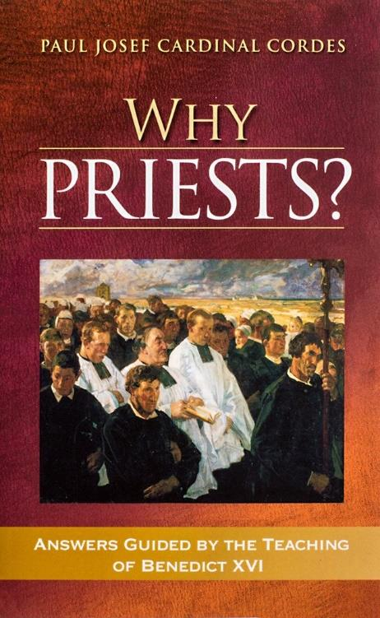
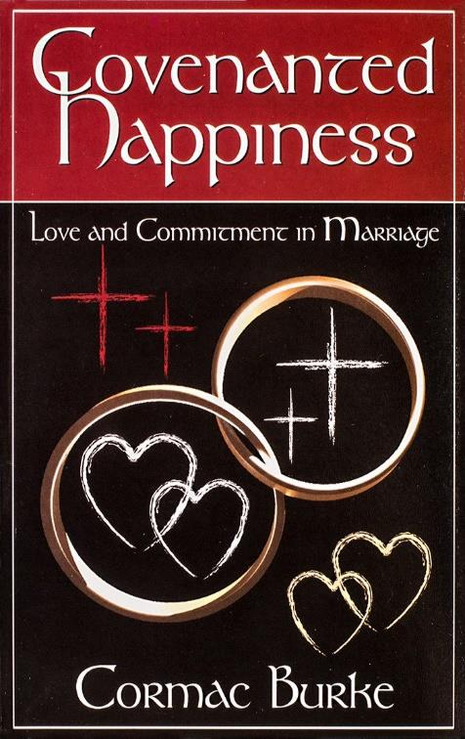
Celibacy, Personality, and the Gift of Self 19

We want to help you become a saint every day, from right where you are and share Christ with others.
Have you ever tasted the beauty of God’s presence? It's natural to want to experience his closeness more often—as often as you can! As St. Josemaría Escrivá said: “Either we learn to find our Lord in ordinary, everyday life, or else we never find Him.”
We can help you discover and grow closer to God every day in your work, family life, and other ordinary activities. We want you to become a saint and everything we publish and do is directed towards that goal.
Thank you
Thank you for reading the booklet. Please feel free to redistribute the booklet to anyone who might benefit from it. If you are interested in similar reading, see the related books below.

HELPING YOU FIND GOD WHEREVER YOU ARE

