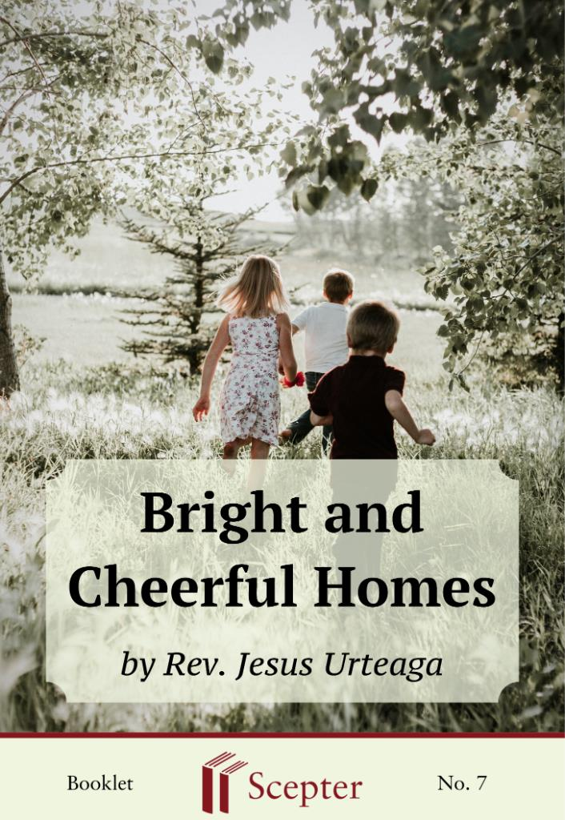

SCEPTER BOOKLETS

Bright and Cheerful Homes

By Rev. Jesus Urteaga

Scepter Publishers
PO Box 360694,
Strongsville, Ohio 44136

Toll Free: 800-322-8773 (US & Canada only) Tel: 212-354-0670
Fax: 646-417-7707

info@scepterpublishers.org

www.scepterpublishers.org

©1965 Scepter Publishers
Second Edition, © 2019
Booklet and Cover design by Parker Eidle Booklet Number: 7

© Scepter Publishers, Inc. This information protected by copyright of Scepter Publishers, Inc., New York, NY USA. It is for the free use of readers and we encourage you to redistribute this without permission. None of this information can be sold, either in electronic or print form, unless permission has been obtained from Scepter Publishers, Inc. Direct all inquiries to
info@scepterpublishers.org.

CONTENTS

Introduction
1
God’s Hope: Your Children
2
Living Homes
4
Christ in Your Home
6
Divine Filiation
7
Serving Others
9
Being With Them
12
Light and Joy
13
Influence and Example
15
Be Positive
17
BRIGHT AND CHEERFUL HOMES

1

INTRODUCTION

The undertaking I want to speak to you about is an enormous one: rearing your family. I am much more concerned about your home than about whatever bad or dangerous atmosphere you may find in the street. I am much more worried about the way of life your children will learn in your home, following your example, seeing you live your life, than I am about anything they may learn from the faithlessness and faults of other people. Here is a really important question: Are you giving them that "something"—and it is a very great something—that they must have if they are to live truly Christian lives?
Just think about the kind of world we can create for the people of tomorrow if only we get your children to understand, to realize fully from this moment on, that Christ is really alive; that they must serve the Church and be ready to lose everything, their wealth, their honor, and their life, if necessary; that Christians must take an active part in public life, so as not to let true Life be suffocated and buried, hidden away in people's consciences.
Christ wants, needs, people to spread the blaze of love which he came to Earth to enkindle.
Do you realize the great things we will achieve tomorrow—and that tomorrow is already dawning—if we make the effort now to train our children as God and his Church want us to train and educate them? They must be faithful people, determined, strong-willed, enterprising, responsible, hardworking, freedom-loving, fearless, without inhibitions, without silly scruples, afraid of nothing, people of faith, hope, and love, with a great love, a vigorous charity that will spur them into action, from feeding the hungry to waking up all those around us who are asleep and in danger of losing their places in Heaven. And don't deceive yourself: there are many whose eternal salvation is at stake.

CATHOLIC BOOKS FOR SPIRITUAL GROWTH
BRIGHT AND CHEERFUL HOMES

2

GOD’S HOPE: YOUR CHILDREN

God’s hopes for great things from these children. Now are you beginning to see the dimensions of your mission? God has entrusted some people with the destiny of nations. To others he has committed the duties of achieving great things, divine or human. He leads some along wide and pleasant paths, while he takes others through monotonous ways and arduous roads in this world with a promise of great things in the next.
He may have chosen you for these or similar duties. But besides that, and much more important, he has placed in your hands—you yourself know whether they are clean hands—the lives of a few children, little angels or little rascals as the case may be. And you will have to give a serious and sincere account of that duty when God calls you to judgment. "Only then shall we see clearly," says Garrigou- Lagrange, "all that was demanded of us by our particular and individual vocation: as a mother, as a father, as an apostle."
Be happy, father-apostle and mother-apostle. God has asked you to collaborate with him. Many great things can be done in this life; but there is none so great, so noble, so beautiful as this: to help your child grow up to become a Christian and a saint.
Yours is a great and sublime mission, mothers, because the glory of your children will be your glory too. Many things were left unsaid by that woman in the Gospel who was so impressed with Christ and so full of praise for his Mother: "Blessed is the womb that bore you." Blessed indeed are those mothers who try to bring up their children in a Christian way. Fathers, yours is a mission of sacrifice because there will be many days when the fruit of your work will not be seen at all. Your attitude and mine must be completely self-sacrificing, completely disinterested; for we have to stand aside and let them go their own way in life, after giving them our lives little by little, day by day. It is a mission that is very great, very noble, very beautiful, and (need I say?) very worrying. The responsibility you carry on your shoulders is tremendous, and it is a responsibility that you can neither escape nor lighten.
Tell me, does the rearing of your children have any other purpose except helping them to become other Christs? Answer that question, and CATHOLIC BOOKS FOR SPIRITUAL GROWTH
BRIGHT AND CHEERFUL HOMES

3

discard your self-pity as you remind yourself that Christ died, hanging on a cross.
Yes, you will have to go through trials, sorrow, and fears; through discouragement, uneasiness, cares, and worries. But don't let this dark side eclipse your ambitions and hopes. You will experience wonderful joys and delights. You will enact your deepest dreams, and you will yield abundant fruit.
I think you will find, if you look back, that you have been guided through life by rules your own parents taught you. Well, those are the things I want to talk to you about, those few things that are forgotten nowadays. I want to speak to you about the principles that ought to direct your own life, the life of your home, and the life of your children, so that you and they may be called, in the fullest meaning of that phrase, children of God.

CATHOLIC BOOKS FOR SPIRITUAL GROWTH
BRIGHT AND CHEERFUL HOMES

4

LIVING HOMES

We need homes with an atmosphere that is healthy, strong, affectionate, and manly, human and supernatural, in which children will be brought up—not just to resist the evil influences of the pagan world—but so that they themselves will transform that world in accordance with God's intentions.
My heart always goes out to those first Christian homes which were born and nurtured in the warmth of Jesus' own words, in which the faith of the new converts was fully lived. They still kept alive in the atmosphere of their homes the life-giving echo of the Lord's words: "Love one another; love one another." Is there anything more alive, more living, than love? And how those first few loved each other!
You cannot hope to make a home as they did just by hanging things on a wall. No, homes are not brought to life by adding more things. Christian families, like the mustard seed, grow from inside out. And they must grow, without limit. Don't be complacent. Don't set your standards low! We are not trying to produce good or even very good homes, with a certain standard of external decency, decorum, or respectability. Believe me, what we are trying to achieve is much more than that. Remember that that we hope to restore Christianity to the world from our homes. So what we want to implant in the world first has to be grafted onto your homes. It is in large Christian families that we will find spiritual strength to carry out the great Christian revolution the world is waiting for, although it doesn't know it.
With truly Christian families we shall form men and women who will go out like Davids and work to achieve the triumph of Christ in every aspect of human activity. And even a single home can do much! Give me Christian homes, and I shall no longer be frightened by the pagan streets.
Give me Christian homes, and I shall not worry about the evils surrounding us on all sides. Give me Christian homes, and I shall cease to fear the current entertainments or the beaches. Give me Christian homes, and godless education will no longer terrify me.
You are no doubt anxious to make adults out of your children, and that is good. But is it enough really? "Christianity proclaims," says Schumacher, CATHOLIC BOOKS FOR SPIRITUAL GROWTH
BRIGHT AND CHEERFUL HOMES

5

"in a supremely emphatic manner something new, a new relationship about what is most intimate in human nature; and this is valid both in time and in eternity. To ‘be a Christian’ is something new, something completely different, something vastly superior to merely ‘being a man.’ In becoming a Christian a new vital order begins in the fullest sense of the word."
We need homes like that of Lazarus and Mary, like the home of the parents of James and John. The more Christian your home is, the more similar it will be to the home at Nazareth, our model in everything. Study it.
Contemplate it. Pray about that dwelling which housed that blessed family.
Watch its inhabitants. Learn from them. Try to imitate them, asking yourself in every moment: Is this the way St. Joseph would have acted? How would our Lady do the things I'm doing? The more parents resemble St. Joseph and the blessed virgin, the more their children will resemble Jesus the child.
If you live and put into practice Christ's doctrine in your home, you will find that you hardly ever need to say anything to make that home really come to life. Live that doctrine. Live like people who have come back to life. Live in Christ, who remains alive in your home, in your midst. Sow these ideas in the minds of your children, and you will reap eternal life for yourselves and for them. Make an effort to model your home life on that of Christ, and neither rain, nor wind, nor floods will have any effect on it, because it will be built on solid rock.

CATHOLIC BOOKS FOR SPIRITUAL GROWTH
BRIGHT AND CHEERFUL HOMES

6

CHRIST IN YOUR HOME

You must welcome Christ into your home. You must see him as somebody who really loves your children, remembering how affectionate he was toward those children whom he blessed when they went near him. Do not fall into the temptation of thinking that God is too great or too busy to worry about the little material problems of your children.
You must come to see the real Christ--who knows the pain of a mother giving birth, who understands the worry of a woman who has lost some money, who feels compassion for a mother on the death of her son. For Christ is never unmoved by any sorrow, any pain, any sadness. Pray, and these realities will come alive. Then you will turn to him moved by the conviction that he—and he alone—can cure the leprosy, blindness, deafness, or death of the soul, any soul.
If you do so, your children will learn to live with him as with a good friend, with a brother whom they love with a genuine love, with an affectionate father who is deeply interested in them, with a God who became a man because his delight is to be with the children of men, as we read in Scripture.
Then, once you live this way, any holy pictures you have around the house will take on a new meaning and will help your children to be more conscious of the presence of the living God. Then, for example, a glance at a figure of Christ looking down on us from a crucifix will be enough to remind us that "love is deeds, not sweet words." And a glance at a picture of our Lady will restore a smile to your face.
You have a heavy responsibility to make sure your children do not have a vague notion of God. You and I have a heavy responsibility to make sure they never imagine that he is indifferent to any of their problems. We have a heavy responsibility to make sure they learn to treat Christ with the affection of children.

CATHOLIC BOOKS FOR SPIRITUAL GROWTH
BRIGHT AND CHEERFUL HOMES

7

DIVINE FILIATION

There is only one true basis for the whole of our Christian life. Your children have been brought forth into supernatural life by God. And they must live, therefore, as children of God. This is the basis which is to support the whole weight of a genuinely Christian life: divine filiation.
They are children of God, and so they should learn—be taught—to turn to him continually. This turning to him is the beginning of their life of prayer: they should speak to God about all their affairs, with simplicity and sincerity, just as they speak to you. They should speak to him when they get up, when they go to bed, at mealtime, when they begin to play, and when they have to put their toys away.
They are children of God, and so you must teach them those vocal prayers that will be important during their childhood and also afterward in the formation of their interior life. They are children of God, and so they should love his Mother, who is their mother too. They are children of God, and so they should live an intense sacramental life.
If your children learn to live divine filiation—first, of course, you must live it—they will never experience discouragement or fear or sadness. They will have learned to see themselves habitually at the feet of their loving Father. And for him, the Almighty, there are no obstacles, no difficulties. We can do all things, we repeat with St. Paul, in him who gives us strength.
If you and your children go deeply—or even just try to go deeply—into the truth that you are God's children, then you will realize that you and they can give divine value to every act you perform during the day, no matter how ordinary, tiny, or trivial.
Nothing we do is worthless if we remain, as good children of God, in his grace. We must keep this fact always in mind; it will be an immense help to us. It will encourage all of us to do things well, finishing them, without sparing ourselves, for the benefit of God and others. What we give the Lord will not be limited to a few moments of prayer. Everyday life becomes divine when a person lives it, every minute of it, as a child of God. Everything can be made into prayer, love, peace, joy. Help your children to look for and find God in every circumstance.

CATHOLIC BOOKS FOR SPIRITUAL GROWTH
BRIGHT AND CHEERFUL HOMES

8

Understand their weaknesses. Let them "see" the patience of God in your understanding and forgiveness. Don't tell them all the time to “be good.”
Stop barking at them. "Stay quiet, and be good" is a phrase children hate.
They want action simply because they are normal and healthy. That horrible phrase annoyed one poor child so much that he asked: "Mommy, in Heaven will we have to be good too?"
Parents should not talk about God all the time. If you really live your divine filiation, then your children will grow up in surroundings, and in an atmosphere where all the supernatural realities and truths are lived in a normal way. You will infect them; they will pick it up through osmosis. And that is the important thing. If our life and our death are abandoned in the hands of the Lord, then no difficulties, no doubts, no shocks, will frighten us.
"It is I. Fear not," says the good Father who looks after us in every difficulty.
Living homes, yes; but maintaining living homes demands a great deal of you. You must teach your children about God primarily and mainly by means of your life, your example. It is no use going into raptures about how good God is, if they see afterward that you do not approach him as frequently as you preach. They are watching you.
The great transformation that Christianity has to bring to our dying world must be carried out first in the lives of us who call ourselves Christians, ready to penetrate later into society, into every sector of society. Your children will either form part of the lifeless mass, the heap of moving bodies that walk about our streets, or else they will join the living men and women who have risen and accepted life. They will live as they see you live.

CATHOLIC BOOKS FOR SPIRITUAL GROWTH
BRIGHT AND CHEERFUL HOMES

9

SERVING OTHERS

Sometimes I wonder if we should not organize a society for the prevention of cruelty to people, where human beings could take refuge from lashing tongues, slanders, gossip, and all kinds of destructive criticism and sarcasm. A most common failing among "good people" is gossip. Do not speak badly of others—ever. Don't limit charity to giving a little money to the poor. The best charity stays within; it is silent. For the greatest charity consists in understanding other people, putting yourself in their place.
Harm no one: let this simple idea be the subject of many discussions with your children. Little by little get them to realize that there are many other people in the world besides themselves, each one of whom they must learn to respect, as they are.
And your children will learn the deep meaning of charity if they see their parents loving each other very much, as much as they did before they were married. With those little eyes that pry into everything, children will see the affection or friction, the joy or disharmony that exists between Mom and Dad. They will love you and will love one another very much, if you parents love each other as you should.
There is a whole educational program implied in the principle of not hurting other people. But you must not allow yourselves to be content with negative lessons about love. You will be approaching the ideal when efforts of each member of your family are aimed at making the others happy.
To become a saint by making life more pleasant for other people, by making life easier for someone in need; there you have a whole program of sanctification through joy.
Parents: this is how you will merit heaven—fully in the afterlife and partially in your home. Do not unburden your troubles on your family. On the contrary, let your shoulders bear the weight of theirs. Be careful not to let your house be filled with bad humor; no angry scenes; no outbursts of rage; no fits of temper; no quick answers; no hurtful words; no spite, no grudges.
Your family must not become victims of hard knocks you receive from other people in the street, in the office, at the counter, or from neighbors.

CATHOLIC BOOKS FOR SPIRITUAL GROWTH
BRIGHT AND CHEERFUL HOMES

10

Parents: no selfishness, or your children will catch it. No petty bargaining, or they will grow up to be mean and petty. No negative criticisms, or they will learn to cut other people to shreds. No misunderstandings, or you will make them miserable.
Your own life must be one of service. Your children must see with their own eyes how they are to give themselves to others. When they see how you behave within the family, they must understand that love in this life consists of doing good deeds.
Little by little you should explain the meaning of the Gospel to them.
There you have a wonderful family apostolate. Try to show them that the affection Christ had for his followers made him wash the feet of his disciples.
Get them to develop a spirit of serving other people and teach them what that involves: a spirit of sacrifice. If you fail to do that, they will grow up to be selfish, comfort-seeking, miserly souls. Unless they have the right background, they will be scared when they are told of the concern they ought to have for the problems, needs, interests, rights, tastes, and lives of others.
We cannot avoid the paradox of the cross; nothing else works. I must tell you—to do otherwise would be to lie-that man becomes fully developed, fully realized, only when he gives himself to other people, when he sacrifices himself. Man is never happier than when he is making other people happy.
Does that seem strange to you? Well, open the Gospel: "He who keeps his life will lose it, and he who loses his life will keep it unto life everlasting."
If you really want your children to grow up with this spirit of serving other people, teach them that all the talents they have received from God (intelligence, memory, willpower, strength, spirit of initiative, spirit of hard work, loyalty, and all the human and supernatural virtues) have a social purpose. They have received them all from God to be put at the disposal of their neighbors: their money, their goods, and their great ideals. Get them to want to imitate the boy whose fish and loaves of bread were multiplied because he did not stingily hold onto them.
If you want your children to "catch" this spirit of service, teach them always to respect the rights, opinions, and property of other people. In your family life, for instance, do not allow anyone to embarrass anybody else or make jokes at the expense of each other. Teach them to share their things.
Try to find out whether your child is a good friend, whether he is sincere and loyal to his companions. Find out whether he has learned to be CATHOLIC BOOKS FOR SPIRITUAL GROWTH
BRIGHT AND CHEERFUL HOMES

11

generous with his things, especially his time. Has he gotten over the business about "a tooth for a tooth..."? Is he vindictive? Is the most frequent word in his vocabulary "my"?

CATHOLIC BOOKS FOR SPIRITUAL GROWTH
BRIGHT AND CHEERFUL HOMES

12

BEING WITH THEM

Are you the mother of that boy who complained: "I never see my mother because she is always out giving lectures on how to educate children"? I know many parents who are quite happy with themselves because they work hard. I must tell these parents that any occupation that takes up every hour of the day is not Christian. Your work is diabolical if it keeps you from attending to God, to your spouse, to your children, to your relatives and friends. By this I mean that, in your schedule, there must be time set apart not only for your work, but also for God and for your recreation and rest, which does not mean doing nothing, but attending to your family and your apostolate.
You ask me how you are to find time to be with them. But that focus is all wrong. Remember: the first and most important treasures for you are your spouse and your children. After that, you can begin to ask how you are to find time for work and other occupations.
Do you have get-togethers? Cheerful family reunions when all the members of the family tell about the incidents and little happenings of the day; when the father and mother relate family history and anecdotes; when everybody forgets the cold and troubles of the world outside; when everybody learns to do things to cheer up the others.
The family gatherings should always be packed with thoughtful acts and attentions. These family gatherings are not the time to look over schoolwork, to transact domestic business, or to dispatch your children's requests for rides, money, permissions, etc. They are simply time to befriend your children. In get-togethers children should learn to love, to be delighted with their parents, like Lazarus' sister when she was sitting at the Lord's feet.
It is the time when parents and children play together, tell stories, sing songs, laugh, when everybody is in good humor. It is the blessed hour of family rest and recreation.

CATHOLIC BOOKS FOR SPIRITUAL GROWTH
BRIGHT AND CHEERFUL HOMES

13

LIGHT AND JOY

Your home will be bright if it is full of "temptations" that lead your children to struggle to be better and to direct their lives toward God. A bright home is a piece of Earth transplanted from Heaven, where children learn guiding principles regarding God, life, death, mankind, the world, and love.
The success of parents as educators of their children is assured not so much by using proper means or techniques as by making sure that they have established and understood clearly the goals they are pursuing. If a sculptor derives a thrill from converting a cold, inert piece of marble into a statue, it ought to be much more adventuresome and rewarding for parents to fashion their children into human and supernatural masterpieces; it is a partnership that draws them closer together the more they try to draw out the best from each of their children—each different, each a different challenge.
It makes a great difference in our lives that Christ is the Light! And with him, the home cannot be anything else but cheerful. Cheerfulness and good humor should be our constant companions if we live with God, even when material goods are lacking. If your home does not generate good cheer, then there is something wrong with the way you are living Christianity. Even the darkest and most difficult days bring their little joys, at least for God's children. Cheerfulness is not automatic; we must develop it. Frequently the greatest detail of charity—not to mention mortification—is to smile, above all when our first reaction is to frown or complain.
Keep your family cheerful and amused. Contribute to their joy and healthy recreation in every way. "Under the reign of boredom," we are told by Chevrot, "nothing great is desired." And great desires are the first steps on the road to sanctity and to the great undertakings which we are called to achieve. During that period when your daughter is becoming a young woman and your son is growing into a man, think up every means you can to keep them from being bored. Boredom comes from idleness, which is the worst enemy of children at that stage of their lives.
There are some tragic parents, unbearable parents, who have never been cheerful and can never infuse cheerfulness into their homes. I must CATHOLIC BOOKS FOR SPIRITUAL GROWTH
BRIGHT AND CHEERFUL HOMES

14

warn you parents that almost all bad-tempered, neurotic, embittered children have gloomy parents.
There are some intolerable parents who regard everything as a good excuse for scolding. They scold not because the child is bold or careless, but because they are annoyed at their own failure to make their child behave perfectly, in their own image and likeness. They are irritable to such a degree that they are unchristian. Such parents are impossible to live with. I promise you that if they go on like that they will completely deform their children.
You must bear in mind that the development of your children's personality depends, to a great extent, on how you solve the ordinary little unexpected and innumerable problems that crop up in your everyday life.
Knocking over a glass of water is no reason to send a child to eat in the kitchen. But they are so intolerant! And then they want the child to control himself and stop crying. What can you expect? Who is supposed to give him an example of self-control? "Do not rouse your children to resentment," says St. Paul.
Celebrate the great feast days of the Church and of the family as good children of God. This should be done, even if you have to skimp on other meals during the preceding week. There is no need to spend a lot of money on these celebrations; little extra things and touches go a long way.
Don't deprive your little girl of five or six of the experience of helping get breakfast ready. Let them all begin to help, boys and girls, as soon as they are able, in the big and little duties of the home.
Everything should have a positive orientation in your home. It should not be your aim, for instance, to "put up with" each other, or to "tolerate"
each other. You will find no joy in that attitude. Let your aim be to begin again on the way of love, since marriage is precisely the way of sanctity along the path of human love.
A Christian home must remain a home, just as a man who is holy must remain a man. Avoid anything that smells of the clerical or monastic. Yours is a lay or secular spirituality. Sanctity is essentially one; but when we speak of different "spiritualities," we refer to the many ways of becoming saints.
You have a particular vocation to follow in the world, so concentrate on it.
The Christian family, therefore, must be the same as any other family but with a new and attractive way of life—the Christian way of life.

CATHOLIC BOOKS FOR SPIRITUAL GROWTH
BRIGHT AND CHEERFUL HOMES

15

INFLUENCE AND EXAMPLE

Parents who consider themselves to be good teachers often talk too much. Twenty-five percent of the "advice" they give usually would be quite sufficient, and in some cases this beneficially could be reduced to a more tolerable figure of one percent.
Don’t you realize that you talk too much? As if the children's education were in proportion to the number of words you speak! But in fact the seed that is to yield fruit makes no noise when it falls on the ground.
Don’t talk so much; you are often preaching or pontificating, and it has become boring. Christ is the best educator that people ever had, and he spent nine-tenths of his life in a carpenter's shop in Nazareth without saying anything to us in words.
Of course at the other extreme, which is equally dangerous, we find careless or intimidated parents who neglect their duty to direct the shaping of their children's lives. These parents must realize that children know nothing; they have to learn everything. Maybe the only thing they know when they come into the world is how to drink their mother's milk; and it is that nature endowed them with this instinct, because if they had to wait until they were taught it, some would surely die of hunger.
There are many things you want to, and ought to, tell your children.
But, please, before speaking, let them learn from your life. But in giving good example, don't set yourself up as the example. That would be gross presumption. You are not meant to put on an act. To give example is not, in itself, to be a motive of your actions.
Your children are interested in your life. They will be influenced and affected by all your fears, social prejudices, scruples, lusts, attachments, likes and dislikes, manias, grudges, superstitions. They will be warped by all your big and little lies. All those sentiments, noble or base, lofty or petty, radiate outward and become as it were "family sentiments." If you know a child, you can know pretty much what his parents are like.
If you are tyrants, your children will be either rebels or people lacking personality.

CATHOLIC BOOKS FOR SPIRITUAL GROWTH
BRIGHT AND CHEERFUL HOMES

16

If you are unyielding, they will be hypocrites.
If you are distrustful, they will be timid.
If you spoil them, they will be soft and irresponsible.
If you have little faith, they will have none at all.
If you have little hope, they will be barren in their marriage.
If you have little love, they will be envious.
If you do not love freedom, they will be servile, at least for a while. But afterward, watch the fireworks.
If you preach what you do not practice, they will be pharisaical.
If you are misers, their heart will be in money.
If you are scrupulous, they will be obsessed with impurity.
If you are individualistic, they will be useless in the fight to save the world.
You teach more when you are not trying to teach than when you put on a serious face and set out to give lessons. When you come home from work, when you lay down the newspaper to talk to them, when you are having meals with them, when you pray, when you get down on your hands and knees and play with them, when you smile with your lips but your eyes show that you are worried about something, when you do not boast or look for compliments, when you refuse to be downhearted by others' jealousy, when you are least concerned with teaching your children, they think to themselves: I want to be like my father.
It is easy to worry about the dangers of movies or books or magazines or bad companions. It is easy to complain about the bad influences at work on your child as soon as he leaves the house. It is easy to blame "nowadays"
for everything. But listen to Pius XII: "The danger caused by the movies in undermining the faith of our young people is less grave than that which could stem from possible defects and failings of their educators. What a powerful reminder of your responsibilities!"

CATHOLIC BOOKS FOR SPIRITUAL GROWTH
BRIGHT AND CHEERFUL HOMES

17

BE POSITIVE

Somewhere between the attitudes of those parents who never get involved, who want only to be left in peace (they are so tired), and those others who punish their children for trivialities, is the ideal attitude, the attitude you must adopt.
If you are constantly harping on their defects and are content if they happen to be "good" for a change, you must realize that you are in danger of smothering their great ambitions, the holy aspirations they may have. Don’t you see that they will grow up believing—and what an accursed belief!—that a man is good if he keeps away from everything bad? Look: can you show me anybody who has done anything worthwhile in life simply by avoiding evil?
Do you know any holy person with a motto containing negatives? Do you think that Christ came to Earth just so that we would avoid evil? No, he came so that we could have life. Maybe you thought that sanctity means avoiding violations of the law of God? Well, you are wrong: sanctity consists in living the virtues, spending ourselves in a burnt offering of love.
How many Christians do you think there are today who realize that the vocation of an ordinary Christian is a vocation to apostolate, a lay apostolate of friendship and confidence, on a one-to-one basis? Believe me, it is impossible to convince your children they are called—and how lucky they are—to spread the good news if they think it consists of negatives and prohibitions. You can slap a child, for example, for banging the door and shout at him to close it quietly. But you can also praise him when he closes a door carefully. And the praise will be much more effective, more positive, more educational, and more Christian; it is something he will never forget.
Take a day to try this out. You will be convinced. If you watch a little, you will easily find ten things which you can praise your children for. And ten praises will save you a hundred reprimands.
Broadly speaking, the following could form a positive program for your home:
More love than fear.
More virtues than sin.

CATHOLIC BOOKS FOR SPIRITUAL GROWTH
BRIGHT AND CHEERFUL HOMES

18

More angels than devils.
More contrition than attrition.
More confidence than fear.
More amusement than boredom.
More encouragement than scoldings.
More rewards than punishments.
More praise than censure.
More ideals than prohibitions.
More cheerfulness than bad humor

CATHOLIC BOOKS FOR SPIRITUAL GROWTH
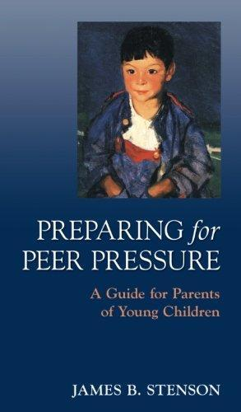
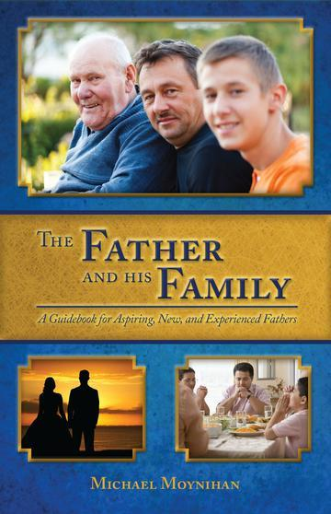
BRIGHT AND CHEERFUL HOMES

19

We want to help you become a saint every day, from right where you are and share Christ with others.
Have you ever tasted the beauty of God’s presence? It's natural to want to experience his closeness more often—as often as you can! As St. Josemaría Escrivá said: “Either we learn to find our Lord in ordinary, everyday life, or else we never find Him.”
We can help you discover and grow closer to God every day in your work, family life, and other ordinary activities. We want you to become a saint and everything we publish and do is directed towards that goal.
Thank you
Thank you for reading the booklet. Please feel free to redistribute the booklet to anyone who might benefit from it. If you are interested in similar reading, see the related books below.

CATHOLIC BOOKS FOR SPIRITUAL GROWTH

